This leaflet only gives general information. You must always discuss the individual treatment of your child with the appropriate member of staff. Do not rely on this leaflet alone for information about your child’s treatment.

This information can be made available in other languages and formats if requested

Alder Hey Children’s NHS Foundation Trust

Eaton Road

****Liverpool

L12 2AP

****Tel: 0151 228 4811

[www.alderhey.nhs.uk](http://www.alderhey.nhs.uk)

**© Alder Hey Review Date: June 2025 PIAG: 405**



**Clinical Health Psychology**

**Terry’s Trip to Alder Hey**

**An adventure you do not want to miss…**



**Information for patients,**

**parents and carers**

****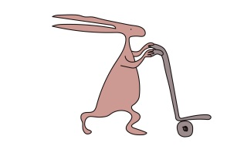

**Terry the tortoise**

Hello. It is great to meet you!

This is Terry the tortoise.



Terry lives with Mum, Dad and his sister Shelley.



What does your home look like?

Draw your home here!



**Who are you?**

What animal do you wish you could be? (draw it here!)

My name is

__________________________

My age is

__________________________

I am in year ________________ in school



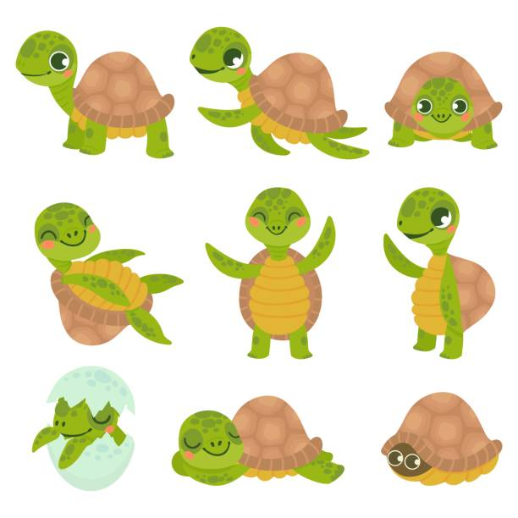

Terry likes sleeping, playing tennis with Shelley, baking with Dad and going on slow walks with Mum.

Some of the things that Terry doesn’t like are the dark, loud noises like fireworks, snakes, broccoli and Brussels sprouts.

Terry doesn’t like the dark because it makes him feel worried. When Terry is worried, he disappears into his shell.

I feel worried… so I am hiding in my shell.



He sometimes gets a tummy ache and feels like he needs the toilet. He has thoughts like “what if there is something waiting for me in the dark?” and he can feel like crying.

**Learning about you**

|  |  |
| --- | --- |
| **My likes**  This includes things you love doing and make you happy. | **My dislikes**  This includes things you do not like doing and do not make you happy. |
|  |  |

**Does anything make you feel worried?**

**What makes you go into your shell?**

makes me feel worried.



Draw, colour and write on me how your body may feel when you are worried.

Another thing that makes Terry worried is going to the hospital.

Terry has to go to the hospital to get check-ups and for doctors to help him feel better when he is unwell.



But Terry doesn’t like going. He has thoughts like “going to the hospital is going to hurt”, “the doctors will be scary” and “I don’t know what it’s going to be like”. He gets tummy pains and feels sick and sweaty.

When he knows he’s got an appointment he disappears into his shell, cries and tells Mum and Dad he doesn’t want to go. Terry doesn’t like talking to his family about going to the hospital.

I really don’t want to go to the hospital, so I am hiding in my shell.



How do you feel when you know you have a hospital appointment?

You can draw or write how you feel below...

Terry’s parents have received a letter for his next appointment at Alder Hey Children’s Hospital. They tell him when the appointment is. Terry gets upset and disappears into his shell.

Mum and Dad don’t like seeing Terry upset and say to him “let’s visit the hospital so you know what to expect for your appointment. This might help you feel better when we talk about the hospital”. Terry comes out of his shell and agrees to do this.



**Your hospital appointment**



**Day**

**Date**

**Month**

**Appointment time _____________**



Terry and Dad plan to go to the hospital for a visit so Terry can get used to it and know what to expect. This is a really big and scary thing for Terry to do, but he is with Dad so he knows he can speak to him and get a cuddle from him if he’s feeling worried when he is there.

Terry and Dad set off for the hospital. They leave plenty of time to get there so that they don’t have to rush.



They arrive at the hospital and walk into the Atrium. It is a big and busy space with a lot of people. This makes Terry worried, and he disappears into his shell.

Dad reassures him that some of these people in the Atrium are children like Terry, and other people are staff (e.g., doctors, nurses, Speech & Language Therapists and psychologists) that are there to help young people like Terry.



It is ok, Terry. The staff in Alder Hey are here to help you.

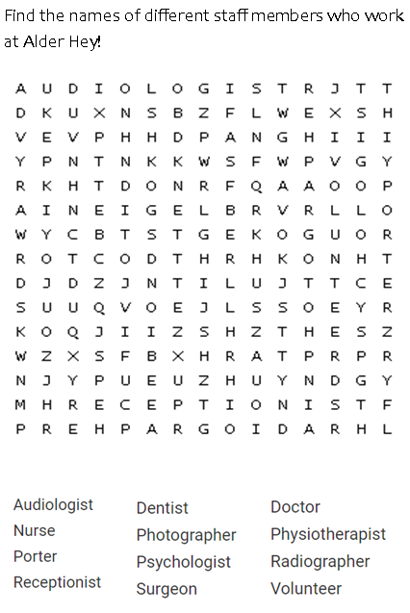**Word search**

Find the names of different staff members who work at Alder Hey!



Terry and Dad find the waiting room.

Terry has brought his favourite toy, iPad and some colouring pens to keep him busy and having fun while he waits.



He notices that there are some other toys and books in the waiting area that he can play with as well.

You could also look at the **Alder Play** app. This app can help you get used to the hospital environment and it includes activities to help keep you busy while you are waiting!

Check it out here: <https://alderplay.alderhey.nhs.uk/>

**What could you bring or do at the hospital when you visit?**

Have a look in the ideas box to help you to come up with your own ideas!

Music

Fidget toys

Fluffy toys

A book

Colouring pens that smell nice

Terry and Dad are then brought into the appointment room. This is where the different staff talk to them about how they are going to help Terry. There are a lot of different people and Terry starts to feel overwhelmed. He disappears into his shell and starts breathing fast.



I feel worried. My heart is beating really fast.

Put one of your hands up and spread your fingers out nice and wide.

Move your pointing finger of the other hand up and down each finger … like you are tracing it.

When you move up a finger **BREATH IN**… when you move down a finger **BREATH OUT.**

**You are doing great!**

Dad suggests to Terry that they do some breathing exercises to help. They do some finger breathing exercises together (look at the next page to learn all about this!).

Once Terry feels calmer, a play specialist comes into the room and explains Terry’s procedure to him and plays some games with him to make him feel better about it.

Take a big deep breath in and out… look around you...

Name 5 things you can see…

Name 4 things you can feel…

Name 3 things you can hear…

Name 2 things you can smell…

Name 1 thing you can taste….

You just practised being “in the moment” - **great work!**

Here are some tips to help you. It is really important to practise these tips when you are feeling happy and calm.

This means that when you are feeling worried or nervous you can do these exercises because you will be super, super good at them!

**Here are some tips to help you manage your big feelings…**



Pretend you are Terry the tortoise and you are going to hide in your shell...

Shrink your head into your body, and then pull your body and shoulders up wards.

After 10 seconds you can release and come out of your shell! **Well done**!

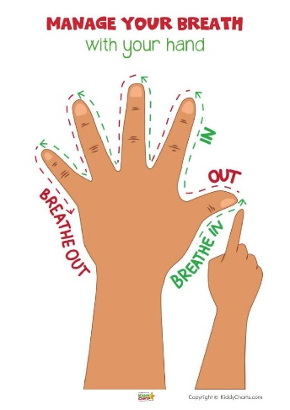



**Write your questions below.** (Remember to look in the ideas box for some ideas!)

Terry’s doctor then comes in to talk to him about what he should expect for his appointment in a few weeks.

He tells them that if he has any questions, he can ask these to anyone he meets on the day. This includes his doctors, parents, nurses and the volunteers in the hospital. Terry decides that he will write a list of questions.



How long will my appointment last?



When will I be allowed to go home after my surgery?

Will my mum/dad/grown-up be allowed to be with me?

**Your questions**

You might have some questions you want to ask at your appointment. **The Alder Hey staff love being asked questions** and we want to make sure we can do our best to answer any questions you may have. **It is a really good idea to write down any questions** you have before your appointment so you do not forget to ask them!

Terry and Dad then get taken to the room where he will have his procedure in a few weeks’ time. Terry notices that it looks like a normal room with a bed in it. It isn’t as scary as he expected! The staff that he meets in the room are friendly and smiley.





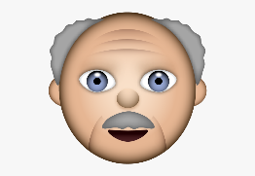

As Terry is leaving the hospital, he passes another young person who is looking very nervous. Terry stops to talk to them. He says, “I was worried too but I’ve learned all these things that can help me”.

Terry realises it’s okay to feel worried. He has been able to talk to Dad about how he is feeling throughout the day. He tells the other young person “Don’t forget to let your grown up know how you are feeling!”.

I feel nervous!



Remember to tell a grown up how you are feeling. They can help you.



**Talking to others and sharing what you have learned**

You have learned so much by reading through this booklet.

You should be very proud of yourself and all of your hard work!

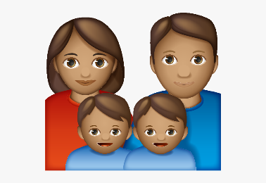

Circle the images of who you would tell if you feel nervous, worried or scared about coming to the hospital?

Is there anyone else you could tell how you are feeling?

________________________________________________

Terry and Dad go home. He feels better after visiting the hospital. He now knows what it is like and how to help himself feel better when he is worried.



I have learned so much! I feel much calmer about visiting Alder Hey hospital in the future.

I am excited to tell Mum and Shelley all about what I have learned!

He tells Mum and Shelley all about his day and the things he has learned. They remind him that he should practice these things when he is feeling calm so that when he is worried and needs to use them, he will be really good at them. Mum asks Terry what he would like to do to relax after his day at the hospital. Terry says he would love to watch a movie with his family, so that is what they do!

Terry now knows what he has to do in the future if he feels worried about visiting the hospital! He will remember to bring a list of ideas of what to do to help himself feel better on the day of his appointment, so he doesn’t forget.

**Checklist**

Use this page to check off all of the activities that you have completed.

Activity 1 - all about you

Activity 2 - learning about you

Activity 3 - your hospital appointment

Activity 4 - word search

Activity 5 - bringing activities to the hospital

Activity 6 - managing your big feelings

Activity 7 - your questions

Activity 8 - sharing what you have learned

Did you complete them all?

**Well done,** you have worked so hard!

**Notes page**

|  |
| --- |
|  |
|  |
|  |
|  |
|  |
|  |
|  |
|  |
|  |
|  |
|  |
|  |
|  |
|  |
|  |
|  |
|  |

**Doodle page**

Leaflet produced by the Clinical Health Psychology team at Alder Hey Children’s Hospital.

Email: [ClinicalHealthPsychology@alderhey.nhs.uk](mailto:ClinicalHealthPsychology@alderhey.nhs.uk)

Telephone: 0151 252 5586