
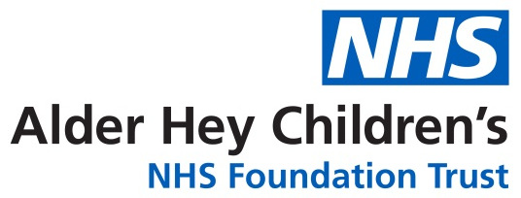

Oncology/Haematology Unit

Telephone maintenance therapy for children with

Acute Leukaemia

Information for Parents and Carers

Introduction

Telephone maintenance therapy maybe offered to children attending clinic for Acute Lymphoblastic Leukaemia. At the moment your child attends Alder Hey Children’s NHS Foundation Trust for clinic every two weeks. Participation in the telephone maintenance clinics means your child will attend their clinic appointments less often.

How will this service work?

When you and your child attend the hospital you will be seen by the Doctor or Advanced Nurse Practitioner and be given four weeks supply of medicines. The medicines will be explained to you. You will receive an Oral Chemotherapy Record with the first two weeks doses of chemotherapy completed. You will also receive a Chemotherapy Dosing Chart that will tell you about dose changes that may happen after two weeks.

Two weeks after this appointment, usually one or two days before your telephone appointment, a full blood count will be taken by your Community Nurse or at your Shared Care Centre or Alder Hey Hospital. The results of the blood count will be sent to Alder Hey.

You will be telephoned with the results of your child’s blood count on your planned telephone clinic apppointment. You will also be advised of the dose of medicines your child will need to take for the next two weeks. Please write the blood results and the dosage information on the Oral Chemotherapy Record. A copy of these instructions will be sent to you by e-mail. Please check the information against what you have written on the Oral Chemotherapy Record. If any information is different to what you expect please contact the Oncology/Haematology Daycare Unit.If you change your telephone number or email address please ensure you update us immediately or we will not be able to contact you with the above information.

If you do not receive a telephone call for your childs clinic consultation please telephone

0151 252 5804 during clinic times (9-1pm).

When you return to the hospital for your child’s next appointment you must bring:

- Any unused medication (return to pharmacy)
- Oral Chemotherapy Record

For further information
If you have any concerns or worries about your child then please contact the Oncology/Haematology Daycare Unit for advice on 0151 293 3684
This leaflet only gives general information. You must always discuss the individual treatment of your child with the appropriate member of staff. Do not rely on this leaflet alone for information about your child’s treatment. This information can be made available in other languages and formats if requested.

Alder Hey Children’s NHS Foundation Trust
Eaton Road
Liverpool
L12 2AP
Tel: 0151 228 4811
www.alderhey.nhs.uk
© Alder Hey Review Date: October 2026 PIAG: 016

