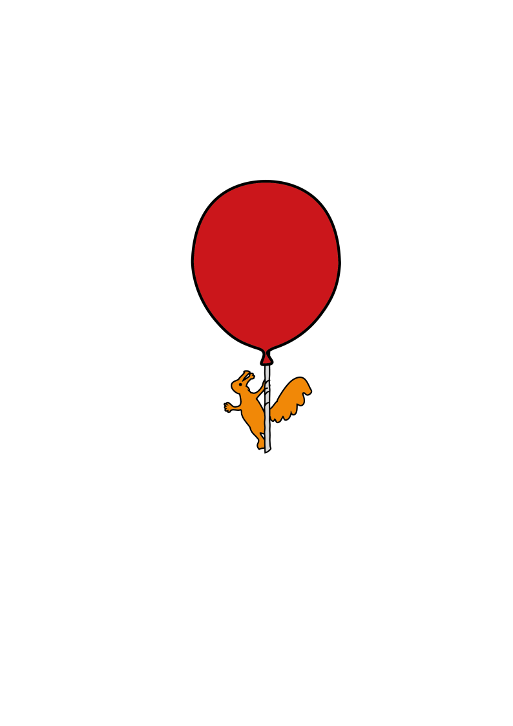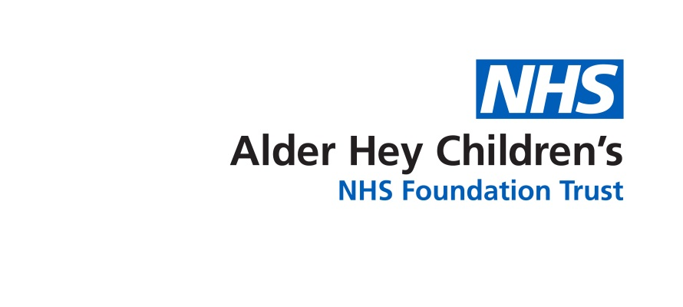

Department of Pharmacy

**Talking about problems with medicines**

Information for children aged five – eight yearsold.

(To be read with a parent or grown up)

**Introduction**

Are you worried that a medicine is making you feel worse? It might be a side effect. This leaflet is to help you talk with a doctor or nurse about any worries you may have.

**What is a side effect?**

Medicines usually help people get better. Many people take medicines without any problems.

But sometimes medicines can make you feel poorly.

When this happens it is called a side effect. If you think you have had a side effect it’s really important that you tell a grown-up.

**Is it easy to spot a side effect?**

Medicines can cause different side effects in different people. Some side effects are bad and some are mild. Knowing if a side effect has really happened (or not) can be hard.

**Lily’s story**

Lily’s ear was hurting. She went with her mum to see the doctor. Dr Jones said that a germ was making Lily’s ear ache.

Dr Jones gave Lily some medicine to make the germ go away. She said the medicine would take a few days to work.

Lily did not mind taking the medicine – it was yellow and tasted like a banana.

The next day Lily had earache and a headache too!

Lily’s mum thought the head might be a side effect of the medicine.

Lily and her mum went back to see Dr Jones.

Dr Jones told Lily it was very rare for this medicine to give people headaches. She said “The same germ that is making your each ache is also making your head ache. The medicine will soon make both aches go away.”

Lily and her mum agreed that she should keep taking the banana medicine.

When Lily woke up the next day she felt much better. Her earache and headache had both gone away!

**Tom’s story**

Tom was in hospital and he had an operation on his tummy

Dr Wood gave Tom some medicine to stop his tummy hurting.

The medicine worked.

Tom started feeling very itchy. He couldn’t stop scratching!

Dr Wood said “The medicine is good at stopping pains but it makes some people itchy. This is a side effect of the medicine.”

Dr Wood stopped the medicine and gave Tom a new medicine.

After that Tom felt much better.

He didn’t feel itchy anymore and his tummy didn’t hurt.

**What you should do if I think you have had a side effect**

If you think you have had a side effect it is really important that you tell someone. Some side effects go away quickly but some stay and some can be serious. You should talk to your mum or dad, or another grown up that you trust. If you are at school you could talk to a teacher. Like Lily and Tom you may want to talk to your doctor or nurse about what to do next.

They will listen to your problems and work out what’s best for you. It might be best to keep taking the medicine like Lily, or it might be best to try another medicine like Tom. If you have had a side effect to a medicine, you can ask anything you want to.

**Here are some questions you may want to ask:**

* How long will the side effects last?
* Can I take my medicine again?
* If I take my medicine again, will I have the same side effect?
* Can I have a different medicine that doesn’t give me side effects?
* What will happen if I don’t take my medicine?

**Who to contact for further details**

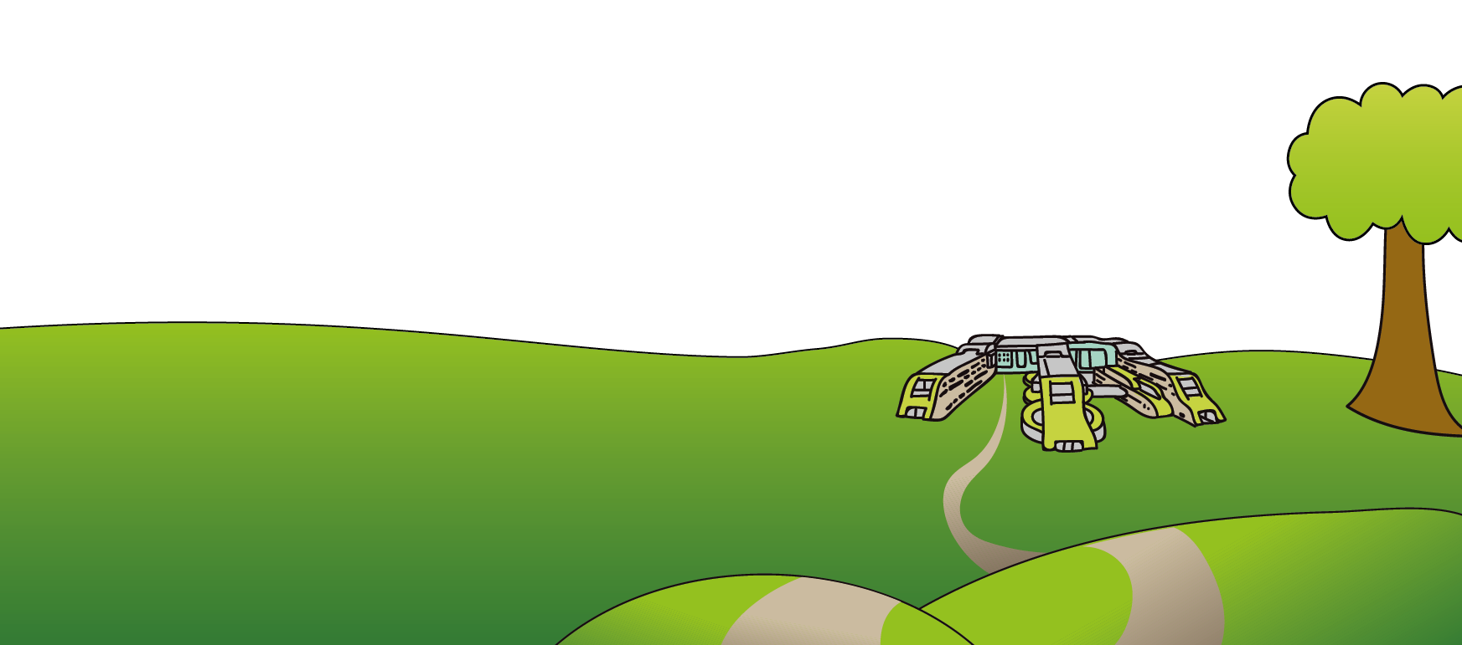If you have any questions about your medicine please ask to speak one of the Pharmacy team, or can telephone us on 0151 252 5311. For more information about side effects, please see the information leaflet that came with your medicine. If you did not get a leaflet, please ask a doctor or nurse for one, or visit the website <http://www.medicinesforchildren.org.uk/>

Parents and Carers - This leaflet only gives general information. You must always discuss the individual treatment of your child with the appropriate member of staff. Do not rely on this leaflet alone for information about your child’s treatment. This information can be made available in other languages and formats if requested.

This leaflet was developed as part of the ADRIC (Adverse Drug Reactions in Children) Programme which was funded by the National Institute for Health Research.

Alder Hey Children’s NHS Foundation Trust

Eaton Road, Liverpool L12 2AP

Tel: 0151 228 4811. [www.alderhey.nhs.uk](http://www.alderhey.nhs.uk)

**© Alder Hey Review Date: May 2024 PIAG: 43**