This leaflet only gives general information. You must always discuss the individual treatment of your child with the appropriate member of staff. Do not rely on this leaflet alone for information about your child’s treatment.

This information can be made available in other languages and formats if requested.

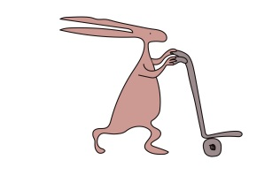

Alder Hey Children’s NHS Foundation Trust
Alder Hey
Eaton Road
Liverpool
L12 2AP

Tel: 0151 228 4811
www.alderhey.nhs.uk

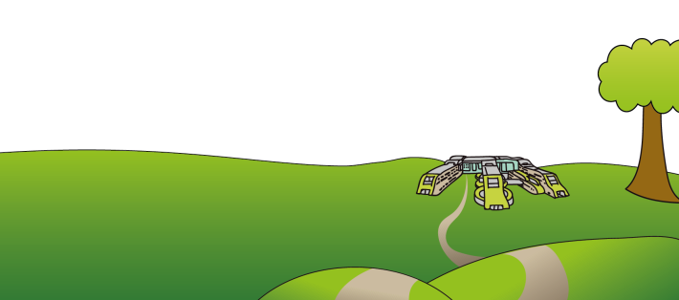
© Alder Hey
Review Date: January 2025 PIAG: 237

Radiology Department
Taking your child home after an
MRI / CT scan under General Anaesthetic

Information for parents
and carers

Taking your child home after an MRI / CT Scan under General Anesthetic

What to do after your child has had a General Anaesthetic for an MRI / CT scan

This leaflet aims to provide you with information about how to care for your child once you are at home.

Children can appear quite alert and active when they are discharged from hospital. However, do not be surprised if your child complains of feeling dizzy or being tired. Your child may feel dizzy and uncoordinated for the next couple of days.

For the next 24 hours:
you should encourage your child to rest.
you should make sure your child’s activities are supervised by a responsible adult.
do not let your child ride a bike.
do not let your child take part in any outdoor activities.
do not give your child fizzy drinks.
do not give your child hard to digest foods such as chips or burgers.

Your child may complain of having a sore throat, hoarseness, muscle ache or pain following an anaesthetic. You can give your child Calpol / Disprol or paracetamol. Do not exceed the recommended dosage for your child’s age.
What to do if your child starts to vomit

If your child vomits on the way home or when you get home, do not be alarmed. Do not give your child anything to eat or drink for 1 hour. After that you can start giving your child a small amount of water or juice. Then gradually start to increase the amount of fluid you give to your child. Once your child can keep fluids down, you can begin to give them a light diet.

If vomiting continues please contact your GP out of hours telephone number or your nearest Accident & Emergency Department.

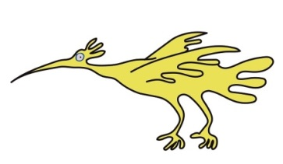

Who to contact if you have any worries following your child’s anaesthetic

Please contact the Day Care Unit for advice by telephoning:
0151 228 4811 Ext 4509
Monday to Friday 8.00am – 7.00 pm

If you have any problems at any other time, please contact:

(staff to insert details)
