Pain Management Team: Chronic Pain Service
TENS – Transcutaneous Electrical Nerve Stimulation
Information for parents, carers and adolescents

What is TENS?

TENS stands for Transcutaneous Electrical Nerve Stimulation. It is a safe and non-invasive treatment that we use for treating pain which does not involve taking medicines. We can use it to treat both acute (new or recent pain e.g. after surgery) and chronic (long lasting) pain.

How does TENS work?

When nerves are irritated or become damaged they start to send faulty messages to the brain. This can be felt as pain, numbness or tingling. Pain that is caused by these scrambled or exaggerated messages from nerves is called neuropathic pain (nerve pain). The scrambled / altered messages reaching the brain can also affect sleep and mood.

The TENS machine sends gentle electrical impulses that feel like a buzzing, tingling or vibrating sensation, to nerves that sense touch. When these touch messages reach the spine they can block the messages sent by the pain nerves, like closing a door. It works for the same reason as when you bump your elbow you will ‘rub it better’. It stops the pain nerve messages from reaching the brain and this reduces the pain felt.

What does the treatment involve?

Small sticky gel pads (electrodes) are placed on the skin, either near the painful area or on the back. These are connected to a small machine (about the size of an ipod), which can easily be clipped to a belt, skirt or pocket. The machine sends mild electrical impulses (that will feel like a gentle tickle or vibration) to the electrodes. These impulses pass through the skin and activate the touch sensing nerves under the skin, which ‘closes the door’ to the pain nerves.

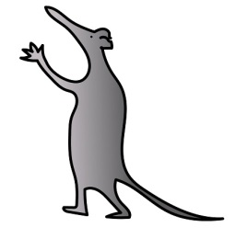
How to use the machine

- Apply the pads to skin that is clean and dry before switching the machine on.

- The skin should be free from creams and lotions before applying the pads –otherwise they will not be able to stick to the skin.

- Do not place the pads over jewellery.

- The TENS machine has several settings to choose from depending on the type of pain felt. A member of the Pain Team will discuss all of these, provide advice on which settings might be more helpful and demonstrate how to use the machine.

- The machine can be worn for as long as needed during the daytime.

- Activities such as going to school, being with friends, sports or other interests can be carried on as usual.

- The machine must be turned off before removing the sticky pads

- The sticky pads must always be replaced back onto the plastic they came on – this helps them keep their sticky nature for as long as possible.

- The pads can be re-used many times so long as they remain sticky. If they are no longer sticky, please contact the Pain Team to arrange for replacement pads to be supplied
Using the TENS machine safely

The TENS machine is a very safe treatment however as it is powered by a battery it is an electrical appliance. It is important not to get the machine wet. It cannot be worn in the bath, the shower or whilst swimming. If the machine becomes dirty, damp cloth can be used to wipe it clean whilst it is switched off. We also advise that the TENS machine is not used in bed, in case a fault develops whilst sleeping.

Each time the electrodes are used the pads should be checked to make sure they are sticky and not too dry. If they seem dry rubbing them with a damp finger (whilst disconnected from the machine) can improve the stickiness. The wires should be regularly checked to make sure they are in good repair, with no cracks or exposed wires.

Are there any reasons for not using TENS machine?

There are very few reasons that the TENS machine cannot be used, which makes it a very good therapy for most people.

- If someone has had a pacemaker or any other electrical device to their heart, they must not use the TENS machine. The doctor, nurse or any other member of the Pain Team should be informed if this is the case.

- The pads should not be used on any broken skin, blisters or unhealed scars.

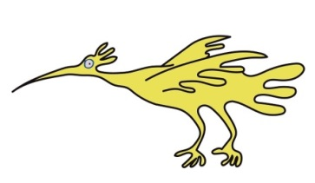
- TENS should be used with caution in children with epilepsy – Check with your Doctor or Physiotherapist first

- Electrodes should not be placed on the neck.

Are there any side effects?

Sometimes they can cause problems we don’t want - these are called side effects. TENS has very few side effects. There is a small risk of skin irritation at the site of the gel electrode.

Although not a side effect some patients (particularly our younger patients) find the tickling sensation ‘weird’ or unpleasant and refuse to wear it. If this is the case we suggest trying it on a very gentle setting and building up slowly, or trying it again when they are a little older.

For further information

Please contact the Pain Service if you have any problems on 0151 252 5003.
Anaesthesia office: 0151 252 5223 Email: pain.service@alderhey.nhs.uk

We have an answerphone and if no one immediately answers the phone leave a message and we will get back to you as soon as possible.
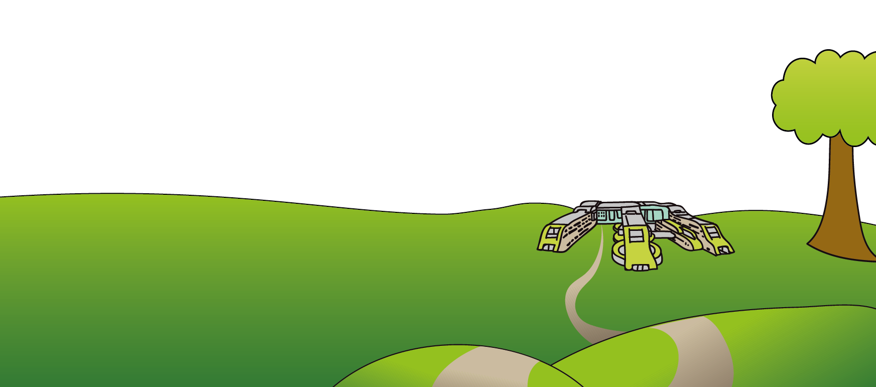
This leaflet only gives general information. You must always discuss the individual treatment of your child with the appropriate member of staff. Do not rely on this leaflet alone for information about your child’s treatment. This information can be made available in other languages and formats if requested.

Alder Hey Children’s NHS Foundation Trust
Eaton Road
Liverpool
L12 2AP
Tel: 0151 228 4811
www.alderhey.nhs.uk

© Alder Hey Review Date: December 2021 PIAG: 097

