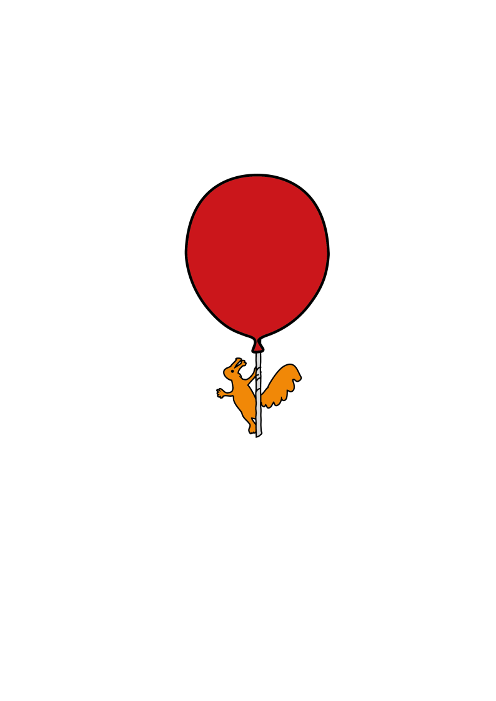

Department of Clinical Biochemistry

**Sweat Test**

Information patients, parents and carers

**Introduction**

This leaflet has been produced to provide information for children and young adults who have been referred for a sweat test. In addition, it explains what the results may mean and how you can get the results of your test.

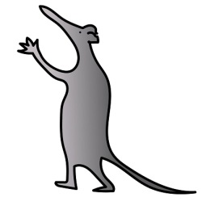**What is a sweat test?**

A sweat test measures the amount of salt (usually as chloride) that is in the sweat.

It doesn’t involve any needles and does not hurt, though it can feel quite strange.

The test will be carried out by a member of staff from the Biochemistry department and usually takes around 45-60 minutes.

**Why does this need to be carried out?**

Sweat tests are usually carried out on people who are having recurrent chest infections, those who have frequent and unexplained pale stools, those that are having problems gaining weight or growing properly, or as part of the Newborn bloodspot screening programme. There are also other rarer reasons for a sweat test.

A positive result may mean that the patient has cystic fibrosis (CF) but a final diagnosis will take into account other symptoms, clinical findings and test results. People with CF have a high amount of salt in their sweat and a normal result can be helpful in ruling out CF. It is important to diagnose this condition as soon as possible in order to begin appropriate treatment.

**How is the test carried out?**

A small area of the lower arm or leg is first wiped with alcohol and then water to remove any oil from the skin surface. Special gel discs containing a chemical called pilocarpine that stimulates sweat production are then placed on the area of skin. The discs are secured in place and a small electric current is passed through the discs from a battery box, to further stimulate the sweating process.

The test is not painful, although a tingling sensation may occur. The discs are left in place for 5 minutes and then removed. There should be a red mark where the pilocarpine has stimulated the skin. This is normal and will fade within a few hours. The skin is then carefully washed with pure water and dried. A plastic coil or ‘watch’ is placed over the stimulated area and secured.

You will then be asked to wait for about 20 minutes for the sweat to be absorbed into the watch. During that time your child (or yourself) is free to play (read) or eat, although salty foods such as crisps should be avoided to minimise any risk of contamination. The tubing is then removed from the watch and analysed in the laboratory.



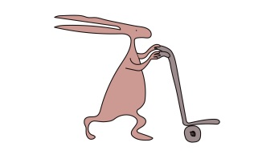

**Does the test hurt?**

Some people experience a tingling sensation on the arm or leg where the sweat has been collected. No needles are involved. Very rarely (1 in 25,000 cases), minor skin burns have been reported. Where this has happened, the patients showed no sign of pain or discomfort during the test, and the burn was not discovered until the discs were removed from the skin. The burns heal completely within one to two weeks with little or no scarring. It is highly unlikely that your child (or yourself) will suffer a burn during the test.

**Results**

In most cases the results will clearly show either a normal, or high (abnormal) salt level in the sweat. Sometimes the results can be borderline and the test will need to be repeated. In a few cases the test may need to be repeated for technical reasons such as not enough sweat has been collected. Many doctors like to confirm an abnormal sweat test with a second sweat test.

The results will usually be available the day after the test. Please telephone the doctor who referred your child (or yourself) for the sweat test.

**Further questions**

If you have questions about the process of doing the sweat test, or if you need to rearrange or cancel a test, please contact the Biochemistry department on 0151 252 5488 or 0151 252 5487.

If you have further questions regarding the need for a sweat test in yourself or your child, please speak to the doctor who has referred you for this test as they can give you further information.

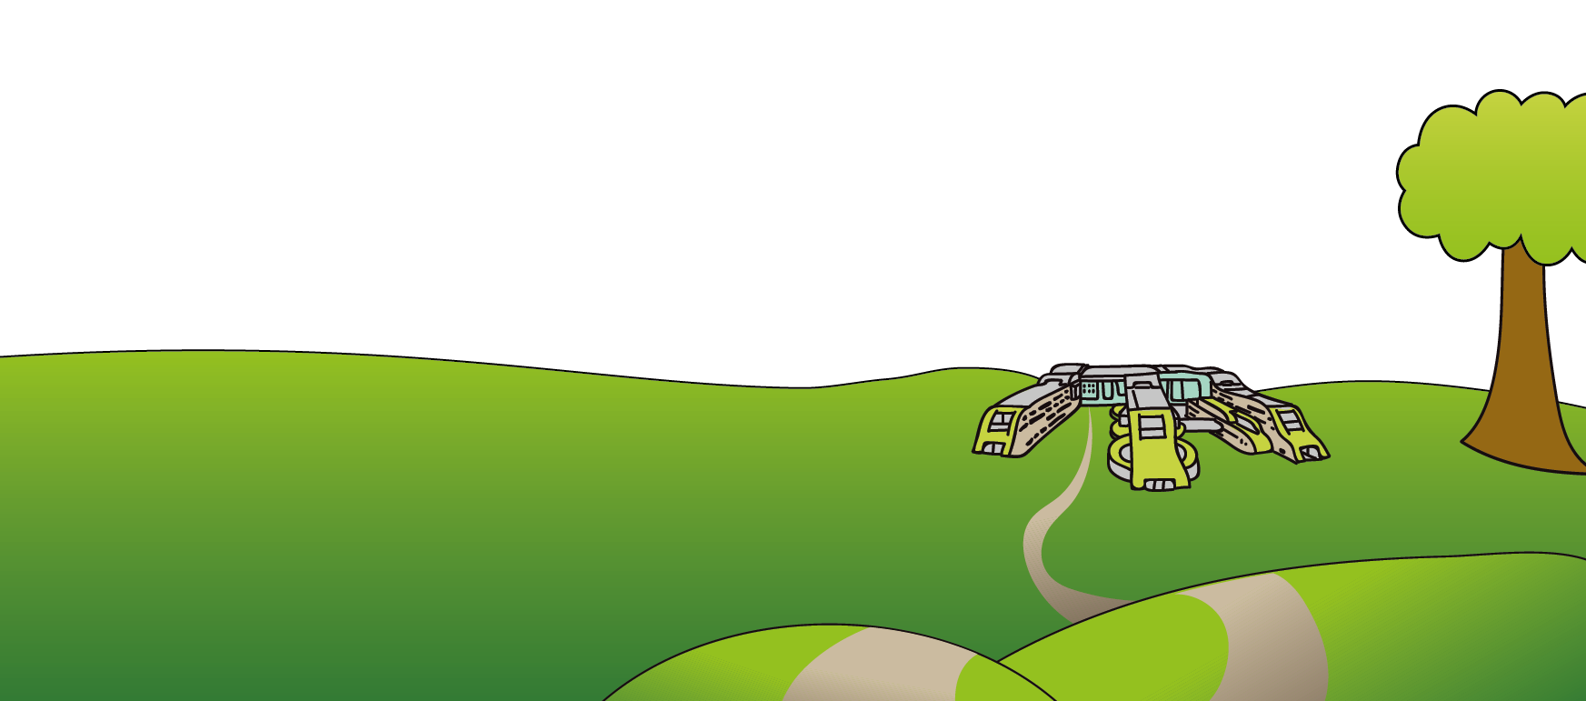This leaflet only gives general information. You must always discuss the individual treatment of your child with the appropriate member of staff. Do not rely on this leaflet alone for information about your child’s treatment. This information can be made available in other languages and formats if requested.

Alder Hey Children’s NHS Foundation Trust

Eaton Road

Liverpool

L12 2AP

Tel: 0151 228 4811

[www.alderhey.nhs.uk](http://www.alderhey.nhs.uk)

**© Alder Hey Review Date: December 2024 PIAG: 215**