Surgical Department

Surgical Drains Discharge Information

Information for patients, parents and carers

What is a surgical drain?

A drain is a thin PVC tube that is placed next to your wound. Its purpose is to remove fluid that collects after an operation. Examples of fluids include blood, pus, serous exudate or bile.

Why do I need a drain?

Body tissue cut during an operation leaks fluid after surgery. If this fluid is not allowed to drain, it can collect under the skin and potentially cause problems.

Drains can also be placed to control and monitor a fistula (abnormal connection between body parts).

Your surgeon will decide on the best drain needed to manage your wound.

The principle reasons for having a drain are:
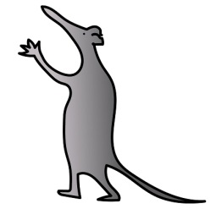
1. To allow the wound to heal.
2. To reduce pain, as a collection of fluid in a closed cavity can cause discomfort.
3. To prevent a collection of fluid which is a potential for infection.
4. To minimise any bruising to the area.

How does a drain work?

Suction drainage – An active (vacuum) drain works by gentle suction. As the area heals, the amount of drainage lessens until it is low enough for the drain to be removed.

Passive drainage – This relies on gravity to take away fluid without additional suction.

Open drain (tubing) – Drains fluid onto a gauze pad or into a small drainage bag.

How long will I have the drain for?

This will depend on the type of surgery you have had. Your surgeon will discuss an estimated time with you.

What are the risks?

In most cases there are very few complications with having a drain in place.
Some of these complications can be:

Infection: An infection can occur around the drain site at any time following surgery and you may need treatment with antibiotics. Symptoms of an infection can include increased swelling, redness, fluid leakage, an increase in body temperature and increased pain.

Collection of fluid at wound / drain site: There is a risk that fluid may pool beneath your stitch line after surgery if the drain put in during surgery is not working properly. If this happens a doctor will need to assess you and may need to remove the fluid by another method and remove the drain.

Tissue growth: This is when tissue grows around the drain. This happens occasionally when the drain has been in place for a while.

Will I feel pain having a drain?

You may feel some discomfort around the drain site and may need some pain medication to help ease this. However, if you are in constant pain, or get new pain, you should seek advice or attend Accident and Emergency Department so a doctor can review you.

What do I need to do after I go home?

Anytime you need to check your drain site or change a dressing you should always wash your hands before and after.

Remember to be careful when moving about so that the drain or tubing doesn’t get caught on any furniture, to prevent it being pulled out.

What if I accidently remove the drain or it falls out?

Do not panic. The site may leak fluid or start bleeding slightly. With a piece of gauze or clean towel place gentle pressure on the area for around 10-15 minutes until the leakage / bleeding stops. When it stops, cover the drain site with a clean dressing / plaster.
Contact the hospital on the numbers provided for advice.

If it continues bleeding, please go to your nearest Accident and Emergency Department so you can be assessed.

If possible, keep the drain or take a picture so your doctor can check that all parts of the drain are present.

Measuring drainage

If you need to measure drainage amount, the nurse looking after you will show you how to do this before going home.
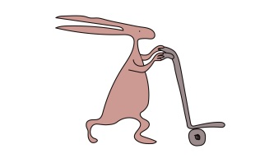
What if the drain appears to be blocked?

Do not panic. Sometimes clots of blood or tissue can appear in the tubing.
Please contact the numbers provided for advice.

You think you may have an infection?

Symptoms of infection include increased swelling, redness, tenderness, fluid leakage, an increased temperature, increased pain around drain site, or it begins to smell.
Please seek medical attention by attending Accident and Emergency Department.

How and when will the drain be removed?

Your doctor or nurse will discuss the plan and explain the procedure of removing the drain to you.

Contact numbers:

Ward 3A – 0151 252 5416

Accident and Emergency Department (via switchboard 0151 228 4811)

This leaflet only gives general information. You must always discuss the individual treatment of your child with the appropriate member of staff. Do not rely on this leaflet alone for information about your child’s treatment.
This information can be made available in other languages and formats if requested.
Alder Hey Children’s NHS Foundation Trust
Eaton Road
Liverpool
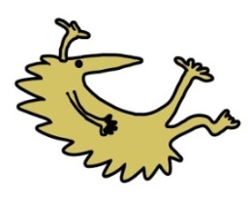
L12 2AP
Tel: 0151 228 4811
www.alderhey.nhs.uk

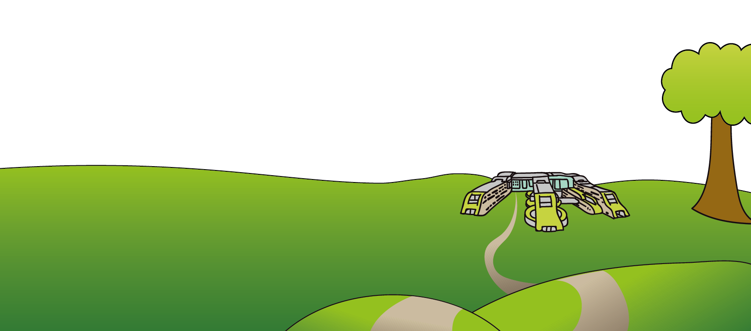

© Alder Hey Review Date: October 2025 PIAG: 316

