Surgical Decision Unit (SDU)

Information for parents/carers

Introduction

The Surgical Decision Unit (SDU)

- This is a 4 bedded unit situated on ward 3A that cares for children requiring surgical assessment, review or treatment who have presented via A & E.

- We also see children who have been previously been treated on 3A or SDU for follow-up investigations or review which cannot be facilitated in the outpatient clinic.

- Children may only attend SDU if it has been agreed by a member of the surgical team.

Frequently Asked Questions (FAQs)

- My child has an been seen on SDU and sent home. We were told to come back the following morning for further review, but they have become unwell overnight. Can I bring them back to SDU in the night?

Answer
If you are worried about your child you should not bring them back to SDU without prior agreement with a member of the surgical team. You should either contact your GP for advice or take them to your nearest A & E department.

- My child has been discharged from SDU following surgery and I am worried they are unwell, can I return to SDU?

Answer
No. If you are worried you should seek advice from your GP or return to A & E. You can call 3A / SDU for advice but should not come back to SDU without prior agreement from the surgical team or Advanced Nurse Practitioner (ANP).

- My child has an appointment on SDU but I am no longer able to attend that day,
can I just come another day?

Answer
You must contact SDU as soon as possible if you are not able to keep your appointment. We can then make a joint decision about your child’s follow up with the team. You should not attend SDU unless it is the day of your appointment, or you have made arrangements with a member of the surgical team.

- My child has been discharged and SDU is now closed for the weekend. Who do I call if I need advice or I am worried about my child?

Answer
You can still call ward 3A / SDU for advice as the nursing staff are still available to take enquiries. If your query is something that can wait till after the weekend please call during opening times. If you are worried about you child please seek medical advice from your GP or nearest A&E.

5) My child has had surgery and we are not expecting to be discharged home before Friday, where will my child be cared for?

Answer
SDU is the short stay area of ward 3A, there are additional 3A beds / cubicles for children who need a longer length of stay.

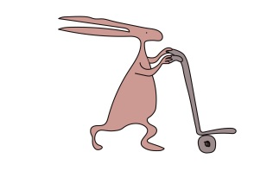
For advice or queries about your child or their appointment please contact a member of staff on ward 3A / SDU:

Telephone 0151 252 5416 or 0151 252 5447.

This leaflet only gives general information. You must always discuss the individual treatment of your child with the appropriate member of staff. Do not rely on this leaflet alone for information about your child’s treatment.
This information can be made available in other languages and formats if requested.

Alder Hey Children’s NHS Foundation Trust
Alder Hey
Eaton Road
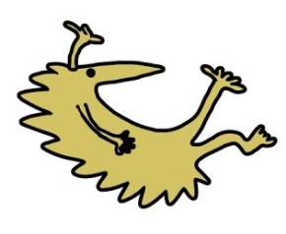
Liverpool
L12 2AP

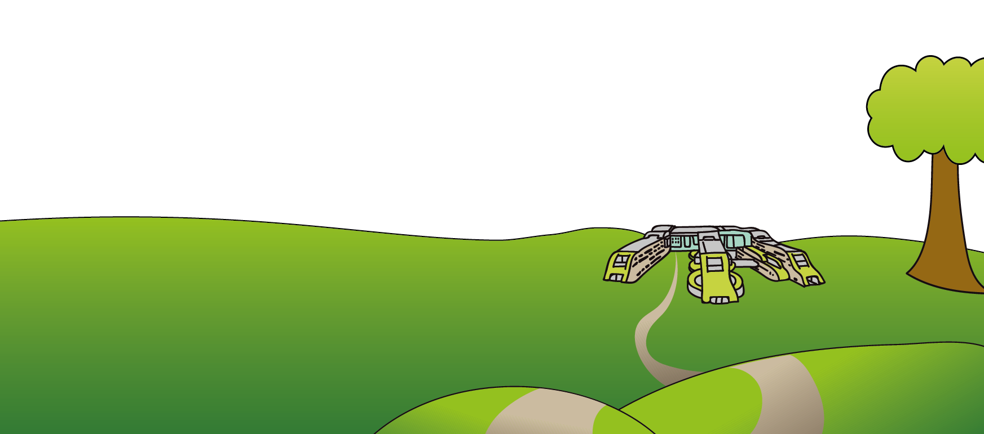
Tel: 0151 228 4811
www.alderhey.nhs.uk

© Alder Hey Review Date: February 2022 PIAG: 247

