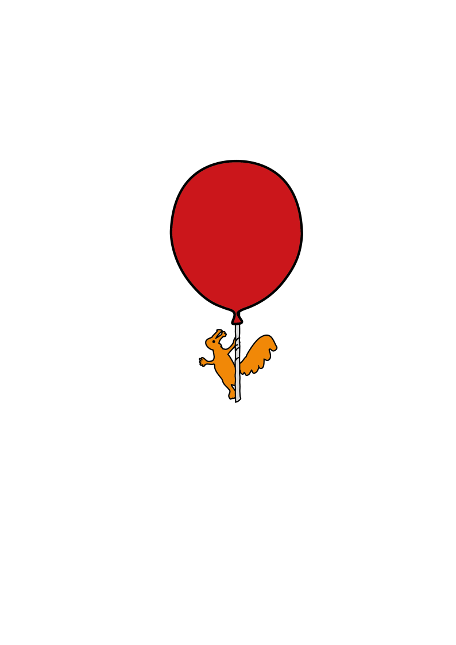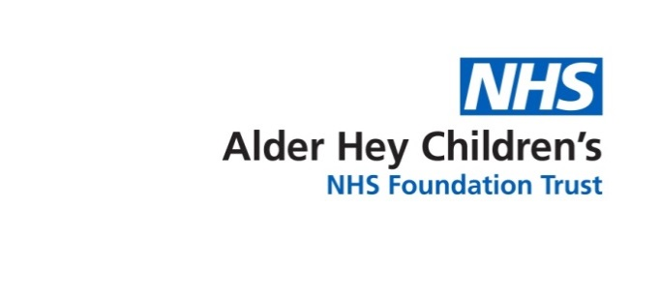

Children’s Speech & Language Therapy Service

**Starting Out With Words**

Information for parents and carers

All children learn to talk at different rates. The way adults use language can help children to communicate.

1. Use **simple language** to talk about what you are doing, e.g. “eating dinner” “Brmm, driving the car”
2. Use lots of different **types of words** all throughout the day to help your child to listen to and learn new words.

Action words (verbs)

e.g. eating, jump, read, drawing, painting, skip, hug, sleep

Words that describe

e.g. hot, wet, soft, big, small, fast,

Naming words (nouns)

e.g. dog, cat, sock, bag, cup, ball etc

names:-

1. Avoid asking too many questions. Instead, comment on what is happening or what you can see. This gives your child an example of the words they could use… try “It’s a cow” (rather than “what’s that?”) or “you’re jumping” (rather than “what are you doing?”)
2. **Repeat** words lots of times so your child gets more opportunity to understand them and then use them…

**car… big car…..**

**car crashed……drive the car…. car up… car down…**

1. Offer your child **choices**, even if they point to show you what they want you are saying the words they could use next time.

“car or book?”

“milk or juice?”



MC900215525[1]

MC900001768[1]

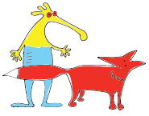

1. Work out what you think your child means and say the words they could try next time (**interpret** their message), for example if your child points to the door to tell you they want to go out, you can say “out” or “open door”

Don’t make your child copy you, just pause and give them time to respond (don’t tell them to “SAY out”)

1. Use fun words, sounds, animal noises etc to help your child learn:

**“Go!” “splash” “brum” “meow” “pop!” “choo choo” “woof” “ready, steady, go”**

For more information visit [**www.alderhey.nhs.uk**](http://www.alderhey.nhs.uk)or talk to your Speech and Language Therapist.

This leaflet only gives general information. You must always discuss the individual treatment of your child with the appropriate member of staff. Do not rely on this leaflet alone for information about your child’s treatment.

This information can be made available in other languages and formats if requested.

Alder Hey Children’s NHS Foundation Trust, Eaton Road, Liverpool, L12 2AP. Tel: 0151 228 4811

[www.alderhey.nhs.uk](http://www.alderhey.nhs.uk)

Speech and Language Therapy Department (Liverpool)

Liverpool Innovation Park,

Kilby House,

Digital Way,

Liverpool,

L7 9NJ.

Tel: 0151 295 3990

Speech and Language Therapy Department (Sefton)

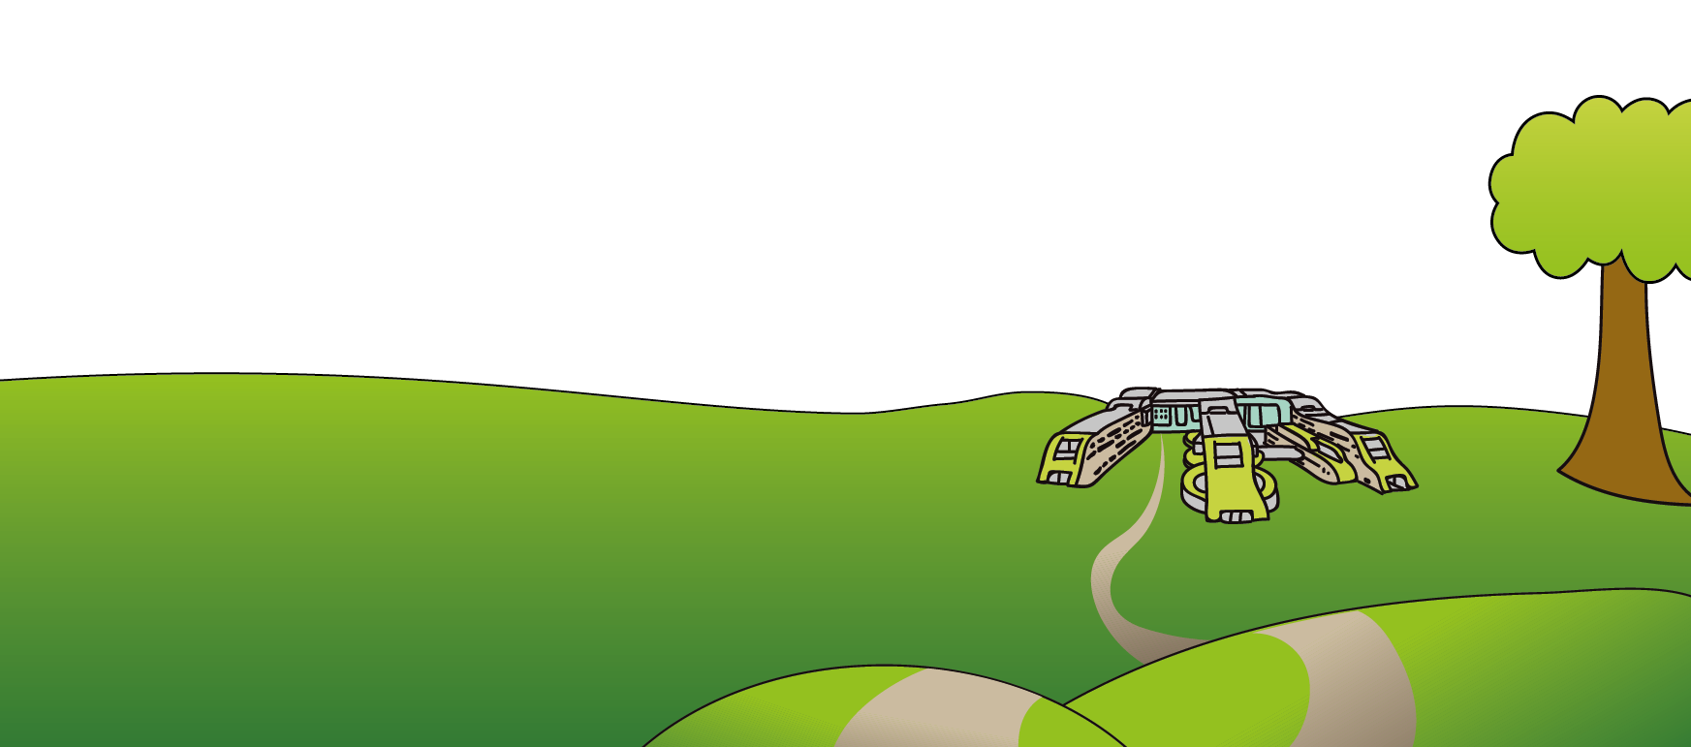Netherton Health Centre,

Magdalene Square,

Bootle,

L30 5SP

Tel: 0151 247 6109

**© Alder Hey Review Date: July 2025 PIAG: 0096**