Paediatric Ophthalmology Department

Squint Surgery

Information for parents and carers

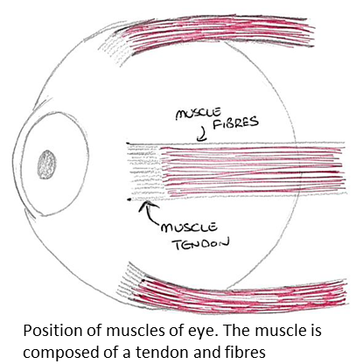
Introduction

Your child’s Consultant/Doctor has advised you that your child would benefit from squint surgery. This leaflet aims to support the discussion you had with the clinician and to enable you to make an informed decision.

What is squint surgery?

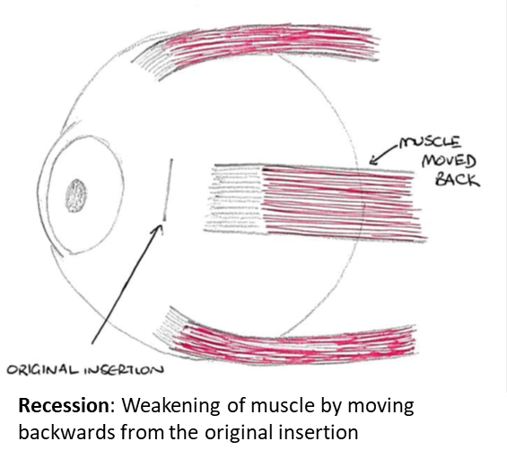
Squint surgery is a very common eye operation. It usually involves weakening / strengthening by moving one or more of the eye muscles on one or both eyes. These muscles are attached quite close to the front of the eye under the conjunctiva, the clear surface layer. On some occasions, only muscles of the squinting eye are operated on. At other times it may be necessary to operate on muscles of the non-squinting eye as well, as this may give better results (by 'balancing' the eyes).

The doctor will explain what is to be done and why this approach has been chosen. Stitches are used to attach the muscles in their new positions and to close the conjunctiva. These stitches usually dissolve.

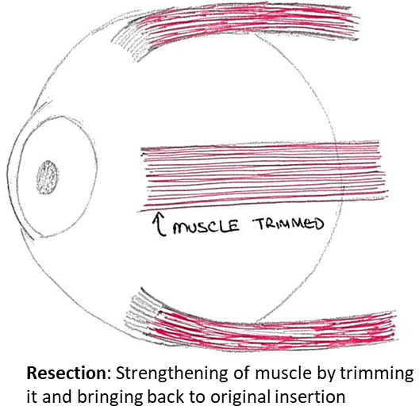
Overall, about 75% of patients will achieve the desired outcome from surgery.1However the squint might not be completely corrected by the operation, and this might not be the aim. Although your child’s eyes could be straight just after surgery, some children require more than one operation in their lifetime. If the squint returns, it might ‘drift’ in either the same or opposite direction. It is not possible to predict when that drift might occur.

What are the benefits of my child having squint surgery?

The aim of the surgery usually is:
- To improve appearance by making the squint less obvious.
- In some patients, to improve how the eyes work together.
- Occasionally, to improve an abnormal position of the head.

What are the risks of my child having squint surgery? 2,3

Squint surgery is generally a safe procedure. However, as with any operation, complications can occur. Generally, these are relatively minor but on rare occasions they could be serious:

- Under and overcorrection
As the results of squint surgery are not completely predictable, the original squint might still be present (under-correction) or the squint direction could change (over-correction). Occasionally, a different type of squint may become noticeable, and may require another operation.
- Double vision
Your child might experience double vision after surgery, as the brain adjusts to the new position of the eyes. This is normal and often settles in days or weeks. Some might continue to experience double vision when they look to the side. Rarely, it can be permanent in which case further treatment might be needed.

- Redness
The redness in your child’s eye can take as long as three months to go away. Occasionally, the eye does not completely return to its normal color, particularly with repeated operations.

- Scarring
Most of the scarring of the conjunctiva (skin of the eye) is not noticeable by three months, but occasionally visible scars will remain, especially with repeat operations. It is important to use any drops or ointment prescribed after the operation to reduce the chance of scarring.

- Allergy / stitches
Some patients might have a mild allergic reaction to the medication they have been prescribed after surgery. This results in itching/irritation and some redness and puffiness of the eyelids. It usually settles very quickly when the drops are stopped.

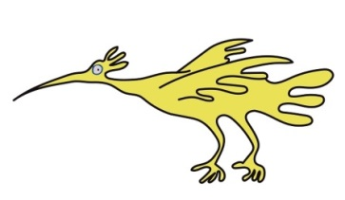
Children might develop an infection or abscess around the stitches. A cyst can develop over the site of the stitches, which could need further surgery to remove it. It is not uncommon for your child to develop some more redness or itching a few weeks after the surgery as the stitches are dissolving. This usually settles within a few days.

Rare/Very Rare
- Lost or slipped muscle
Rarely, one of the eye muscles might slip back from its new position during the operation or shortly afterwards. If this occurs, the eye is less able to move around and, if severe, further surgery can be required. Sometimes, it is not possible to correct this. The risk of slipped muscle requiring further surgery is about 1 in 1,000.

- Perforation of globe
If the stitches are too deep, or the white of the eye is thin, a small hole in the eye can occur, which might require some laser treatment to seal the hole. Depending on the location of the hole, the sight could be affected. The risk of the needle passing too deeply is less than 1 in 1,200.

- Severe Infection
Infection is a risk with any operation and, although rare (less than 1 in 1,500), can result in loss of the eye or vision.
It is important to use the drops prescribed after the operation to reduce the risk of infection.

- Sight-threatening
Although very rare, vision may be permanently affected by surgery. Risk of serious damage to the eye or vision is less than 2 in 1000 operations.

Remember: these complications are detailed for your information – the vast majority of patients have no significant problems.

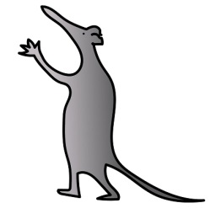
Frequently asked Questions

Does the surgery cure the need for glasses or a lazy eye?

- No, the operation does not aim to change the vision or the need for glasses or patching. Sometimes, more patching is needed after the operation.

Will this squint surgery hurt my child?

- After your child’s operation, their eye(s) will be red and sore and their vision may be blurry. Often your child may be in some discomfort, or even pain, with their eyes, and will not want to open their eyes for the first day. It is important to start the drops that evening, and use painkillers suitable for children, such as paracetamol and ibuprofen, as required. Over the next few days you will find that the pain usually wears off and your child will open their eyes well. The redness and mild discomfort can last for up to three months, particularly with repeat squint operations.

Are there any alternatives to this procedure?

- Squint surgery, when advised by your doctor, is the only surgical way to treat the eye misalignment. Occasionally your doctor will discuss the use of botulinum toxin (maybe referred to as Botox). This is a temporary treatment, and your doctor will discuss if this treatment may be more appropriate.

What will happen if I decide my child will not have squint surgery?

- It is important that you discuss this with your doctor. Your doctor will work closely with your child and you to determine the best course of action for your child.

What sort of anaesthetic will my child be given?

- Your child will have a general anaesthetic. General anaesthesia is drug-induced unconsciousness: it is always provided by an anaesthetist, a doctor with specialist training.

- Appropriate pain relief will be given whilst your child is under anaesthesia, and further pain relief provided as necessary for your child to be as comfortable as possible after their operation.

- Occasionally, general anaesthesia can cause side effects and complications. Fortunately, side effects are uncommon, and are usually short-lived: they include nausea, vomiting, headache and sore throat. Serious complications are very rare, if you wish to discuss this further please ask your anaesthetist on the day of surgery. There is a small risk of damage to teeth, particularly caps or crowns and veneers. Your anaesthetist will take every care, but occasionally damage can occur. Please discuss any concerns with the anaesthetist.

What will happen before the day of surgery?

- A pre-operative assessment (either by telephone or in clinic) is performed in the weeks leading up to your child’s operation date. This is to ascertain if there are any particular health conditions which will need to be considered in view of the anaesthesia.

What will happen on the day of surgery?

- You will be asked to come early so that your child can be prepared for surgery. Your child should not drink or eat before the operation: the exact timings of this will be given before the day of the operation.

- You may go down to the operating theatre with your child and stay until he/she is asleep.

- The operation usually takes up to 60 to 90 minutes depending on the number of muscles that need surgery.

What should I expect to happen once my child has had their operation?

- When your child has recovered from the anaesthetic, and the nurses are happy for him/her to be discharged, you are free to go home – usually a few hours later. Before being discharged you will receive eye drops with instructions. A follow-up appointment will be booked for a few weeks after surgery.

- It is important to remember that your child may be in some discomfort for the first few hours after surgery (please see above). It is also important to remember that it can take up to 3 months to get the final result of the surgery.

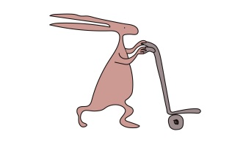
How long will my child be in hospital?

- Squint surgery is nearly always a day-case procedure, so your child should be in and out of hospital on the same day.

Is there anything I can do to care for my child’s eye(s)?

- Start the drops prescribed after the operation that evening. Please resume wearing spectacles, if worn before surgery. Cool compresses can sometimes provide some relief to the eyes.

Discharge information

- Before you go home the nursing staff will give you all the eye drops your child will need.

When can my child get back to normal activities / return to school?

- Normal activity including sports (apart from swimming) can be resumed as soon as your child feels comfortable to take part. Swimming should be avoided within the first four weeks after surgery.

- Your child might need a few days, or one week, off school or nursery.

Will we be given a further appointment?

- We will give, or send, you a telephone or clinic appointment 2-3 weeks after the operation to see how your child is getting on. A subsequent appointment will be booked depending on the consultation. If you have any concerns before this please do not hesitate to contact us.

For further information

This leaflet aims to answer some of the questions you might have about your child’s squint surgery. This leaflet doesn’t cover everything as every child and squint is different. Your doctor will discuss your child’s particular case with you. Please ask the clinical staff about anything you want to be made clear.

Useful Phone Numbers

Eye Clinic: 0151252 5215 (8.30 am – 5.00 pm Monday to Friday). After that time you will need to contact Alder Hey Hospital on 0151 228 4811and ask for the on-call ophthalmologist

Useful website: www.squintclinic.com

Please note: Alder Hey Children's NHS Foundation Trust is neither liable for the contents of any external internet site listed, nor does it endorse any commercial product or service mentioned or advised on any of the sites.

References:
- Astudillo PP, Cotesta M et al, The Effect of Achieving Immediate Target Angle on Success of Strabismus Surgery in Children, Am J Ophthalmol. 2015 Nov; 160(5): 913-8
- Bradbury J, What information can we give to the patient about the risks of strabismus surgery, Eye (Lond). 2015 Feb; 29(2): 252-7
- Bradbury JA, Taylor RH. Severe complications of strabismus surgery. J AAPOS 2013; 17(1): 59–63.

This information can be made available in other languages and formats if requested.
Alder Hey Children’s NHS Foundation Trust
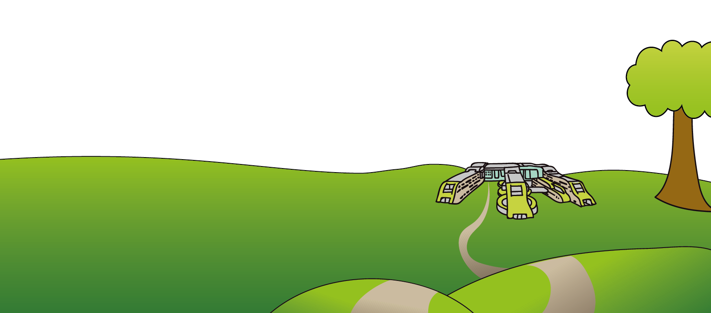
Alder Hey
Eaton Road
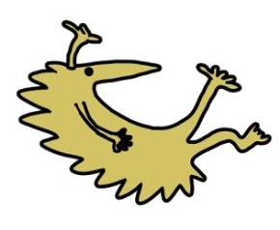
Liverpool
L12 2AP

Tel: 0151 228 4811
www.alderhey.nhs.uk

© Alder Hey Review Date: June 2024 PIAG: 24

