Surgical Day Care Unit

Squint Surgery

Discharge information for parents and carers

Introduction

Your child has had surgery and a general anaesthetic today and is now ready to go home. This leaflet aims to provide you with information to help you care for your child once at home.

General Anaesthetic advice

Most children appear quite alert and active when they are discharged from hospital. However do not be surprised if your child complains of feeling dizzy, tired or is a little clumsy. This may last for a couple of days.

For the next 24 hours

- You should encourage your child to rest
- You should make sure your child’s activities are supervised by a responsible adult.
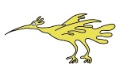
- Do not let your child ride a bike
- Do not let your child take part in any outdoor activities
- Do not give your child any fizzy drinks
- Do not give your child hard to digest foods such as chips, burgers

Your child may complain of a sore throat, hoarseness or muscle ache following an anaesthetic or pain at the site of the operation. You can give your child Paracetamol.
Do not exceed the dosage recommended for your child’s age.

All advice regarding medicines will be given to you when your child is discharged

What to do if your child starts to vomit

If your child vomits on the way home or when you get home, do not be alarmed. Do not give your child anything to eat or drink for one hour. After that you can start giving your child a small amount of water or juice. Then gradually start to increase the amount of fluid you give to your child. Once your child can keep fluids down you can begin to give them a light diet.

If the vomiting continues please contact your GP out of hours number or you nearest Accident & Emergency Department

What to do when your child goes home

- Your child’s eyes will look red after the operation. This is quite normal. The redness will settle within a few weeks.
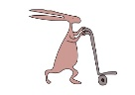
- Try to encourage your child not to rub their eye/eyes.

- Use the ointment and/or drops as prescribed by the hospital.

- Any small stitches used will dissolve in several weeks time.

- The eyelid and cheek may be cleaned with cooled boiled water and cotton wool or tissue. Clean each eyelid area separately, from the inside corner of the eye outwards, as explained by the nurse.

- Your child should continue to wear glasses (if usually worn) until advised otherwise by the doctor.

- Your child can watch television and read as soon as he/she is comfortable to do so.
- When washing your child’s hair, or bathing your child, take extra care to avoid getting soap or shampoo into their eyes.

- Your child can return to school after four or five days, if they feel comfortable to do so.

- Your child should avoid swimming for six weeks.

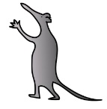
Who to contact if you have any worries

Monday to Friday 07.00–20.00 Day Care Unit 0151 252 5557 / 0151 282 4509

Out of hours: Ward 3A 0151 252 5447

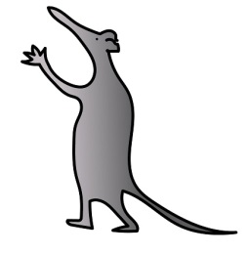
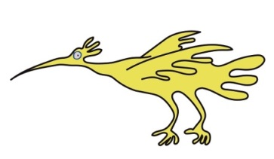

This leaflet only gives general information. You must always discuss the individual treatment of your child with the appropriate member of staff. Do not rely on this leaflet alone for information about your child’s treatment.

This information can be made available in other languages and formats if requested.

Alder Hey Children’s NHS Foundation Trust
Alder Hey
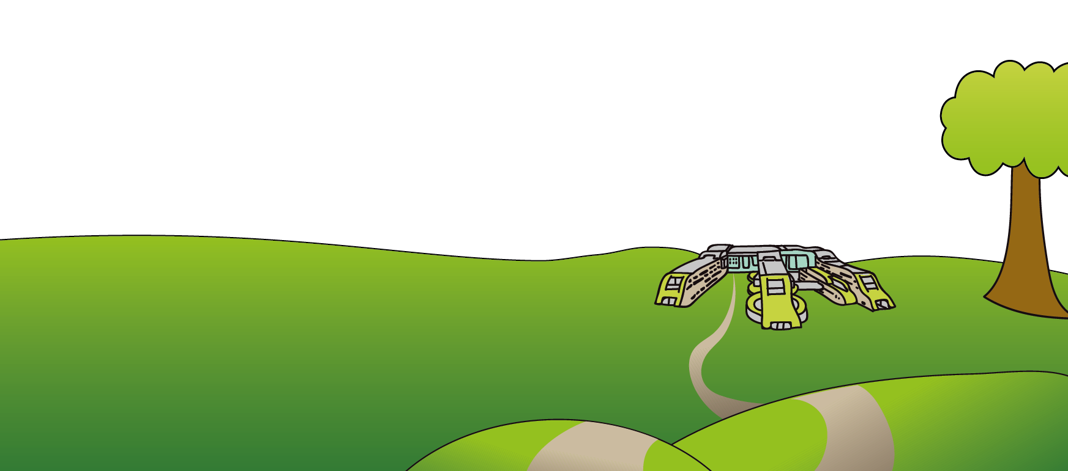
Eaton Road
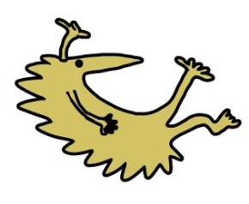
Liverpool
L12 2AP

Tel: 0151 228 4811
www.alderhey.nhs.uk

© Alder Hey Review Date: December 2024 PIAG: 01

