Neuromuscular Physiotherapy & Occupational Therapy Departments

Spinal surgery for children with a neuromuscular condition

Information for parents and carers

Before surgery

Your child will have an assessment by a Neuromuscular Consultant, Anaesthetist, Cardiologist, Specialist Physiotherapist and/or Occupational Therapist before their admission. The physiotherapist may recommend and teach your child to use assisted coughing techniques and the use of specialist equipment before the operation.

It is essential that your child is not constipated prior to admission. If necessary, medication will be prescribed by the doctors.

If you child is taking cardiac medication such as Lisinopril, it will be stopped by the medical team before the operation and reintroduced afterwards. This will be discussed with you by the doctors.

Planning

The needs of your child will be discussed with local teams before the operation. It is useful to have a list of names and contact details of all those involved in the care of your child.

Your child may need a different bed that helps to adjust their position in bed and relieve pressure. It may help to move the bed slightly to allow carers access to both sides of the bed if possible.

Your child may be more comfortable in a shower chair that can recline. It may also be necessary to have head support. Your child may need to use a commode following the operation for a short time. An inflatable hair wash tray can be useful if the bath / shower cannot be accessed in the time following surgery.

Your child will be taller following the operation. Although the spinal rods will hold your child’s back straight, they will continue to need lateral supports in their seat as they may lean to either side from their hips. A tilt in space / recline facility on their wheelchair will help with changing positions. It may be possible to make minor changes to your child’s wheelchair whilst still in hospital but it is necessary to have a full wheelchair review following discharge. We will contact your Wheelchair services / provider before your operation.
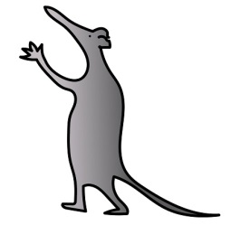
It can be useful to have some form of alternative seating such as a supportive armchair that can be tilted and reclined.

If your child attends a hospice for respite, consider a short stay before returning home. This gives you additional support and time to get used to moving and handing your child confidently.

You need to think about how you will transport your child home when they are discharged. Your child will be taller after the operation. So you need to consider the access to your vehicle taking into account the door frame, not just the height inside the vehicle.

The operation may change the way your child can use their arms as they may not be able to bend forwards. Raising the table or using mobile arm supports can assist with activities such as eating.

What to bring with you

You need to bring your slings from home to use during your stay. The sling needs to have head support and be long enough to accommodate the increase in height. We will discuss this with you at your appointment before the operation.

It can be difficult to look after your child’s hair following the operation so it is a good idea for them to have a haircut before coming in to hospital. Patients with long hair may find it easier with two plaits.

In the first few days after the operation, loose fitting lightweight tops with openings all the way down are easier to manage rather than anything that pulls over their head. Loose fitting shorts, boxers or pyjama bottoms will also be easier.
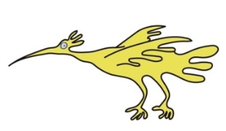
- A lightweight blanket is helpful to cover their legs in the wheelchair.

- You will need to bring the charger and tools for your child’s wheelchair.

- If you us an NIV and/or cough assist machine please bring that with you.

Hospital admission

Your child will be admitted on the day before their surgery. The operation takes a long time, so expect your child to be in theatre for most of the day. Your child will go to intensive care straight after the operation. There may be a chance that your child’s operation is postponed if, due to unforeseen circumstances, a bed is not available on the day of admission. An airflow mattress will be used following surgery. Your child will usually be transferred to the Orthopaedic Ward (4A) for the rest of their stay.

Hospital stay

One parent will be allowed to sleep by the side of the bed once on the main ward. It is not possible to book a room in Ronald Macdonald House. We can check availability once your child has been admitted, however do not rely on this facility.

The pain team will be involved straight after surgery. Your child will return from theatre with multiple intravenous lines in place, one of which will be in their neck.

Nursing and therapy staff will be changing your child’s position frequently in the bed, initially in lying and then working towards a sitting position.

Usually between day four and six after surgery, your child will be hoisted out of bed and into a chair. You will be shown the best way to move your child.

It is essential that your child sits for very short periods initially. The length and frequency of these periods will gradually be increased in consultation with the therapists.

The use of pain relief needs to be coordinated around these times and we will ask you to be involved in this.

Should your current wheelchair be unsuitable after the surgery we will arrange for a suitable loan chair until your local wheelchair service can arrange for a new one.

Hospital stay is usually 10-14 days. Before going home, your child will be provided with pain relief and a plan for increasing the amount of time spent in their chair.
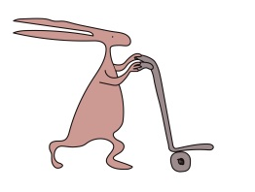
Your child must be eating and drinking adequately with bowel and bladder function returned to normal before discharge will be agreed.

Going Home

Your child needs to be able to tolerate sitting in their wheelchair for the length of your journey home plus 30 minutes. Using pillows in the car may help your child to be more comfortable on the journey home. You will need to bring these from home.

It may be necessary to review some of your child’s equipment once you get home – slings, wheelchair, shower chair.

Your child may have more physiotherapy appointments when you get home. Your child can restart hydrotherapy and standing following discussion with the orthopaedic surgeon.

Therapists will liaise with your local team.

It is important to continue to follow the rehabilitation plan including building up sitting in a chair and use of any respiratory equipment recommended in hospital.

Your child will need to spend some part of their day resting out of their wheelchair initially.
A phased return to school is usually advised.

Contact Details

Alison Shillington - Clinical Specialist Physiotherapist
Tel: 0151 252 5660 email: Alison.shillington@alderhey.nhs.uk

Denise Wooding - Neuromuscular Occupational Therapist
Tel: 0151 252 5660 email: Denise. wooding@alderhey.nhs.uk

Lisa Andre - Spinal Nurse
Tel: 0151 252 5619 email: Lisa.andre@alderhey.nhs.uk

This leaflet only gives general information. You must always discuss the individual treatment of your child with the appropriate member of staff. Do not rely on this leaflet alone for information about your child’s treatment. This information can be made available in other languages and formats if requested.

Alder Hey Children’s NHS Foundation Trust
Alder Hey
Eaton Road
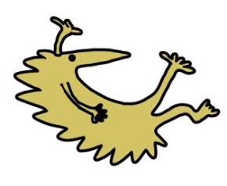
Liverpool
L12 2AP
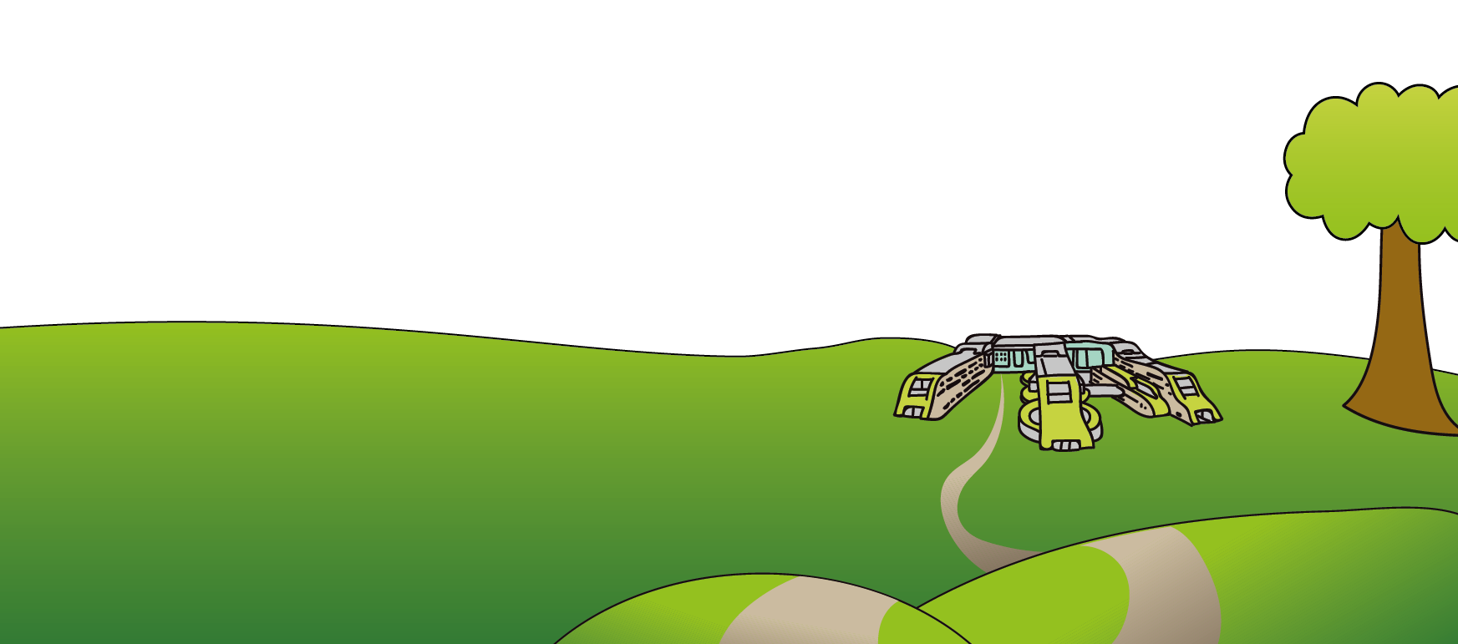
Tel: 0151 228 4811
www.alderhey.nhs.uk

© Alder Hey Review Date: February 2025 PIAG: 30

