What issues do I need to be aware of?

- Some red marking of the skin is normal in standard spinal braces but as the scanned brace is designed to fit close and neat to the skin of the individual, rubbing and redness should not be an issue. If this does occur, please contact the department for a review appointment.

- Children do grow, sometimes frequently and rapidly, please contact the department if you feel the brace no longer fits or becomes uncomfortable for the wearer and you will be provided with a review appointment.

Contact us

If you have any problems or questions please contact a member of
the team who will be happy to discuss them with you.

Telephone: 0151 252 5318
Fax: 0151 252 5319
Email: orthotics@alderhey.nhs.uk

This leaflet only provides general information. You must always discuss the individual treatment with the appropriate staff member.
Do not rely on this leaflet alone for information about the treatment.
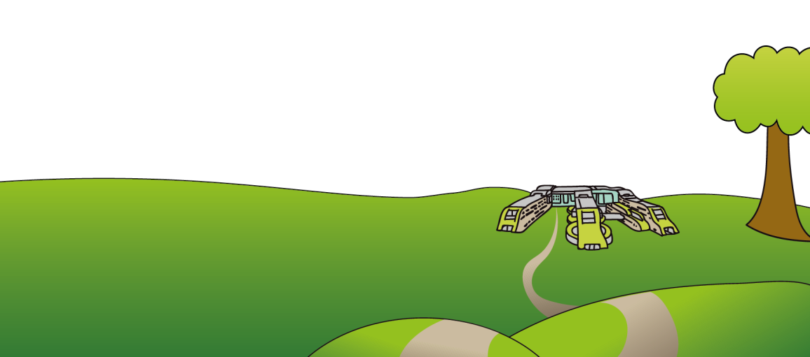
This information can be made available in other languages and formats if requested

Alder Hey Children’s NHS Foundation Trust
Eaton Road
Liverpool
L12 2AP

Tel: 0151 228 4811
www.alderhey.nhs.uk

© Alder Hey Review Date: August 2024 PIAG: 159

Orthotics Department

Spinal Braces

Information for
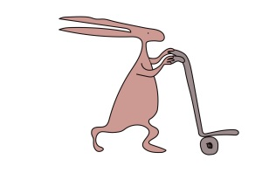
patients, parents and carers

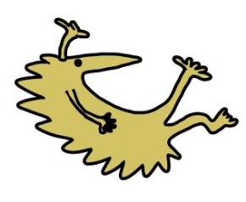

Why has a spinal brace been prescribed and what is my child entitled to?

- Your child has been prescribed a brace, specially designed individually from a scan of their skin surface and utilizing the 3D EOS low dose X-Ray. This combination allows for the perfect fit.

- You will be provided with 1 brace.

- You will be provided with 3 pure cotton seamless vests to be worn under the brace to ensure hygiene and comfort. Extra vests can be purchased for £9.50 each.

Care of the brace

- Regularly clean the spinal brace with mild soap and water, towel dry and keep away from direct heat sources i.e. radiator, as the material may distort.

- It is your responsibility to bring the device to the orthotics department for repairs as and when necessary i.e. when straps or pads become worn down.

- It is also your responsibility to contact the department if the wearers condition changes or if the brace no longer fits correctly.

- You will be provided with a second brace only when the Orthotist or Technician deem it no longer clinically effective or beyond repair.

How is a spinal brace fitted, and wearing the spinal brace.
- The spinal brace will be fitted by one of our trained Orthotists in clinic. The Spinal team have developed a specialist treatment plan to get the best results from wearing the scanned brace.

- The Orthotist will advise you on how to properly fit your child’s brace but when putting the brace on, ensure the brace is in the correct place i.e. the right way around and the straps should be pulled tight enough to ensure it does not move around or slide up and down, but not too tight so that they cause discomfort.

- When first wearing the brace, it should be worn for up to 4 hours. On the second day, this can be extended to wearing it overnight and taking it off in the morning to wash.

- This can then be extended to wearing it longer for school etc. The aim is to work towards the clinically recommended time of 18-23 hours per day.

- It is recommended to wear the brace as tight as possible to achieve the best correction.

- If at 6 weeks following initial fitting, you feel a review is necessary, please let the department know and you will be provided with an appointment.

- At 4 months after initial fitting, you will be provided with repeat
X-Rays in and out of the brace. You must NOT wear the brace for 6 hours prior to this appointment.

