What issues do I need to be aware of?

- Some marking/discolouration of the skin may occur in spinal braces, especially on the pressure points where we are trying to correct your curve. This marking should fade once the brace is removed. Should you be concerned about marking or skin discolouration, please contact us for more advice.

- Please remove the brace and contact the department should any marking progress to rubbing/blistering or skin breakdown.

- When first fitted with the brace, some patients report a bruising type feeling where the brace is pressing, this feeling should reduce as you get used to the brace.

- Children do grow, sometimes frequently and rapidly, please contact the department if you feel the brace no longer fits or becomes uncomfortable for the wearer and we can bring your review appointment forward.

Contact us

If you have any problems or questions, please contact a member of
the team who will be happy to discuss them with you.

Email: orthotics@alderhey.nhs.uk

Phone: 0151 252 5318

Alder Hey Children’s NHS Foundation Trust
Eaton Road
Liverpool
L12 2AP

www.alderhey.nhs.uk

© Alder Hey Review Date: August 2026 PIAG: 159


Orthotics Department

Spinal Braces



Information for
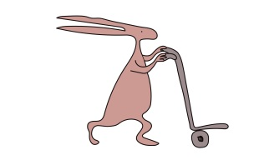
patients, parents and carers


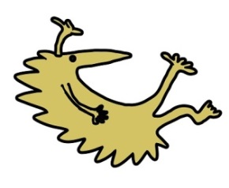

Why has a spinal brace been prescribed and what is my child entitled to?

- Your child has been prescribed a custom-made spinal brace, specially designed from some measurements of their body and a scan of their skin surface using a 3d scanner.

- You will be provided with 1 brace.

- You will be provided with 2 Knit-rite lightweight vests to wear underneath your brace to keep your skin dry, protected and comfortable. If you prefer to wear another type of vest under your brace, you are welcome to do so.

Care of the brace

- Regularly clean the spinal brace with mild soap and water, towel dry and keep away from direct heat sources i.e. radiator, as the material may distort.

- It is your responsibility to bring the device to the orthotics department for repairs as and when necessary, i.e. when straps or pads become worn down.

- Please contact the department if the wearers condition changes or if the brace no longer fits correctly.

- Your brace will be replaced by your Orthotist when they feel is is no longer working as effectively due to growth. Regular reviews will ensure brace adjustments and replacements are managed pre-emptively.

How is a spinal brace fitted, and wearing the spinal brace.
- The spinal brace will be fitted by one of our trained Orthotists in clinic. This will most likely require adjustments on the day in our workshop to optimise the fit of the brace.

- The Orthotist will advise you on how to properly fit your child’s brace.

- It is recommended to wear the brace as tight as possible to achieve the best correction. Lines can be drawn on the brace as a guide if this is helpful. As you get used to your brace, it may be that you can pull it tighter than the original lines, this is a great sign as it means your body is moving into the spaces more.

- When first wearing the brace, it is important to build up wear time gradually. Increasing by a couple of hours each day during waking hours. The brace can be trialled in bed at night from the very first night, it may take you a few nights to be able to comfortably sleep through the night in your brace.

- The aim is to work towards the clinically recommended time of 20 hours per day.

- 6 weeks following initial fitting, an Orthotic review appointment will be arranged to check how you are getting on with your brace. An in-brace x-ray will also be undertaken at this appointment to evaluate the effectiveness of your brace.

- The Orthotics team will continue to review you, and your brace fit every 4-6months.

- The Spinal surveillance team will arrange 4-6 monthly out of brace x-rays of your spine to monitor for any changes. Please do not wear your brace for 6 hours prior to any out of brace x-ray appointments.

- If an appointment with your consultant has been arranged, please do not wear you brace for 6 hours prior to this appointment so that if they need to do an out of brace x-ray at this appointment, they can do so on the day.

