Speech and Language Therapy Department
Speech and Language Therapy following
Cleft Palate Repair
Information for parents and carers

Introduction

This information has been produced by Specialist Speech and Language Therapists based at Alder Hey Children’s NHS Foundation Trust. It is intended for parents and carers of children who have recently undergone cleft palate repair.

The information outlines the development of speech and language skills, and provides advice and strategies aimed at promoting these skills.

Definition of terms

These are the terms that you may encounter:

Speech/Articulation The articulators (e.g. lips, teeth, tongue and palate) help to make different speech sounds. Some sounds are made using both lips (“m, p, b”) and some using lips and teeth (“f, v”).
Resonance This refers to the overall tone of speech i.e. how “nasal” your child’s speech sounds.

Language This refers to the words your child is using regularly.

The development of speech and language skills

Speech and language are skills we learn and develop through a series of stages. As each child is different, the time at which they acquire these skills may vary slightly.

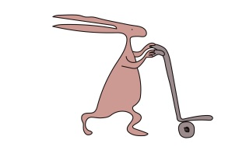
Not all children with a cleft palate will experience difficulties with speech and language. It is important that speech and language development is monitored very closely by your child’s Speech and Language Therapist.

How are speech sounds made?

Speech sounds differ according to:

The place of articulation This depends on the articulators that are used to make them
e.g. lips, tongue, teeth and palate.

The manner of articulation This depends on how they are made, for example whether they are made using friction e.g. “s, f” or whether they require pressure to be built up in the mouth and then released e.g. “p, b”.

Voicing This depends on whether the vocal cords are vibrating e.g. “z” or are still e.g. “s”.

How is the palate involved in speech?

The roof of the mouth is made up of the hard, bony palate at the front and the soft palate at the back. The soft palate is made up of muscles that allow it to move upwards and backwards to close off the nose. This prevents air from escaping through the nose during speech.

If the palate does not separate the nose from the mouth properly, this will allow air to escape into the nose resulting in speech sounding more nasal.

Why does my child need speech and language therapy?

Whilst not all children with a cleft palate will require ongoing speech and language therapy, it is essential to monitor your child’s speech and language development even at this early stage. Early intervention is important because children learn through experiences, copying others and play.

After the palate has been repaired your child can now experiment with new sounds that they previously found difficult.

It is easier to prevent speech and language errors rather than to correct them once they occur. The Speech and Language Therapist can suggest activities to encourage good speech habits even before speech develops.

General advice
Learning language should be pleasurable, in the context of a fun, happy, relaxed interaction, which occurs in everyday life. It is important that your child does not feel under pressure to speak.

Be wary of assuming your child is being lazy. Speech errors have developed over time and have become a habit for the child.

When working with your child on their speech it is important to consider the environment, for example avoid distractions by reducing background noise, such as turning off the television, radio, washing machine etc. This is especially important, as children with a cleft palate are prone to middle ear problems, which may affect hearing. It is therefore important to ensure that your child’s hearing is checked regularly.

Speech activities
- Establish a routine for working with your child. Activities should be carried out on a daily basis and may also be incorporated into general play.

- It is important for you to get down to your child’s level where they can hear and see you best.

- When playing with your child the parent/carer should aim to repeat back any normal speech sounds such as “p, b, t, d, k, g” made by the child to encourage interaction.

- Certain sounds are easier for your child to make, such as nasal sounds “m, n” and sounds made at the back of the mouth “k, g”.

- Children with a cleft palate may have a tendency to make sounds in their throat such as “uh” rather than in their mouth such as “p”. To reduce the likelihood that your child will use throaty sounds, it is important to encourage normal speech sounds such as “p, b, t, d”.

- When repeating sounds back to your child, replace throaty sounds with normal speech sounds instead. These sounds are particularly good as they are visual. Face your child so that they can see how you say the sounds.
Examples of activities to encourage the use of first sounds/words:

Naming  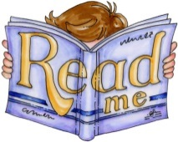 | Read to your child using simple, short phrases, emphasising key words.
Feely bag/box  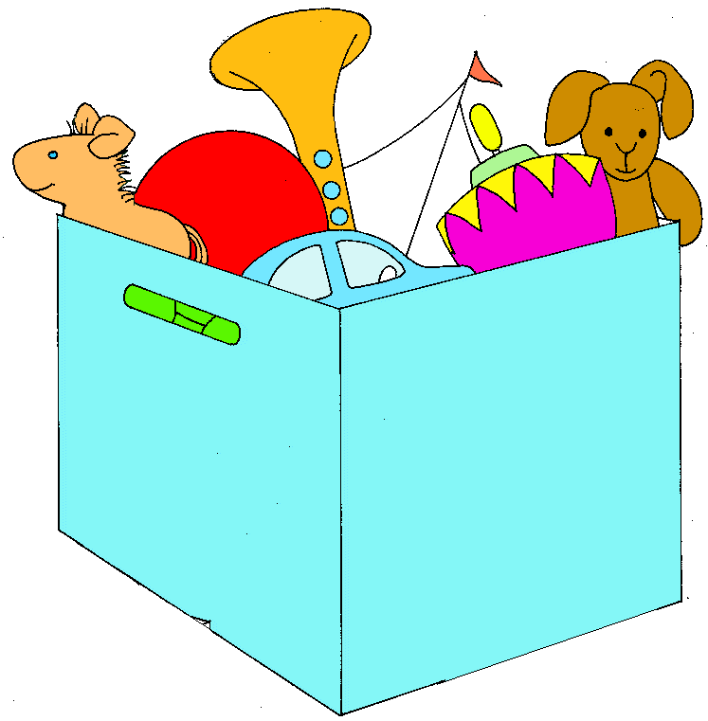 | Select everyday objects/toys e.g. cup, ball, pen, doll, teddy, girl; place them in a bag/box, take turns to pick an object out and name it.
Modelling correct pronunciation | This includes naming objects, offering choices, responding positively to errors made by your child.
Posting box/ Shape sorters/ Stacking rings/ Inset puzzles/ Building towers.  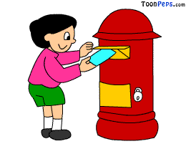 | Give your child one shape or piece of the puzzle and encourage them to look and listen to the sound you make before handing the piece over. Try saying the following sounds “p, b, t, d, k, g”, it does not matter if your child does not always copy you, as they will still benefit from hearing the correct production of the sound.
Repetitive rhymes  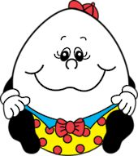 | Such as Pat-a-cake, Baa Baa Black Sheep, Little Bo Peep, Humpty Dumpty.
“Bye-bye”  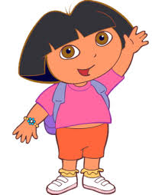 | Say bye-bye each time you put away a toy or place down the flaps when reading paper flap books.
“Boo” / “Peek-a-boo”  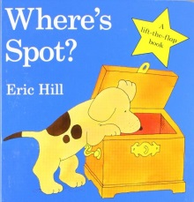 | Used when lifting the flap when reading paper flap books, playing with pop-up toys and playing hide & seek games.

“Pop”  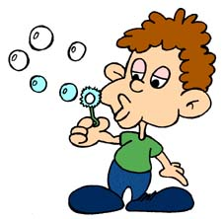 | Used when popping bubbles and playing with pop-up toys.

Who to contact for further information

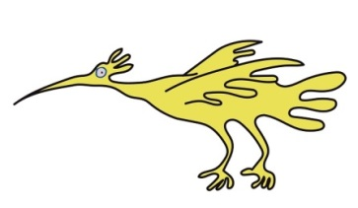
Should you have any queries or questions that may need answering, please do not hesitate to contact:

The Speech and Language Therapy Department
Alder Hey Children’s NHS Foundation Trust
Tel: 0151 252 5404

For information regarding your local support group contact Cleft Lip and Palate Association (CLAPA) on:

clapamerseysidedrw@btinternet.com
www.clapa.com.

This leaflet only gives general information. You must always discuss the individual treatment of your child with the appropriate member of staff. Do not rely on this leaflet alone for information about your child’s treatment.

This information can be made available in other languages and formats if requested.

Alder Hey Children’s NHS Foundation Trust
Alder Hey
Eaton Road
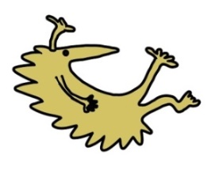
Liverpool
L12 2AP
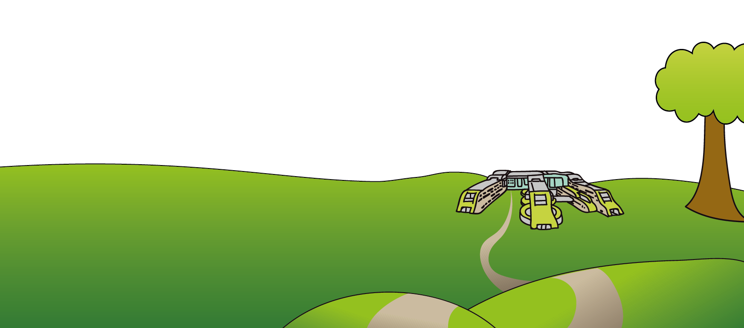
Tel: 0151 228 4811
www.alderhey.nhs.uk

© Alder Hey Review Date: June 2024 PIAG: 49

