Craniofacial Team
Speech, Language & Feeding in Syndromic Craniosynostosis
Information for parents and carers

Why will my child need to see a Speech and Language Therapist?
The Speech and Language Therapist (SALT) plays an active role within the Craniofacial Team. This is because children born with a craniofacial syndrome can have a higher risk of speech, language and feeding problems than children in the general population. This can be dependent on the location of the synostosis and the type of syndrome
Currently, only supraregional craniofacial units in the UK have specialist speech and language therapists with this dedicated caseload. The aim is to provide the highest quality and clinically effective specialist Speech and Language Therapy service. Therapists within the service are actively involved in research and clinical audit projects, and share findings in journal publications and through education and training.
Is my child likely to have a speech and/or language delay?
There is a wide range of severity, from mild to severe; involving any area of speech and/or language development. Early identification of speech and language delay can be helpful in minimising any long term effect. For this reason, we assess the early speech and language skills of all patients.
There are many reasons why a child with a craniofacial syndrome might have a problem with speech, language or feeding and the most common ones are listed below. The Speech and Language Therapist works in a multidisciplinary team to help each child individually with their specific needs.
Factors affecting speech, language and feeding are:
- Airway difficulties (breathing).
- Hearing.
- Vision.
- Cognitive (learning) impairment.
- Social skills
- Oral/facial structure.
- Unrelated to craniofacial diagnosis.
It is really important that children with syndromic craniosynostosis are seen regularly by the Speech and Language Therapist for assessment and advice
The Speech & Language Therapist is usually present at clinic appointments and is also available for assessment and advice when your child is in hospital.
When will my child see the Speech and Language Therapist?
- Feeding: Children with syndromic craniosynostosis may have feeding difficulties at any age and may require input from a Speech and Language Therapist. The SALT team at Alder Hey can see children with syndromic craniosynostosis for a feeding assessment either as an inpatient or as an outpatient as required. It may be that local, community SALT teams are also involved in your child’s care.
At the first visit and at approximately six months of age feeding will be reviewed. Then at different stages of feeding development further assessments may be carried out e.g. cup drinking, weaning, chewing etc.
Often, feeding is assessed as part of a multi-disciplinary team, and this can include people from Dietetics, Ear Nose and Throat and Respiratory Teams.
- Communication: Advice about communication for a child with syndromic craniosynostosis can be given at any time. This can be when attending another clinic appointment or one made specifically to discuss communication skills.

There are routine times when assessment appointments are made. The first routine assessment of speech and language skills is at approximately 18 months of age. This is a face to face assessment, observation of play and an assessment of early language skills. This provides us with a baseline of ability and allows early identification of any speech and or language difficulties that are emerging.
Speech and language is then assessed between the 3rd and 4th birthday, before starting school. At this age, children are more likely to co-operate with a formal assessment
The next two assessment ages coincide with school moves; age 6-7, before going into junior school and at age 10-11 before moving to secondary school. A final assessment may be carried out prior to finishing school age 16.
What will happen in the assessment?
Approx. Age at assessment
18 months
3 years
6-7 years
10-11 years
16 years if required

The Speech & Language Therapist will look at all elements of language including:
- Receptive (understanding) language.
- Expressive (use of) language.
- Speech.
- Resonance (airflow).
- Social communication skills.
- Play.
All of these assessments are carried out in conjunction with screening assessments by our clinical Psychology Teams. This is so results can be compared with your child’s overall learning ability.
Following on from any assessment, reports are written and copied to members of the Craniofacial Team, parents/carers, GPs and any other professional that is involved.
What about my local Speech and Language Therapy Team?
At any stage where a speech and/or language difficulty is diagnosed, a referral can be made to the local SALT team. They will provide an appropriate local service, whilst the SALT at the Craniofacial Team will still be involved routinely.
Most assessments are carried out alongside a clinic appointment to avoid extra travel.
Written speech and language advice can be given in a clinic appointment if required.
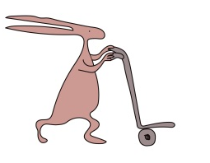
For any questions or queries, please do not hesitate to contact the SALT team on the number below:
0151 252 5404

This leaflet only gives general information. You must always discuss the individual treatment of your child with the appropriate member of staff. Do not rely on this leaflet alone for information about your child’s treatment.

This information can be made available in other languages and formats if requested.

Alder Hey Children’s NHS Foundation Trust
Alder Hey
Eaton Road
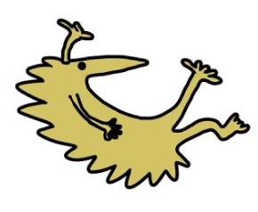
Liverpool
L12 2AP

Tel: 0151 228 4811
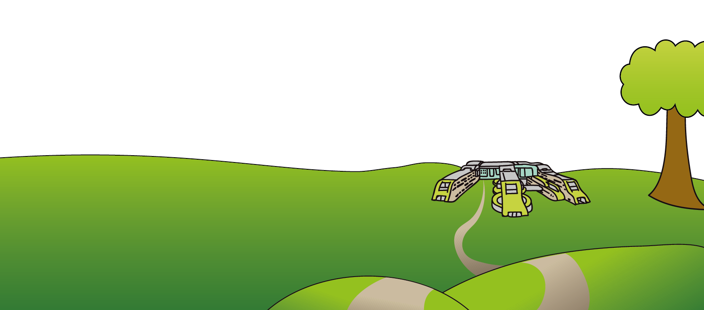
www.alderhey.nhs.uk

© Alder Hey Review Date: June 2024 PIAG: 160

