Craniofacial Department
Speech & Language Development in Single Suture
Craniosynostosis
Information for Parents and Carers

Why does my child need to see a Speech and Language Therapist?
The Speech and Language Therapist (SALT) plays an active role within the Craniofacial Team. This is because there is a recognised and increased incidence of speech and/or language delay in children with single suture craniosynostosis. In the general population, about 6-10% of children might have a delay in their speech and/or language development .
In children with non-syndromic single suture craniosynostosis the incidence of speech and/or language delay can be as high as 40%.
Currently, only supraregional craniofacial units in the UK have a SALT team for this dedicated caseload. The aim is to provide the highest quality and clinically effective specialist Speech and Language Therapy service. Therapists within the service are actively involved in research and clinical audit projects, and share findings in journal publications and through education and training.
Is my child likely to have a speech and/or language delay?
There is a wide range of severity, from very mild to severe; involving any area of speech and/or language development. Early identification of speech and language delay can be helpful in minimising any long term effect. For this reason, we assess the early speech and language skills of all patients.
Speech and language delay can happen in children who do have their craniosynostosis operated on and in those who don’t.
Other factors that can affect speech and/or language development include learning difficulties, a family history of speech and/or language problems and hearing problems.
What will happen in the assessment?
The Speech and Language Therapist will look at all elements of language including:
- Receptive (understanding) language.
- Expressive (use of) language.
- Speech.
- Social communication skills.
- Play.
The Speech and Language therapist can also assess children’s feeding skills if required.
All children with a diagnosis of craniosynostosis will receive routine assessments at key times in their childhood.

When will my child be assessed?
The first assessment will be at approximately 18 months of age. This will usually coincide with either a pre-operative or post-operative clinic appointment. This is a face to face assessment, observation of play and assessment of early communication skills; This provides us with a baseline of ability and allows early identification of any speech and or language difficulties.
Approx. Age at assessment
18 months
3 years
6-7 years (if required)
10-11 years (if required)
15-16 years (if required)
Speech and language is then assessed between your child’s third and fourth birthday, before they start school. At this age, children are more likely to co-operate with a formal assessment.
Following on from this, formal assessments can be done again at ages 6-7 and 10-11. These are currently only carried out where there are concerns with regard to speech and/or language development.
Following on from any assessment, reports are written and copied to members of the Craniofacial Team, parents/carers, GPs and any other professional that is involved.
What about my local Speech and Language Therapy Team (SALT)?
At any stage where a speech and/or language difficulty is diagnosed, a referral can be made to the local SALT team, They will provide an appropriate local service, which may include a clinic visit, a home visit or assessment in nursery or school. The SALT at the Craniofacial Team will still be involved routinely.
Most assessments are carried out alongside a clinic appointment to avoid multiple appointments; however this is not always possible.
Written speech and language advice can be given in a clinic appointment if required.
If you have any questions or queries, please do not hesitate to contact the SALT team on the number below:
0151 252 5404
This leaflet only gives general information. You must always discuss the individual treatment of your child with the appropriate member of staff. Do not rely on this leaflet alone for information about your child’s treatment.
This information can be made available in other languages and formats if requested.

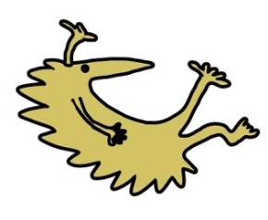
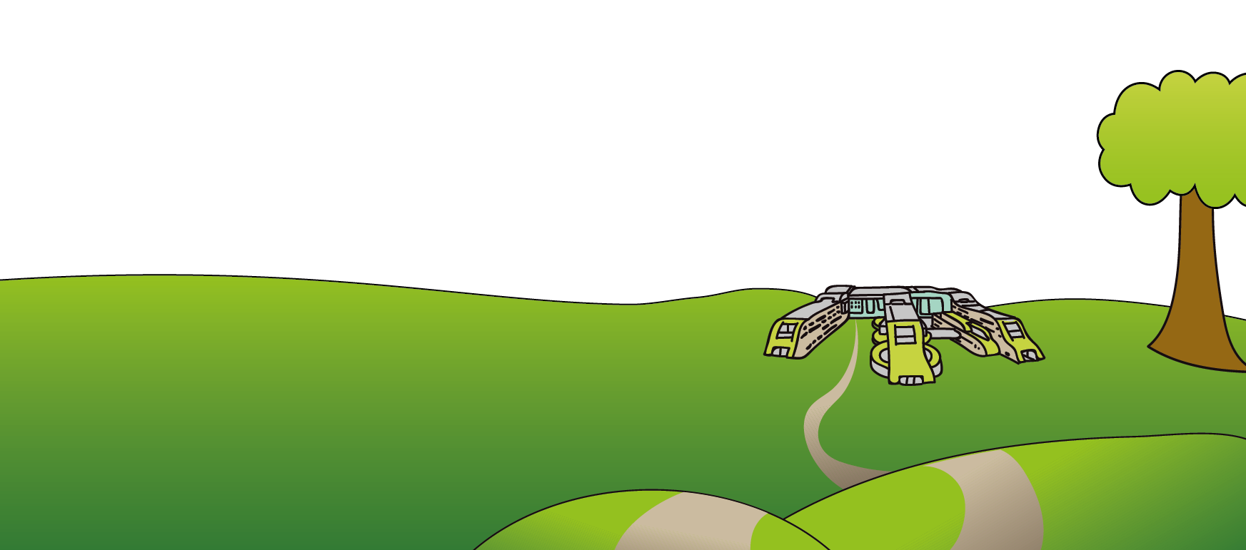
Alder Hey Children’s NHS Foundation Trust
Alder Hey
Eaton Road
Liverpool
L12 2AP

Tel: 0151 228 4811
www.alderhey.nhs.uk

© Alder Hey Review Date: June 2024 PIAG: 0014

