Ear Nose & Throat Department
Softening ear wax
Information for parents and carers

Introduction

You have been asked to bring your child to the Ear Nose & Throat Department (ENT) to have wax removed from their ear/s. Wax in the ear is natural and should never be removed by anyone other than a trained health care worker.

Information for carers

Before we start the procedure, the wax in your child’s ears needs to be soft to assist in its removal. You can help to soften the wax 2 weeks before their appointment in ENT.

You will need to have
- some ordinary olive oil
- a teaspoon or a dropper (the dropper can be purchased from a chemist)

Once a day insert a few drops of olive oil into the ear/s which needs to have the wax removed. To do this, follow the steps below.
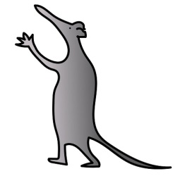
Step 1 Ask the child to lie on their side with the affected ear upper most.

Step 2 Put a small amount of olive oil onto a clean teaspoon or in the dropper

Step 3 Gently pull back the pinna (marked A on diagram)

Step 4 Insert the oil into the canal (marked C on diagram) of the ear

Step 5 Gently massage the tragus (marked B on diagram) whilst still holding the
pinna

Step 6 Ask the child to lie for about 10 minutes, after which when they sit up,
wipe away any excess oil

Holding the child’s ear

Pina - gently pull back
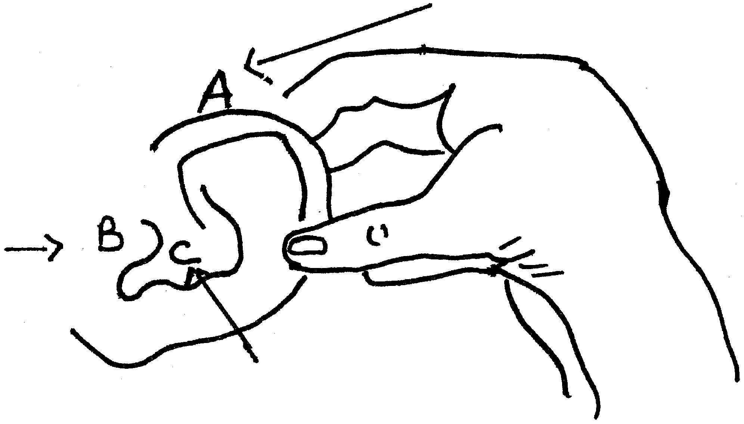

Tragus
(Front of ear)

Canal

There are no clinical risks involved in this procedure, but do be careful to use a small amount of olive oil.

The use of cotton buds to remove ear wax will only cause further problems by packing the wax down into the canal of the ear.

Never insert objects into the ear.

Support

If you need any further advice or help on how to use olive oil to soften ear wax please telephone:

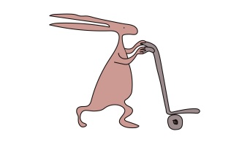
The ENT Outpatients Department; 0151 252 5206

The ENT Nurse Specialists, 0151 228 4811 ex 3757

The ENT Outpatients Department is open Monday-Friday 08.00-17.00

This leaflet only gives general information. You must always discuss the individual treatment of your child with the appropriate member of staff. Do not rely on this leaflet alone for information about your child’s treatment.
This information can be made available in other languages and formats if requested.

Alder Hey Children’s NHS Foundation Trust
Alder Hey
Eaton Road
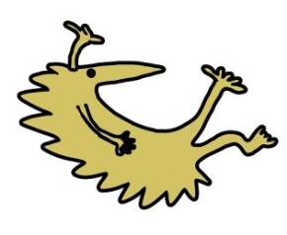
Liverpool
L12 2AP

Tel: 0151 228 4811
www.alderhey.nhs.uk
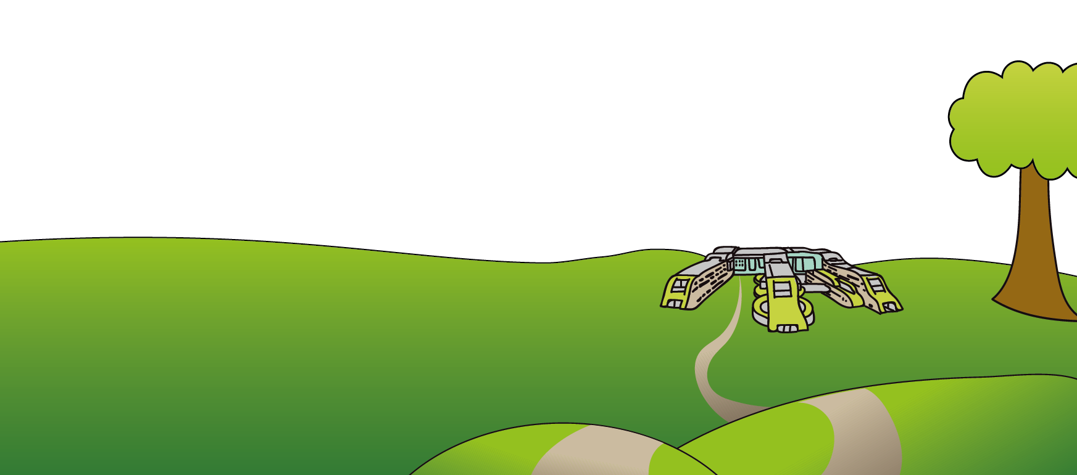

© Alder Hey Review Date: August 2024 PIAG 13

