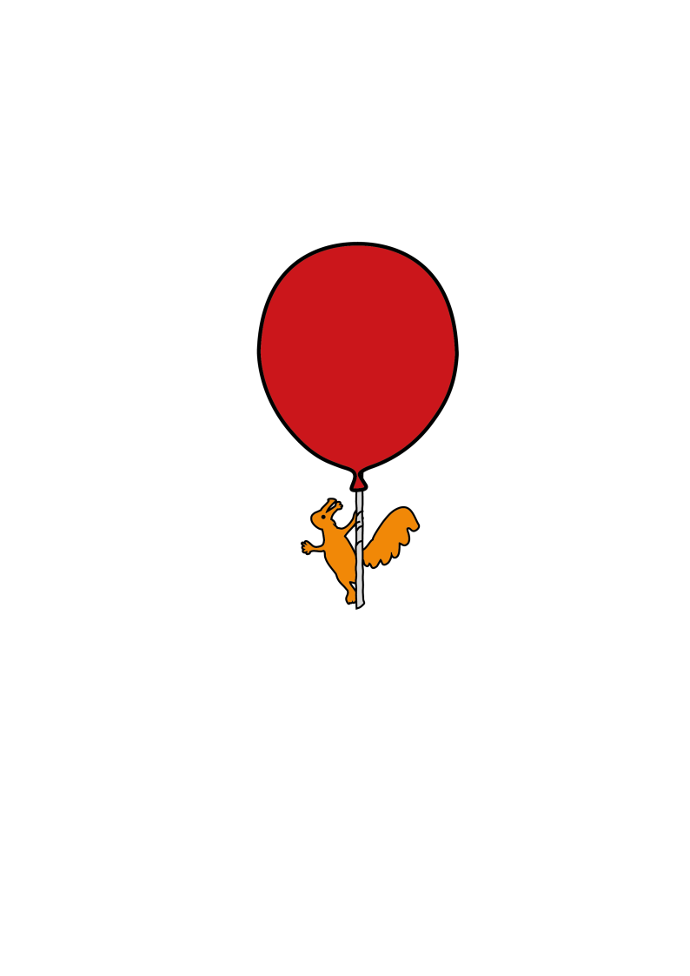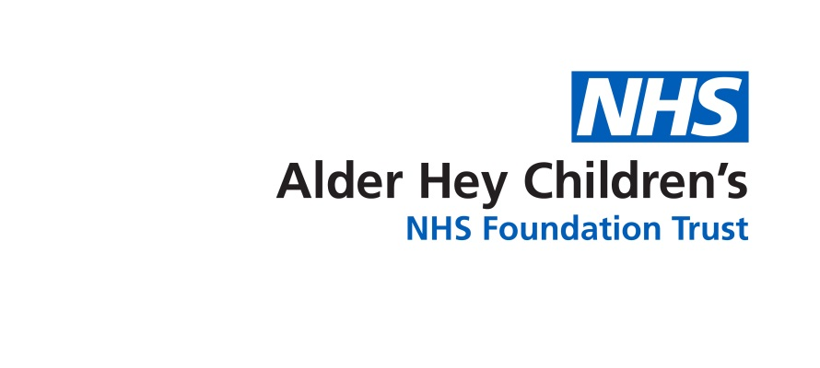

The Roald Dahl Neurophysiology Department

**Sleep Deprived EEG Test**

Information for parents and carers

**What is a sleep deprived EEG test?**

A sleep deprived EEG is a test which records the activity of the brain which has been deprived of sleep for a set amount of time. It records the activity through small electrodes which are applied to the scalp with a special paste. Simultaneous video is also recorded. It is used to help investigate a number of conditions, most commonly black outs or seizures.

Your child may have already had a routine EEG carried out. However additional information is often obtained from the test if your child is tired. The procedure is the same as a standard EEG except your child will be sleep deprived. It will be useful if your child falls asleep during this test, but this may not always be possible

**In your child’s appointment letter there is a specific set of instructions to follow for the sleep deprivation process. Please do not allow them to fall asleep in the car.**

**Will this EEG test hurt my child?**

No, as it is a painless test and there are no side effects. Sleep deprivation can slightly increase the risk of your child having one of their typical episodes but this is rare.

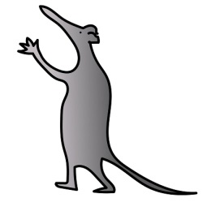

**How long will this procedure take?**

The test takes between 45 to 90 minutes, but on average around 60 minutes.

**What should I expect to happen during this test?**

The test is performed by the Clinical Physiologist who will explain all aspects of the test

thoroughly. Small disc shaped disposable electrodes are applied to your child’s scalp

using a water soluble sticky paste. We do not shave / cut their hair.



Photograph of a patient being tested Photograph of electrodes attached to patients scalp

For the test please ensure your child has clean hair which is free from hair gel etc.

Please make sure your child continues with their regular medication unless advised otherwise by your child’s Consultant.

Your child can watch a DVD during electrode application, which takes around 10 minutes and they can bring in their favourite DVD or a small hand held toy if you prefer. If your child is a baby or infant, please bring a bottle with you in case they want a feed.

**During the test**

During the EEG, your child’s brain signals appear as wavy lines on a computer screen. Simultaneous video is also recorded. You will be asked to sign a form to allow for consent for teaching purposes.

If your child is able to co-operate, or is old enough to understand, they will be asked to

open and close their eyes during the test. They may also be asked to breathe deeply for

a short time, which may, in one or two situations, provoke a typical episode or event

(*however this is very rare*).

They will be shown a strobe light to see if their brain is sensitive to flashing lights (*only a*

*very small percentage of children are sensitive*) – this is called photosensitivity.

In some people, strobe lights may trigger an episode or event (*again this is rare*) but this procedure is an important part of the EEG test. The result of this part of the test will give the doctor more information which *may* help to make a diagnosis.

Due to being sleep deprived, your child may feel tired during the test. There will be an opportunity for them to lie down and fall asleep naturally during the recording.

The Clinical Physiologist cannot show you any waveforms or give you the results of the EEG on the day of the test. It is reported by the Consultant in the department and you will receive the results at your next clinic appointment.

**At the end of the test**

There are **no after effects** and we remove the electrodes with a little warm water. Your child can then go back to school or nursery if you so wish.

For further information or if you wish to re-arrange or cannot attend for any reason, please call: 0151 252 5375.

This leaflet only gives general information. You must always discuss the individual treatment of your child with the appropriate member of staff. Do not rely on this leaflet alone for information about your child’s treatment. This information can be made available in other languages and formats if requested.

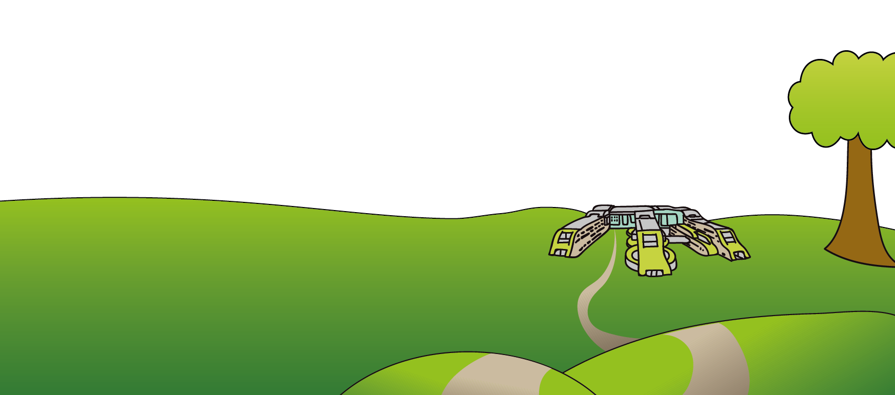Alder Hey Children’s NHS Foundation Trust

Alder Hey

Eaton Road

Liverpool

L12 2AP

Tel: 0151 228 4811

[www.alderhey.nhs.uk](http://www.alderhey.nhs.uk)

**© Alder Hey Review Date: January 2025 PIAG: 73**