

Safeguarding Team

**Skeletal Survey**

Information for parents and carers

**Introduction**

This leaflet aims to provide parents and carers with general information about an examination called a skeletal survey. We hope you find the information useful but if you have any questions please do not hesitate to contact us.

**What is a skeletal survey?**

A skeletal survey is when x-rays are taken of the skull, chest spine, pelvis, arms legs, hands and feet. It is similar to having photographs taken and will not cause any pain. An x-ray machine directs x-rays through parts of the body being examined onto a film or imaging plate. Images are produced of the structure in the body. The survey is used to examine the bones and to see if there is any bone damage.

**Where will the skeletal survey take place?**

The examination will take place in the Radiology Department at Alder Hey Hospital.

**Who will be doing the skeletal survey?**

The skeletal survey will be performed by a Radiographer or Assistant Practitioner. The procedure will be explained and you can ask any questions that you have.

Alder Hey is teaching hospital and a student may also be present. You can request that the student is not present during the examination.

**What happens during the examination?**

The Radiographer will advise parents how they need a child to be positioned and where parents can sit during the examination. The Radiographer will be able to see and hear parents at all times.



**How long will it take?**

This varies for each child but should take approximately 45 minutes

**How do I get the results?**

After the examination a Consultant Radiologist (specialised x-ray doctor) will examine the images and produce a report. The report is sent to the doctor who asked for the skeletal survey and parents will be contacted with the results of the report. The results are not normally available on the same day of the survey.

**What happens after the examination?**

If a child has no other appointments in the hospital they will be able to leave. Children who are

in-patients will be taken back to their ward. Sometimes it is necessary for the examination to be repeated after two weeks. If so, parents will be contacted with another appointment.

**How to prepare for a skeletal survey x-ray**

A child does not need any special preparation but it may help if they wear clothes that are loose fitting and easy to remove**.**

Parents may be asked to remove some of the child’s clothing and any jewellery or metal, for example poppers on vests.

Though the examination is not painful, younger children may get distressed as they will need to be held still for the x-rays. Sometimes it is necessary to arrange for a child to be sedated so that they are settled during the survey.

If a child is on pain relief for any reason it is better if this is working at its best during the examination.

**Relatives and escorts**

A friend or relatives can accompany parents to act as an advocate. They will not be allowed into the examination room except in exceptional circumstances.

**Interpreters**

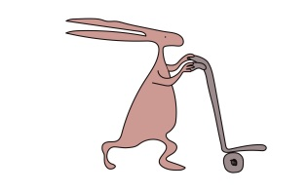If parents need an interpreter, or prefer to be communicated with in a particular way, they should inform staff when they are given the appointment for the skeletal survey.

**Siblings and other children**

We are unable to offer childcare facilities.

**For further information**

If you have any specific needs or questions before the skeletal survey takes place, please contact us and we will try to help you.

Our contact number is: 0151 252 5609

This leaflet only gives general information. You must always discuss the individual treatment of your child with the appropriate member of staff. Do not rely on this leaflet alone for information about your child’s treatment. This information can be made available in other languages and formats if requested.

Alder Hey Children’s NHS Foundation Trust

Alder Hey

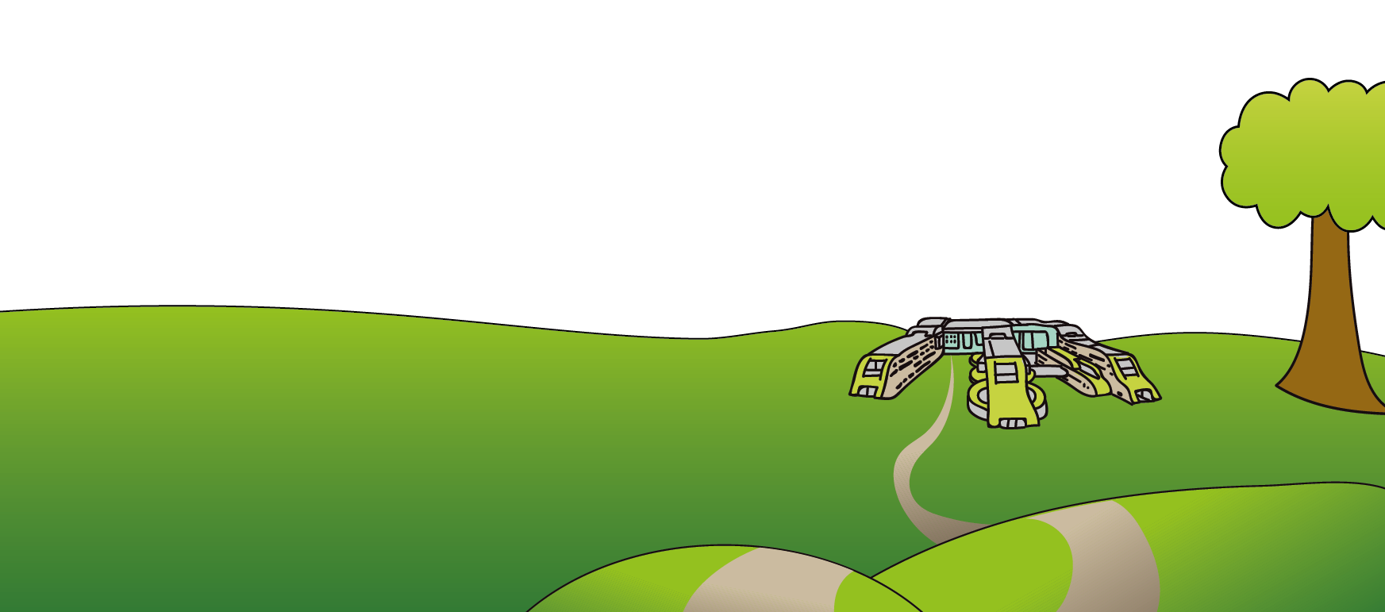Eaton Road

****Liverpool

L12 2AP

Tel: 0151 228 4811

[www.alderhey.nhs.uk](http://www.alderhey.nhs.uk)

**© Alder Hey Review Date: November 2024 PIAG: 015**