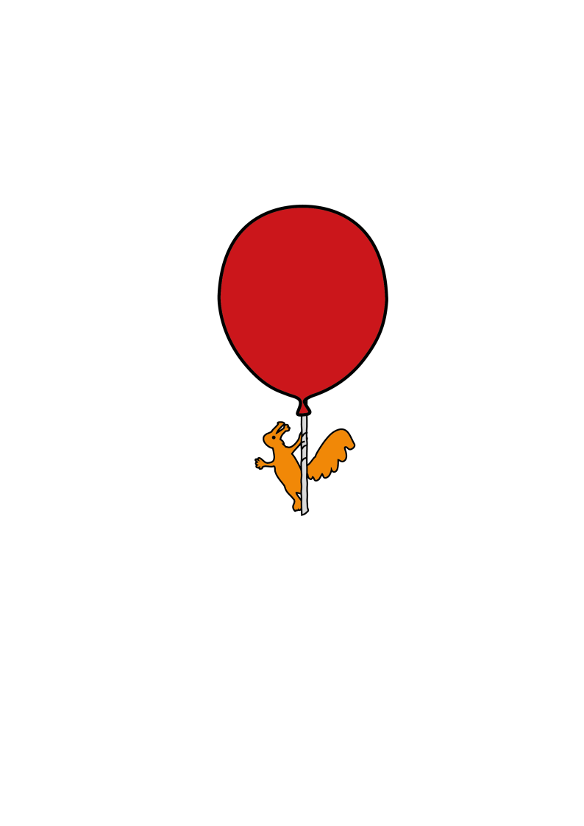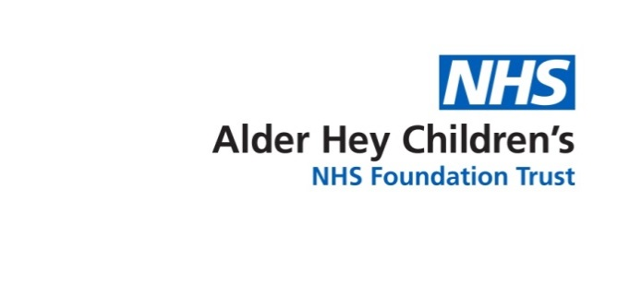

Children’s Speech & Language Therapy Service

**Singing With Your Child**

Information for parents and carers



Songs make learning language fun. They can help your child learn new words.

By singing them again and again your child will know which bit comes next and enjoy the interaction with you. As your child becomes more familiar with the songs you can pause and let them fill in the missing word. This will also help your child take turns, listen and wait with anticipation to the song.

MC900084346[1]Why not try some of these Nursery rhymes with your child…***remember*** to: **sing slowly** giving them a chance to join in, add some **actions or signs** to support language, **wait** for them to fill in words, and have a good time!

MC900199240[1]

Five little speckled frogs

Sat on a speckled log

Eating some most delicious grubs.

One jumped into the pool

Where it was nice and cool

Then there were four green speckled frogs

Wind the bobbin up,  
Wind the bobbin up,  
Pull, pull, clap, clap, clap.  
Wind it back again,  
Wind it back again,  
Pull, pull, clap, clap, clap,  
Point to the ceiling,  
Point to the floor,  
Point to the window,  
Point to the door,  
Clap your hands together, 1, 2, 3,  
Put your hands upon your knee.

MC900438203[1]

Incey, Wincey Spider

Climbed up the water spout;

Down came the rain

And washed the spider out;

Out came the sunshine

And dried up all the rain;

And Incey Wincey spider

Climbed up the spout again.



MC900446060[1]

Twinkle, twinkle, little star,  
How I wonder what you are.  
Up above the world so high,  
Like a diamond in the sky.

Twinkle, twinkle, little star.  
How I wonder what you are.

MC900390920[1]

Hickory, dickory dock,

The mouse ran up the clock.

The clock struck one.

The mouse ran down.

Hickory, dickory, dock.

MC900438203[1]

Humpty Dumpty sat on a wall,  
Humpty Dumpty had a great fall.  
All the king's horses and all the king's men  
Couldn't put Humpty together again.

For more songs and rhymes visit your local library for books or visit[**www.wordsforlife.org.uk/songs**](http://www.wordsforlife.org.uk/songs)

For more information visit [**www.alderhey.nhs.uk**](http://www.alderhey.nhs.uk)or talk to your Speech and Language Therapist.

This leaflet only gives general information. You must always discuss the individual treatment of your child with the appropriate member of staff. Do not rely on this leaflet alone for information about your child’s treatment. This information can be made available in other languages and formats if requested.

Alder Hey Children’s NHS Foundation Trust, Eaton Road, Liverpool, L12 2AP. Tel: 0151 228 4811

[www.alderhey.nhs.uk](http://www.alderhey.nhs.uk)

Speech and Language Therapy Department (Liverpool) Speech and Language Therapy Department (Sefton)

Liverpool Innovation Park, Netherton Health Centre,

Kilby House, Magdalene Square,

Digital Way, Bootle,

Liverpool, L30 5SP

L7 9NJ. Tel: 0151 247 6109

Tel: 0151 295 3990

**© Alder Hey Review Date: July 2025 PIAG: 0099**