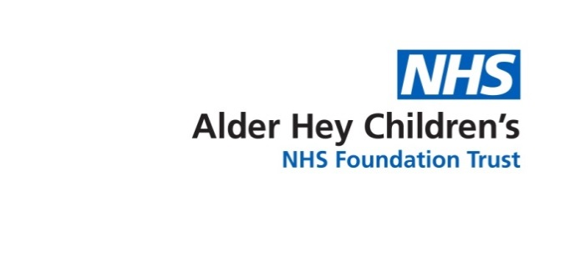



Children’s Speech & Language Therapy Service

**Signing and Gesture to Support Language**

Information for parents and carers

Using actions and gestures can support children’s language learning: it can help them understand what is being said and give them a way to communicate. Actions and gestures offer your child something visual to look at alongside the spoken word so children can see and hear what you are saying.

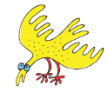Signing systems such as ‘Makaton’ and ‘Signalong’ are key word signing systems that offer a more structured and consistent approach to using signs. When we sign to support language it is recommended to sign the important words in the sentence to help the child understand. (Look at their websites for further information about signing).

***Signing tips!***

* Make sure your child is looking at you before you begin talking and signing to them
* Just sign the important words (the key words) in the sentence
* Be consistent…if you are unsure of the ‘Signalong’ or ‘Makaton’ sign just make up an appropriate action or gesture and use that
* If signing at home remember to let nursery, friends and family know so they can also communicate effectively with your child
* When starting to use sign at home or nursery pick a few signs a week and use these frequently to help both you and your child learn
* Be practical! Start introducing signs that are useful words for your child and what they will be interested in or want to try to ask for e.g. favourite toys, animals, food, toilet, coat etc.
* ALWAYS say the word with the sign

It is important to remember that signing can help your child learn language and say more words.

**It does not stop children from talking** and will not make them ‘lazy’ talkers. As children’s talking develops they tend to drop the signing and will just use the words.

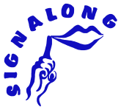

For more information about signing please visit the Signalong website

<http://www.signalong.org.uk/> or the Makaton website <https://www.makaton.org/uk>

For more information visit [**www.alderhey.nhs.uk**](http://www.alderhey.nhs.uk)or talk to your Speech and Language Therapist.

This leaflet only gives general information. You must always discuss the individual treatment of your child with the appropriate member of staff. Do not rely on this leaflet alone for information about your child’s treatment.This information can be made available in other languages and formats if requested.

Alder Hey Children’s NHS Foundation Trust, Eaton Road, Liverpool, L12 2AP. Tel: 0151 228 4811

[www.alderhey.nhs.uk](http://www.alderhey.nhs.uk)

Speech and Language Therapy Department (Liverpool) Speech and Language Therapy Department (Sefton)

Liverpool Innovation Park, Netherton Health Centre,

Kilby House, Magdalene Square,

Digital Way, Bootle,

Liverpool, L30 5SP

L7 9NJ. Tel: 0151 247 6109

Tel: 0151 295 3990

**© Alder Hey Review Date: July 2025 PIAG: 0086**