
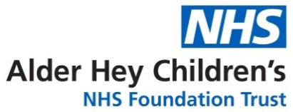
Children’s Speech & Language Therapy Service
Signing and Gesture to Support Language

Information for parents/carers and settings

Using actions and gestures can support children’s language learning: it can help them understand what is being said and give them a way to communicate. Actions and gestures offer your child something visual to look at alongside the spoken word, so children can see and hear what you are saying. Your child might be making up their own gestures or you might already use gesture and actions as you talk.

Signing systems such as ‘Makaton’ and ‘Signalong’ are key word signing systems that offer a more structured and consistent approach to using signs. When we sign to support language it is recommended to sign the important words in the sentence to help the child understand. (Look at their websites for further information about signing).
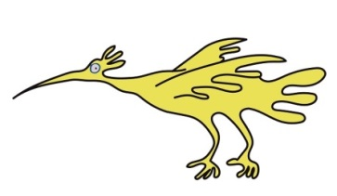

Signing tips!
- Gain your child’s attention before you begin talking and signing to them
- Just sign the important words (the key words) in the sentence
- Be consistent…if you are unsure of the ‘Signalong’ or ‘Makaton’ sign you could make up an appropriate action or gesture and use that consistently
- If you use signing at home remember to let nursery, friends and family know so they can also communicate effectively with your child
- When starting to use signing at home or nursery pick a few signs a week and use these frequently to help both you and your child learn new words
- Singing action songs is a great way to use actions and signs e.g. ‘this is the way we brush our teeth’
- Be practical! Start introducing signs that are useful words for your child such as, what they are motivated by or might want to ask for e.g. favourite toys, animals, food, toilet, coat etc.
- ALWAYS say the word with the sign
- Always use your home language with your child, speaking more than one language does not cause children to have language difficulties.


It is important to remember that signing can help your child learn language and say more words.
It does not stop children from talking and will not make them ‘lazy’ talkers. As children’s talking develops they tend to drop the signing and will just use the words (there are some children who will use sign as a main language, your therapist will discuss this with you if appropriate)


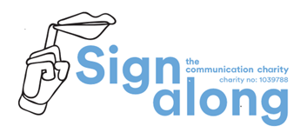

For more information about signing please visit the Signalong website
http://www.signalong.org.uk/ or the Makaton website https://www.makaton.org/uk

Baby Sign and Communication: Types of sign systems and getting started with baby signing - BBC Tiny Happy People also has lots of information and further links

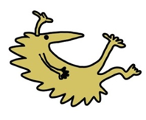

Alder Hey Community Speech and Language Therapy Department
Sefton (0151 247 6109) Liverpool (0151 295 3990)
Childrensslt@alderhey.nhs.uk
Speech and language therapy - Alder Hey Children's Hospital Trust
(click this link or type into search engine)

This leaflet only gives general information. You must always discuss the individual treatment of your child with the appropriate member of staff. Do not rely on this leaflet alone for information about your child’s treatment.
This information can be made available in other languages and formats if requested.

Alder Hey Children’s NHS Foundation Trust
Alder Hey
Eaton Road
Liverpool
L12 2AP
Tel: 0151 228 4811
www.alderhey.nhs.uk

© Alder Hey Review Date: May 2028 PIAG: 0086

