




Haematology Department
Sickle Cell and Red Cell Disorders at Alder Hey
Information for parents and carers

Introduction
This leaflet is designed to introduce the sickle cell team to you and explain how to access the services we provide.

Telephone Numbers you may need

Direct Telephone: 0151 252 5070

Ward 3B Inpatients ward 0151 252 5212
Ward 3B Daycare 0151 293 3684
Ward 3B Outpatients 0151 252 5804

Alder Hey (switchboard) 0151 228 4811

Accident and Emergency 0151 252 5035

Consultant’s secretaries: 0151 293 3680

The Haematology Team

Haematology remains a specialised area of medicine and needs to be treated by people with experience in this area. Your team includes:

Sickle Cell & Thalassaemia Nurse Specialists: Louise Smith
Tracey Bloodworth

Sickle Cell & Thalassaemia Psychologist: Kristina Fenn

Haematology Nurses: Sharon Thind
Rebecca Rogers
Collette Brougham

Consultant Haematologists: Dr Russell Keenan
Dr Banurekha Thangavelu
Dr Jessica Sandham

Haematology Administration Assistant: Annie Quirk

Where to find us

Your sickle cell team will be located on Ward 3B. 3B is located in the middle ‘finger’ of the hospital building, on the 3rd floor. 3B will be the ward, whenever possible, that your child will be admitted to. It also has a day unit where your child will go for transfusion. Clinic is also located on ward 3B.

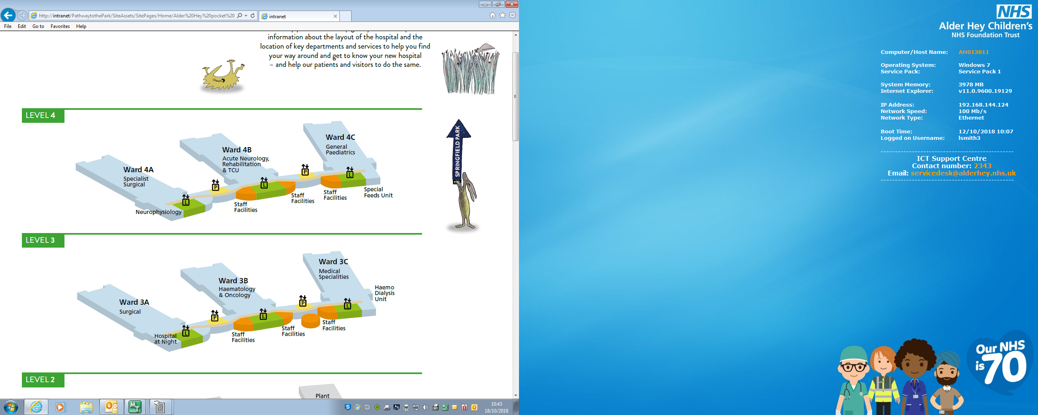
We are open between 9am and 5pm, Monday - Friday, for:

- Reviewing your child
- Giving advice
- Answering queries and talking through worries

Where to go if your child is unwell

If your child becomes unwell you must attend Accident and Emergency department.
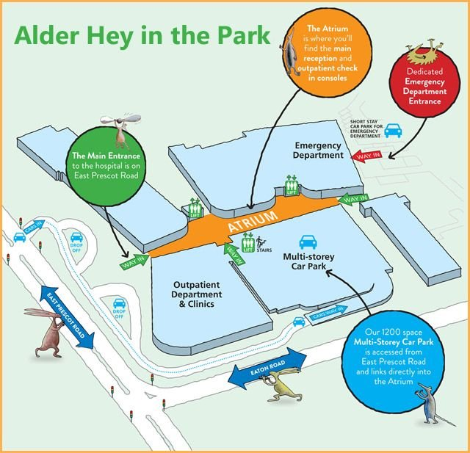
Out of hours

If you require advice, ring Ward 3B (0151 252 5212) who will give you advice or speak to the consultant haematologist on call who will give advice. If your child is unwell, you must attend the accident and emergency department

What to do in an emergency

Ring the ambulance (phone number 999) they will take you to the closest hospital.

On arrival at A&E tell the triage nurse and the doctor of your child’s condition. Your child will have a care plan on the computer system informing the doctors about their current medication, usual pain treatment and any other significant issues

Clinics

Why come to clinic?

It is very important that you attend your child’s clinic appointment. Clinic appointments give the haematology team the opportunity to assess your child and ensure that they have no problems. Sickle cell disorder is very variable. Some children with sickle cell disorders have lots of painful episodes and some children have very few. Some children have frequent admissions to the hospital and some have none. Even if your child has very few painful episodes they can still develop long term complications, particularly with their lungs and kidneys. We look for early signs of these complications in clinic and will offer treatment to stop long term complications developing. For children with thalassaemia we will ensure that they are getting maximum benefit from their blood transfusion programme and monitor that they are not getting any long term complications from iron overload.

If your child is on any medication or treatment these will be monitored in clinic and any changes to treatment decided there.

Clinic also gives you the opportunity to ask questions and get information on how to care for your child. Clinic is also a good place to meet other children and families with sickle cell and thalassaemia. Once a year, your child will have a full annual review in a designated clinic.

When is clinic?
Wednesday pm Nurse led Hydroxyurea review clinic
Thursday pm Routine sickle cell clinic/Annual review clinic

You must keep your appointments even if your child seems well. Please turn up for your clinic appointment on time as being late will impact on the rest of the clinic.

How do I change a clinic appointment or what do I do if I can’t come to clinic?

Ring the Haematology Outpatient Clinic on 0151 252 5804, as soon as you know that you cannot attend, so that the appointment can be rearranged.

How often does my child need to come to clinic?

Most children will be seen in clinic at least every six months. Babies with sickle cell and thalassaemia will be seen more often. Children who are on some medications or treatments may be seen every month.

Your child will also be given a clinic appointment when they are discharged from the ward following an admission
What should I do if I want an appointment earlier than planned?

Sometimes you may have questions, non-urgent concerns about your child or other issues that you want to discuss with a doctor. You can ask for a clinic appointment to do this. Ring the Haematology Team on 0151 252 5070 and they will be able to organise a clinic appointment for you.

If your child is unwell and you want to see a doctor straight away then you will be asked to bring them to accident and emergency.

What will happen at clinic?

When you arrive at clinic, report to reception to let them know that you are here. Arrive on time for your appointment.

We will then weigh and measure your child and do their blood pressure and oxygen saturations. We will also ask your child for a urine sample. This is to check that their kidneys are working properly and to check that your child is taking their penicillin / erythromycin

Your child may need blood tests. This is usually done in the clinic or sometimes you may need to go to the phlebotomy department, which is located by Costa Coffee on the ground floor.

If your child needs any extra tests you will receive an appointment letter for this. If your child has another appointment, then go to that appointment first and then attend the clinic. Again, please arrive on time.

Who will I see in clinic?

In clinic you will see a clinic nurse or support worker, the nurse specialist, the psychologist, the consultant haematologist or the specialist registrar. Sometimes there will be medical or nursing students sat in with the doctor.

What if I need an interpreter?

If you need an interpreter to help you with your clinic appointment, please let us know before your clinic appointment, and an interpreter will be provided for you.

Inpatient & Daycare stays?

Whenever possible, 3B will be the ward that your child will be admitted to if unwell or needing daycase transfusions.

Parents / carers and siblings can visit at any time. Other visitors can visit between 10.00am to 7.30pm. All child visitors must be accompanied by a parent / carer. These times and number of visitors are subject to change, you will be informed of changes as they happen.

IMPORTANT REMINDER

Please tell us if you change your address, phone number, family doctor or if you are moving to another area

What services does the Sickle Cell Team offer?

Sickle Cell and Thalassaemia are life-long conditions. The Haematology team aims to help your family live with Sickle Cell. There are a variety of services available to you.

Review of your child and advice
The Sickle & Thalassaemia team will perform regular reviews of your child in the Outpatient clinic, monitoring their growth and development, alongside blood & other tests to ensure your child is well and not developing any side-effects of treatment. We also offer advice and support as listed below.

Support

The Sickle & Thalassaemia team are here to provide support. Living with Sickle Cell and thalassaemia needs some adjustment, which can cause anxiety for you, your child and other family members. We are accessible to anyone who has contact with your child. We can give you advice or just be there for a chat; at home, over the phone, or in the clinic.

Information

We have a selection of written information available on Sickle Cell and thalassaemia, targeted at all age ranges. If you feel that you, your child, another family member, teacher etc, would like some information then just ask and we can help you.

Benefits & Immigration advice
The Specialist Nursing team can offer advice and direct you to services that can help you further with these issues.

Home Visits

It is often easier for us to talk with you at home without the interruption of other activities or events in the hospital. Home visits are an opportunity for you to talk in more depth about your child’s disorder, or about any issues or concerns you may have. A visit at home could be more convenient for you or other family members who may not be able to attend hospital but have questions to ask. It is also a good place for us to meet you to give you education on Sickle Cell and Thalassaemia. We may phone you to ask if we can visit you at home. To arrange a visit just contact The Sickle Cell & Thalassaemia Nurses.

School / Nursery Visits

School visits can be done at your child’s school. These visits enable us to support the information you have given already and encourage them to contact us if they have any concerns. You are welcome to join us at the school or nursery visit, or we can go alone.

The visits are important to help the staff to understand your child’s disorder and to work appropriately with them. If you are having problems with your child’s school, for example, they don’t understand your child’s condition, have worries about it, or your child has been excluded from certain activities, the Nurse Specialist can visit the school and talk through their concerns.

Share your experience

We like to know what you and your child think of the service that we are providing for them. There are a few ways in that you can feedback your views.

Patient satisfaction survey
Every year we will send you a questionnaire to fill out asking you and your child’s opinion on different parts of the service. This may be done at your clinic visit.

Patient Stories
From time to time, your child may be asked to write a story about an experience they have had at Alder Hey. This can be a positive or negative story.

PALS (Patient Advice and Liaison Service)
If you have any concerns or suggestions about improving the current service your receive, you can contact PALS who will make sure that your issues are raised.

You can visit them in the Atrium near the Treehouse from 9.00am to 4.00pm, Monday to Friday.
Or you can:
• Email pals@alderhey.nhs.uk
• Call 0151 252 5374 or 0151 252 5161.
• Write to: PALS, Alder Hey Children’s NHS Foundation Trust, Eaton Road, Liverpool L12 2AP.

Further information
If you have any questions or want any further information please contact your sickle cell team on 0151 252 5070.

Useful websites
www.alderhey.co.uk
www.sicklecellsociety.co.uk
www.ukts.org

Alder Hey Children's NHS Foundation Trust is neither liable for the contents of any external internet site listed, nor does it endorse any commercial product or service mentioned or advised on any of the sites.

This leaflet only gives general information. You must always discuss the individual treatment of your child with the appropriate member of staff. Do not rely on this leaflet alone for information about your child’s treatment.
This information can be made available in other languages and formats if requested.


Alder Hey Children’s NHS Foundation Trust
Eaton Road
Liverpool
L12 2AP

Tel: 0151 228 4811
www.alderhey.nhs.uk

© Alder Hey Review Date: April 2027 PIAG: 0070

