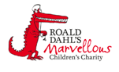
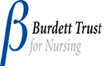

Haematology Department
Sickle Cell Disease – Chronic Complications
Iron Chelation Therapy
Information for parents and carers

Introduction

This leaflet is designed to explain about the long term (chronic) complications of sickle cell disease. The information does not cover everything. If you are ever worried about your child then please contact your Sickle Cell Team or take your child to Accident and Emergency Department
What is chelation?

Chelation is the name of the treatment that removes excess iron from the body.

Why does my child need chelation?
Your child’s body needs some iron to help produce haemoglobin. Blood transfusions contain iron and after a period of time of being on a blood transfusion programme, iron starts to build in the body. The body cannot naturally get rid of this excess iron, so it gets stored in organs in the body.

What damage can having too much iron do to my child?
If the excess iron is not removed then it will start to cause damage to organs in the body.
The main organs that are affected are the:

Liver The iron damages the liver and causes scaring (cirrhosis).

Heart A large amount of iron in the heart causes irregular heart rhythms and heart failure.

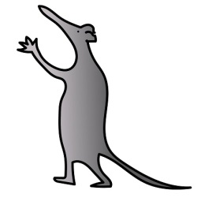
Endocrine organs Excess iron in the hormone glands or pancreas causes poor growth, delayed puberty and diabetes.

What are the current medications used for chelation?

Currently for children with sickle cell disease there are two types of chelation therapy
- Desferrioxamine (Desferal) and Deferrasirox (Exjade).

- Desferrioxamine

Desferrioxamine is a medication that is given by a needle placed just under the skin (subcutaneous) or into a vein (intravenous) and infused for 10-12 hours using a pump.

- Deferrasirox
A tablet that is taken once daily.

Both medications are effective at removing iron from the body. Your doctor will advise you which one will be better for your child.

What are the side effects of chelation?

Chelation is used a lot and most people have very few side effects from the medication. However some side effects are possible.
Desferrioxamine

- Irritation to the skin where the needle is placed. Rotating the needle site can help to reduce this.

- Ringing in the ear and/or affected vision. Your child's hearing and eyes will be checked every year to make sure there are no problems

Deferrasirox

- Stomach pain and indigestion.
- Kidneys problems: blood tests will be performed regularly to check that the kidneys are working properly.
- Skin rashes.
- Blurred vision.
- Hearing problems.
If your child develops any of these symptoms stop giving them the medication and contact your Sickle Cell Team.

How will I know if my child has too much iron in their body?

You will not be able to tell by looking at your child that they have too much iron in the body. There will only be signs and symptoms when the iron overload is severe and it has started to affect the way the heart, liver and endocrine organs work.

If you spot any of the following signs and symptoms you must report them to your sickle cell team immediately:
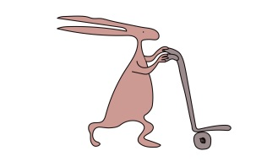
- Palpitations.
- Irregular heartbeat.
- Muscle weakness.
- Fatigue.
- Joint stiffness, swelling.
- Increased thirst.
- Passing urine more often.
- Weight loss.

These symptoms may be caused by other things but if you notice them report them.

As part of your child's blood transfusion programme they will have regular blood tests. One of these blood tests, Ferritin, will look at the amount of iron your child has in their body.

Your child will have an MRI scan every year and this will accurately measure the amount of iron in the liver and heart.

Are there any other treatment options?

No. Chelation is the only way to remove excess iron from the body.

Further information

If you need further information please contact your Sickle Cell Nurse Team on 0151 252 5070

Useful websites

www.alderhey.co.uk
www.sicklecellsociety.co.uk

Alder Hey Children's NHS Foundation Trust is neither liable for the contents of any external internet site listed, nor does it endorse any commercial product or service mentioned or advised on any of the sites

This leaflet only gives general information. You must always discuss the individual treatment of your child with the appropriate member of staff. Do not rely on this leaflet alone for information about your child’s treatment.
This information can be made available in other languages and formats if requested.
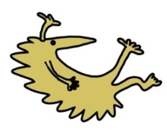
Alder Hey Children’s NHS Foundation Trust
Alder Hey
Eaton Road
Liverpool
L12 2AP
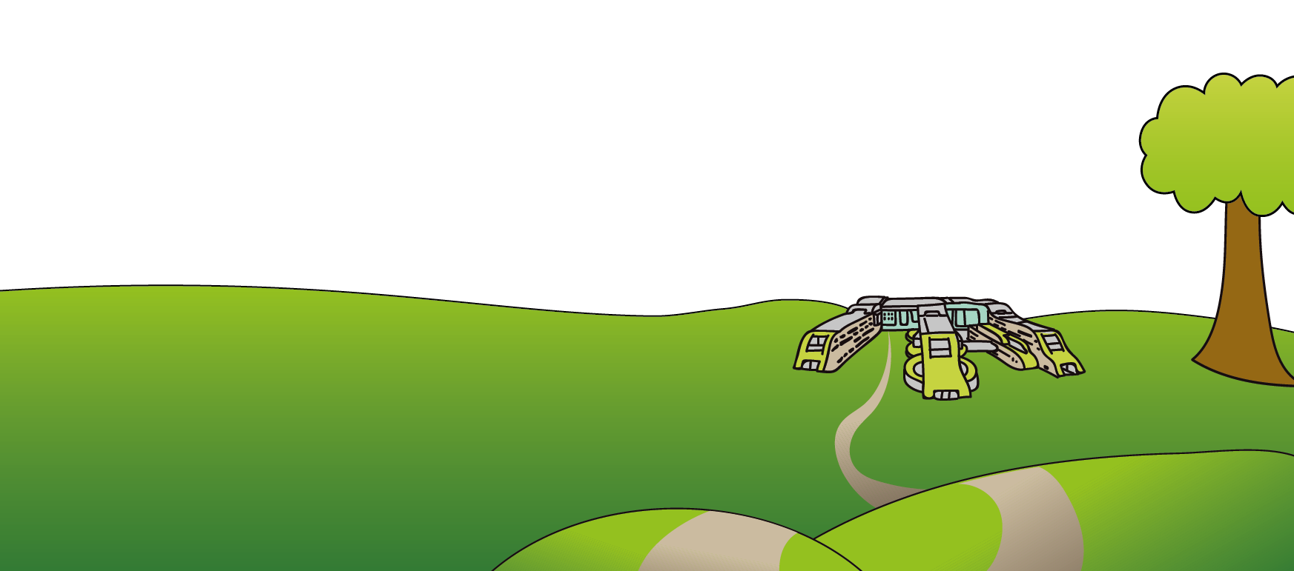
Tel: 0151 228 4811
www.alderhey.nhs.uk

© Alder Hey Review Date: April 2024 PIAG: 0048

