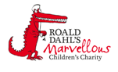

Haematology Department
Sickle Cell Disease – Chronic Complications
Gallstones
Information for parents and carers

Introduction

This leaflet is designed to explain about the long term (chronic) complications of sickle cell disease. The information does not cover everything. If you are ever worried about your child then please contact your Sickle Cell Team or take your child to Accident and Emergency Department

What are gallstones?

Gallstones are hard, pebble like deposits that are formed from different substances in the body, including Bilirubin and Cholesterol. Gallstones are also known as Cholelithiasis. They form in the bile duct or gall bladder. The gallbladder is an organ that stores and releases bile. Bile is made from Bilirubin in the liver and helps to break down fatty foods in the small intestines. Bile flows from the liver to the gallbladder through the bile duct.

Why is my child more likely to get gallstones?

People with sickle cell disease are constantly breaking down red blood cells. This causes an excess of bilirubin which leads to an excess of bile which can cause sludge or gallstones.

How can a gallstones affect my child?

Gallstones are not usually harmful. Sometimes gallstones can lead to problems if they get caught in the bile duct or gallbladder or cause infections.

How common are gallstones?

About 30-50% of children with sickle cell disease will develop gallstones. (Wesdorp et al, 2000)

What are the signs and symptoms of gallstones?

The signs and symptoms of gallstones are:
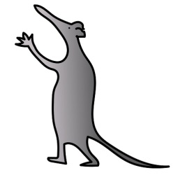
- Abdominal pain.
- Pain in the shoulders and back.
- Fever.
- Nausea and vomiting.
- Yellowing of the skin and eyes (jaundice).
- Dark urine.
- Clay-coloured stool.

What should I do if I notice any of these symptoms?

If you notice any of these symptoms in your child then you should bring them to the hospital for review by a doctor.

How are gallstones diagnosed?

Gallstones are usually diagnosed with an ultra sound. Your child may also have a blood test to check their Bilirubin level.
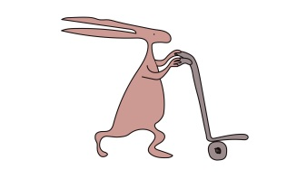
What is the treatment for gallstones?

If your child’s gallstones aren’t causing them any problems then they may just be monitored in clinic. If your child is unwell then the doctors may advise that the gallbladder is removed

What can be done to prevent gallstones?

You may not be able to prevent your child getting gallstones. If your child has a persistently raised Bilirubin or sometimes gets abdominal pains then they will be monitored for gallstones by having ultrasounds.

What is the risk of my child getting gallstones again?

Your child may keep getting gallstones due to the rate that they break down the red blood cells. Once your child’s gallbladder is removed they won’t get gallstones again.

Further information

If you need any further information please contact your Sickle Cell Team on 0151 252 5070

References
Wesdorp, I., Bosman, D., de Graaff, A, Aronson, D., van der Blij, F. & Taminiau, J. 2000. Clinical Presentations and Predisposing Factors of Cholelithiasis and Sludge in Children. Journal of Pediatric Gastroenterology and Nutrition, Vol 31.

Useful websites

www.alderhey.co.uk
www.sicklecellsociety.co.uk

Alder Hey Children's NHS Foundation Trust is neither liable for the contents of any external internet site listed, nor does it endorse any commercial product or service mentioned or advised on any of the sites
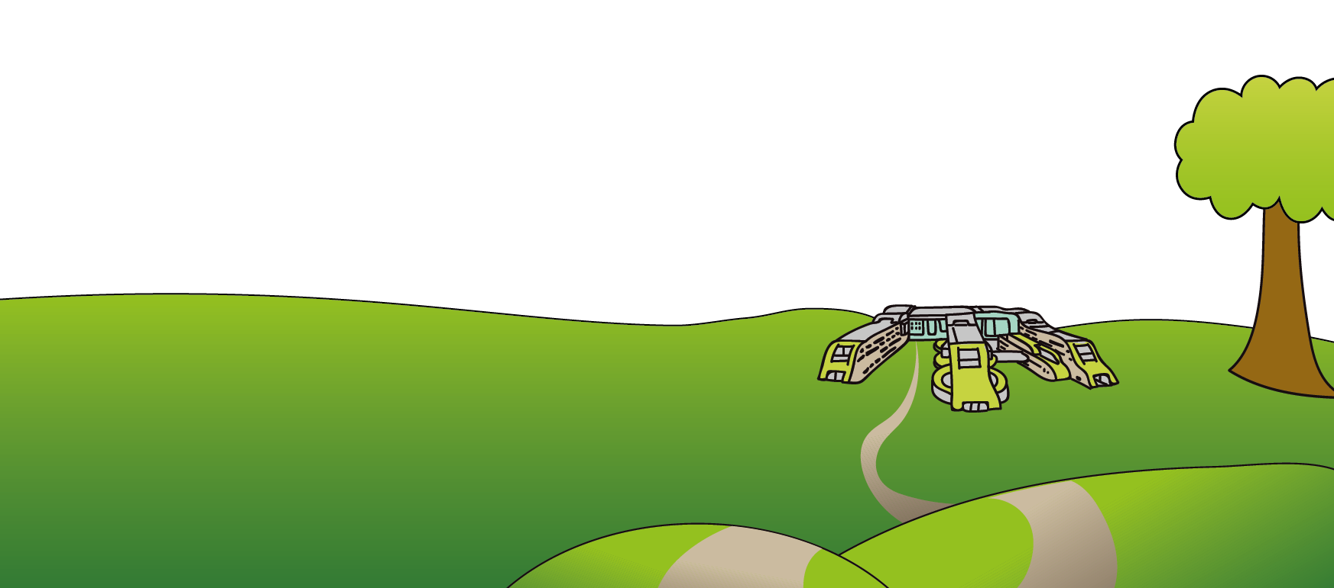
This leaflet only gives general information. You must always discuss the individual treatment of your child with the appropriate member of staff. Do not rely on this leaflet alone for information about your child’s treatment.
This information can be made available in other languages and formats if requested.
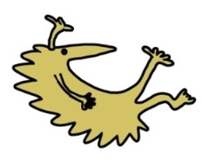
Alder Hey Children’s NHS Foundation Trust
Alder Hey
Eaton Road
Liverpool
L12 2AP

Tel: 0151 228 4811
www.alderhey.nhs.uk

© Alder Hey Review Date: April 2024 PIAG: 0045

