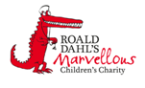
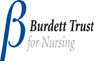

Haematology Department
Sickle Cell Disease – Chronic Complications
Avascular Necrosis
Information for parents and carers

Introduction

This leaflet is designed to explain about the long term (chronic) complications of sickle cell disease. The information does not cover everything. If you are ever worried about your child then please contact your Sickle Cell Team or take your child to Accident and Emergency Department
What is avascular necrosis?

Avascular Necrosis (AVN) is the death of the bone due to reduced or limited blood supply to the bone tissue. This death of the bone (or necrosis), leads to a thick scar tissue developing, which then stops any further healing of the bone, leading to joint pain and loss of function and restricted movement.

What part of the body does AVN affect?
The joints most often affected by AVN are the hip, knee, shoulder, ankle / foot wrist and elbow. This is because they have smaller veins that can provide circulation to the affected area and usually only have a single large blood vessel that delivers circulation. Sickled cells find it quite easy to clump up this one blood vessel and the risk for AVN is developed.
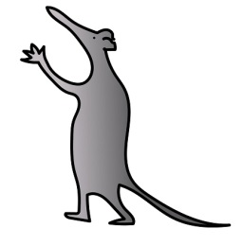
Will AVN affect my child?
AVN usually affects older people with sickle cell disease but can start in late childhood and adolescence. Approximately 41% of adult patients with sickle cell disease get AVN, in children this is much less common (27%). (Almedia & Roberts, 2005)

What are the signs and symptoms of AVN?
The main sign of AVN is pain in the bone that is there even when your child is not having a crisis. Usually this pain is in the joint between the hip and thigh bone, and can be felt when walking.
You may notice that your child might not have a normal range of movement on the affected side. In some people, AVN is so advanced that they might have a slight limp or clicking in movement.
If the bone compresses the nerve, there might be some numbness, tingling or lack of sensation in the affected arm or leg.

What should I do if I am worried about my child?
If your child is getting bone / joint pains when they are not having a crisis you should inform your sickle cell team. They will usually arrange for an x-ray to be done to look at the joints. Sometimes your child may need to have an MRI scan done.

What is the treatment for AVN?
To begin with, management of AVN is with pain medicines and physiotherapy. If the bone is severely affected then your child will be referred to a doctor that specializes in bones. Some types of AVN need surgery and joint replacements.

What can I do to prevent my child getting AVN?
To help reduce your child’s risk of getting AVN you should encourage them to exercise. Exercise increases the circulation in the bone. Low impact exercises such as walking and swimming are good.

You should also make sure that your child has a good calcium intake. So encourage them to have plenty of calcium rich foods such as milk, cheese and yoghurt.

Further information
If you have any questions or want any further information please contact your Sickle Cell Team on 0151 252 5070.
References
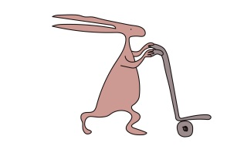
Almedia, A. & Roberts, I. 2005. Bone involvement in Sickle Cell Disease. British Journal ofHaematology, Vol 129.
Useful websites
www.alderhey.co.uk
www.sicklecellsociety.co.uk

Alder Hey Children's NHS Foundation Trust is neither liable for the contents of any external internet site listed, nor does it endorse any commercial product or service mentioned or advised on any of the sites.

This leaflet only gives general information. You must always discuss the individual treatment of your child with the appropriate member of staff. Do not rely on this leaflet alone for information about your child’s treatment.
This information can be made available in other languages and formats if requested.
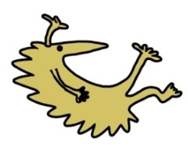
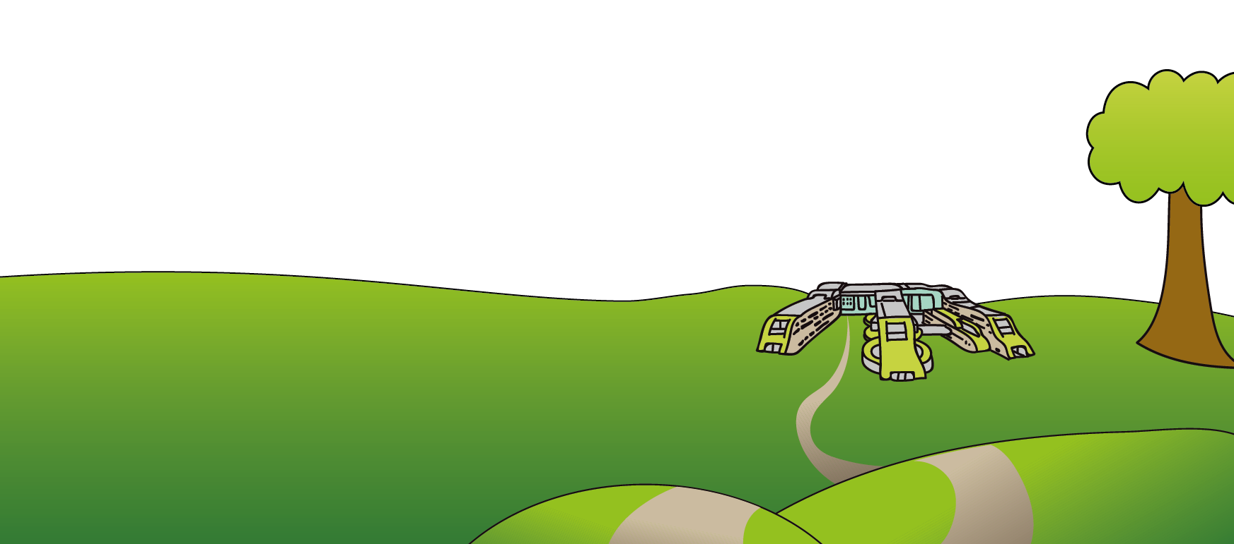
Alder Hey Children’s NHS Foundation Trust
Alder Hey
Eaton Road
Liverpool
L12 2AP

Tel: 0151 228 4811
www.alderhey.nhs.uk

© Alder Hey Review Date: April 2024 PIAG: 0046

