Haematology Department
Sickle Cell Crisis – The Spleen
Information for parents and carers

Introduction
This leaflet aims to provide you with general information about the signs and symptoms your child may have when they are having a sickle cell crisis. If you are ever worried about your child please contact your Sickle Cell Team or take your child to the Accident and Emergency Department.

What is the spleen?

The spleen is a small organ located under the rib cage on the left side of the body. It helps the body to fight infection by removing bacteria (germs) from the bloodstream and it gets rid of old or damaged red blood cells.

What causes the spleen to become large?

Sickled red blood cells get trapped in blood vessels of the spleen and block the flow of the blood out of the spleen. This causes the blood cells to stay inside the spleen instead of flowing through it. This is called sequestration. When this happens, the spleen becomes very large and it is easy to feel. Sometimes sequestration is painful.

Is splenic sequestration serious?

If the spleen enlarges suddenly and the red blood cells cannot get back into the circulation, this causes the haemoglobin level to drop causing severe anaemia. This is a serious and potentially life-threatening problem. When the spleen gradually gets larger over several weeks, the haemoglobin does not change as much, so it is not as serious.

Any enlargement of the spleen is of concern and must be watched for changes. Parents should check their child's spleen every day, particularly when the child is sick. They should know how their child's spleen usually feels, so that whenever the child seems sick they can check the spleen to see if it is bigger.

If the spleen suddenly becomes larger, a doctor should check the child as soon as possible. If a child also has symptoms of a low haemoglobin, this becomes an emergency situation.

What are the symptoms of splenic sequestration?

A child with a low haemoglobin is likely to:

- Be irritable.
- Be unusually sleepy.
- Have a rapid heartbeat.
- Look pale.
- May complain of a headache.
- Have a hard lump under their ribcage (on the left side).
- May complain of tummy pains.
Your child may not have all of these symptoms. Sometimes children can have seriously low haemoglobin without many symptoms. Sometimes the only symptom is that a child is less active.
If your child has any of the symptoms you must take them to hospital.

At what age does splenic sequestration usually occur?

Babies and young children are at greatest risk of splenic sequestration. Complications can develop as young as two months of age, but usually occur between the ages of six months and five years. As children get older, the spleen becomes smaller and eventually it may not enlarge anymore.

Can splenic sequestration happen more than once?

Yes. A child who has one episode of splenic sequestration is likely to have other episodes.

What is the treatment for splenic sequestration?

If the haemoglobin is dangerously low, then red blood cell transfusion is the treatment. If a child has several episodes, surgery to remove the spleen (splenectomy) may be recommended.

What can be done to prevent splenic sequestration?

There is nothing that can be done to prevent splenic sequestration happening. The important thing is to be able to recognise when it is happening so that you can take your child straight to the hospital for treatment.

How to feel for an enlarged spleen

You will be taught by your Sickle Cell Team to feel for your child's spleen. You shouldn't normally be able to feel the spleen as it is tucked away behind the ribs.

Where to find the spleen
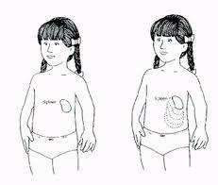
The Spleen
The Spleen

Lay your child on their back. Sit next to your child on their right hand side. With your right hand flat, press on your child's tummy on their left hand side just under the ribs. Your child's tummy should be soft when you press. If you feel something hard, or a lump, this could be your child's spleen.

What should I do if I think I can feel my child's spleen?

If you feel your child's spleen then you must ring your Sickle Cell Team for advice. If your child is unwell or has any of the symptoms described in the symptoms section of this leaflet then you must take them straight to Accident and Emergency Department.

Further information

If you have any questions or want any further information, please contact your Sickle Cell Team on 0151 252 5070.
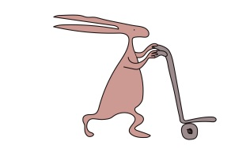
Useful websites

www.alderhey.co.uk
www.sicklecellsociety.co.uk

Alder Hey Children's NHS Foundation Trust is neither liable for the contents of any external internet site listed, nor does it endorse any commercial product or service mentioned or advised on any of the sites.

This leaflet only gives general information. You must always discuss the individual treatment of your child with the appropriate member of staff. Do not rely on this leaflet alone for information about your child’s treatment.
This information can be made available in other languages and formats if requested.

Alder Hey Children’s NHS Foundation Trust
Alder Hey
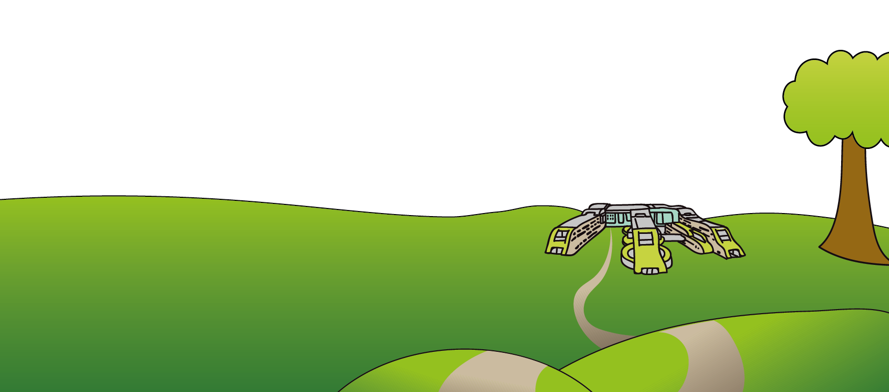
Eaton Road
Liverpool
L12 2AP

Tel: 0151 228 4811
www.alderhey.nhs.uk

© Alder Hey Review Date: April 2024 PIAG: 0071

