**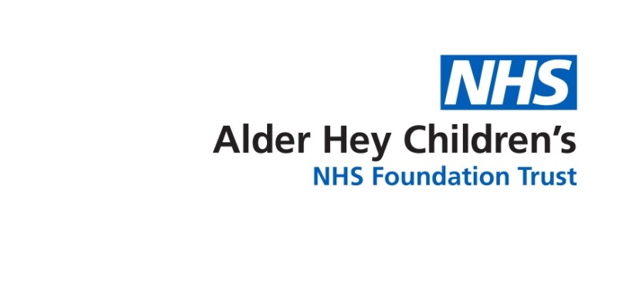*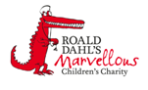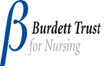***

Haematology Department

**Sickle Cell Crisis – Stroke**

Information for parents and carers

**Introduction**

This leaflet aims to provide you with general information about the signs and symptoms your child may have when they are having a sickle cell crisis. If you are ever worried about your child please contact your Sickle Cell Team or take your child to the Accident and Emergency Department.

**What causes a stroke in sickle cell disease?**

A stroke happens when the blood flow to the brain is cut off. There are two types of stroke - ischemic or haemorrhagic. An ischemic stroke is caused by sickled red blood cells blocking the flow of the blood and oxygen to the brain. It usually occurs suddenly and sometimes happens with a painful episode or infection. A haemorrhagic stroke is a bleed in or around the brain caused by a burst blood vessel. Ischemic strokes are the most common type of stroke in children.

**How likely is it that my child will have a stroke?**

About 10% of children and young people with sickle cell disease will have a stroke by the time they are 20. If they have had a stroke, there is a 70% chance that they will have another one if they don't have any preventative treatment.

**How will a stroke affect my child?**

When blood is cut off to part of the brain, cells in that area die. When the brain cells no longer work, the parts of the body they once controlled don’t work either. A stroke can damage your child’s ability to walk, talk and/or understand. It can also affect their emotions and memory.

**What are the signs and symptoms of a stroke?**

* Sudden weakness or numbness of the face, arm or leg, especially on one side of the body.
* Tingling in arms or legs.
* ****Sudden confusion, trouble speaking or understanding.
* Sudden trouble seeing in one or both eyes.
* Seizures / fit.
* Sudden trouble walking, dizziness, loss of balance or coordination.
* Sudden, severe headaches with no known cause.
* Loss of consciousness.

In very young children you may not notice these signs. If you are worried that your child isn't behaving as they usually do, for example they have inconsolable crying, bring them to the hospital.

It is important to know the signs and symptoms of a stroke so that you can quickly recognize them if your child experiences them.

**What should I do if I think my child is having a stroke?**

If you think your child is having a stroke, you must **ring 999 immediately** and ask for an ambulance. Don’t wait to see if the symptoms disappear. The longer you wait the more damage occurs in the brain. A quick response will help limit the damage.

**What is the treatment for a stroke?**

A stroke is usually treated with intravenous (IV) fluids, oxygen, if the oxygen levels are low, and blood transfusion to get more oxygen to the brain to reduce permanent damage. A CT scan is also needed to tell if a person had a haemorrhagic stroke or an ischemic stroke.

**Will my child have any long term effects from a stroke?**

Everybody recovers differently from a stroke. In general, younger people recover more abilities than older people do. Children often recover the use of their arms and legs and their ability to speak after a stroke. If your child has any problems with their arms, legs or speech after a stroke then they will be followed up by physiotherapy and occupational and speech therapy.

**How can I prevent my child having any further strokes?**

If your child has had a stroke, the doctors will recommend that they go onto a blood transfusion programme. This means that your child will come into the hospital every three to four weeks for a blood transfusion. The aim is to decrease the amount of sickle red blood cells that your child has, to prevent further sickling.

If your child has fits, then make sure that you give them their prescribed medicines as instructed by their doctor.

Ensure you attend all hospital appointments so that your child can be regularly monitored. Your child will also be sent follow up appointments with Neurology doctors.

**Further information**

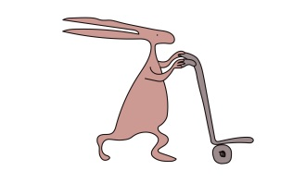If you have any questions or want any further information please contact your Sickle Cell Team on 0151 252 5070.

**Useful websites**

[www.alderhey.co.uk](http://www.alderhey.co.uk)

[www.sicklecellsociety.co.uk](http://www.sicklecellsociety.co.uk)

Alder Hey Children's NHS Foundation Trust is neither liable for the contents of any external internet site listed, nor does it endorse any commercial product or service mentioned or advised on any of the sites.

****This leaflet only gives general information. You must always discuss the individual treatment of your child with the appropriate member of staff. Do not rely on this leaflet alone for information about your child’s treatment.

This information can be made available in other languages and formats if requested.

****Alder Hey Children’s NHS Foundation Trust

Alder Hey

Eaton Road

Liverpool

L12 2AP

Tel: 0151 228 4811

[www.alderhey.nhs.uk](http://www.alderhey.nhs.uk)

**© Alder Hey Review Date: April 2024 PIAG: 0072**