Haematology Department
Sickle Cell Crisis Management – Pain
Information for parents and carers

Introduction
This leaflet is designed to explain about managing a sickle cell crisis. The information does not cover everything and if you are ever worried about your child then please contact your sickle cell team or take your child to accident and emergency.

What is pain?

Pain can come from any part of your body: skin, muscle, ligaments, joints, bones (nociceptive pain), injured tissue (inflammatory pain), nerves (neuropathic pain), internal organs (visceral pain) or a combination of these types of pain (mixed pain).

Pain signals travel from the painful part of the body along thousands of specialised nerve fibres, through the spinal cord, to the brain. When pain signals reach the brain your child will feel the pain. The brain sends signals back to the spinal cord, which can, either reduce or increase the pain further. Pain medicines stop the pain signals reaching the brain.

Diagram showing how pain messages are sent to the brain

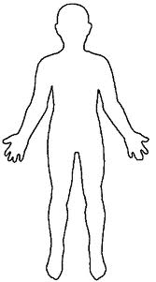
Nerves send painful messages to the brain
Pain Source
Brain receives the painful messages

What causes sickle cell pain?

A painful sickle crisis is triggered by red blood cells getting low in oxygen. When this happens the red blood cells change shape from the usual round doughnut shape to sickle (half-moon) shape. The cells become hard and sticky making it hard for them to get through tiny blood vessels.

Sickle pain is caused by sickled red blood cells clumping together and blocking the normal blood flow through blood vessels. This cuts off the blood supply to nearby tissues so they do not get oxygen. Without oxygen this area starts to hurt. It can happen in any part of the body and causes pain to that part. Pain can start suddenly and last from several hours to days. The pain is known as a sickle cell crisis.

Diagram showing different cell movement
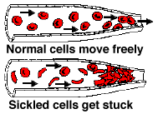
How much pain will my child have when they are having a crisis?

The pain that your child feels can vary in severity. It can be mild to moderate and can be managed at home with pain medicines. But sometimes the pain can be very severe and the pain medicines that you keep at home will not take your child’s pain away. When this happens you will have to bring your child to hospital for stronger pain medicines.

How do I know how much pain my child is in?

To know how much pain your child is in you need to do a pain assessment. If your child is in so much pain that they are not responding to anything that they do, then you should bring them straight to the hospital for review. The leaflet “Pain Assessment” will tell you how to assess your child's pain.

Further information

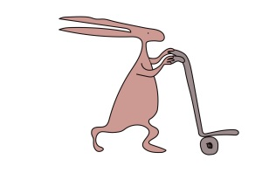
If you have any questions or want any further information please contact your Sickle Cell team on 0151 252 5070.

Useful websites
www.alderhey.co.uk
www.sicklecellsociety.co.uk
www.mychildisinpain.org.uk

Alder Hey Children's NHS Foundation Trust is neither liable for the contents of any external internet site listed, nor does it endorse any commercial product or service mentioned or advised on any of the sites.

This leaflet only gives general information. You must always discuss the individual treatment of your child with the appropriate member of staff. Do not rely on this leaflet alone for information about your child’s treatment.
This information can be made available in other languages and formats if requested.

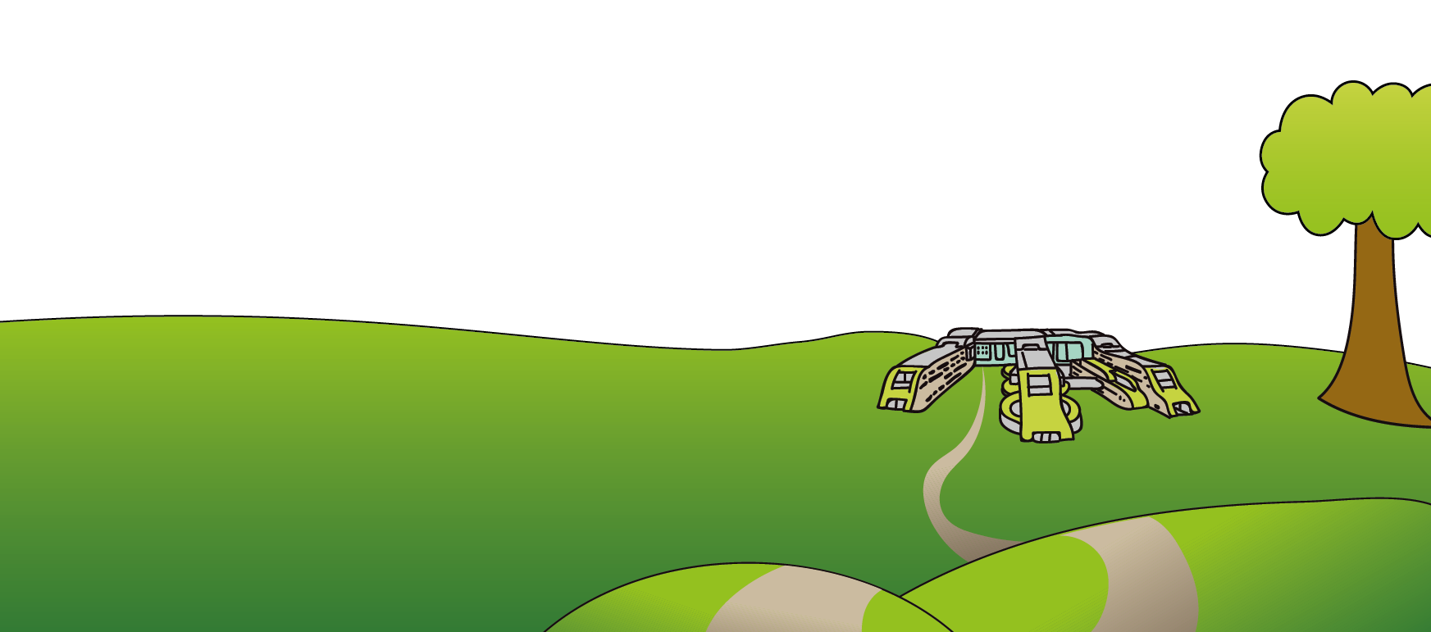
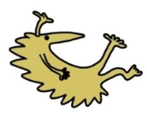
Alder Hey Children’s NHS Foundation Trust
Alder Hey
Eaton Road
Liverpool
L12 2AP

Tel: 0151 228 4811
www.alderhey.nhs.uk

© Alder Hey Review Date: April 2024 PIAG: 0069

