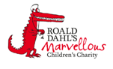

Haematology Department
Sickle Cell Crisis Management – Pain Assessment
Information for parents and carers

Introduction
This leaflet aims to provide you with general information about the signs and symptoms your child may have when they are having a sickle cell crisis. If you are ever worried about your child please contact your Sickle Cell Team or take your child to the Accident and Emergency Department.

How can I assess the signs of my child’s pain?

Before you give your child any pain medicine you need to find out where the pain is and how bad it is. Younger children and babies will not be able to tell you if they are in pain or where it is so you will need to look out for signs that they are in pain.
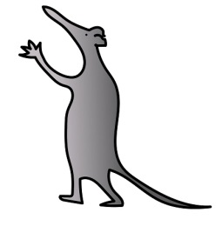
What are the signs and symptoms of pain?

The signs and symptoms of pain are:

For Infants and Toddlers For Older Children
● Irritable / fretful ● Irritable / frustrated / angry
● Persistently crying ● Crying
● Crying when moved or touched ● Facial grimacing
● Keeping body rigid ● Decreased activity level
● Refusing to walk or crawl ● Quiet / withdrawn
● Whimpering ● Holding still or guarding area
● Difficult to comfort that hurts
● Facial grimacing ● Decreased co-operation
● Refusing to drink ● Disrupted sleep
● Unable to sleep / restless ● Fidgety or "dancing" legs
● Grunting

Locating the pain your child feels?

Use the diagram below and get your child to show you where their pain is. Record the location of the pain in their Crisis Diary
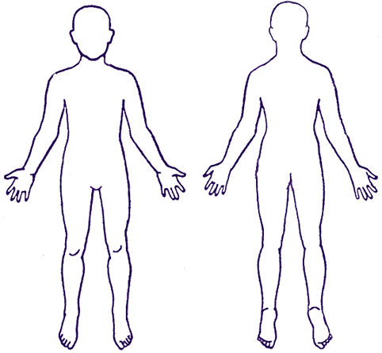
How can I find out how severe my child’s pain is?

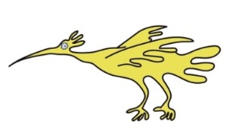
Once you know your child is in pain and where it is, you need to find out how bad it is. You do this by getting a pain score from your child. There are different tools that can be used to help assess your child’s pain. The tool used will depend upon your child’s age and development. Talk to your child’s nurse or doctor about which is the best one for you and your child.

FLACC Pain scale
To be used for children aged two months to seven years.
Instructions: Each of the five categories (F) face; (L) leg; (A) activity; (C) cry and (C) consolability is scored 0, 1 or 2. Score each category and add up total score between 0 - 10.
Category | Score 0 | Score 1 | Score 3
 | Pain indicator | Pain indicator | Pain indicator
(F) face | No particular expression or smile. | Occasional grimace or frown, withdrawn, disinterested. | Frequent to constant frown, clenched jaw, quivering chin.
(L) legs | Normal positon or relaxed. | Uneasy, restless, tense. | Kicking or legs drawn up.
(A) activity | Lying quietly, normal position, moves easily. | Squirming, shifting back/forth, tense. | Arched, rigid or jerking.
(C) cry | No cry (asleep or awake). | Moans or whimpers, occasional complain. | Crying steadily screams or sobs frequent complaints.
© consolability | Content, relaxed | Reassured by occasional touching, hugging or distractible. | Difficult to console or comfort.
Total score ..................................................
FACES Pain scale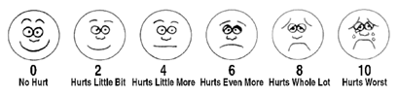
Instructions: Ask your child to point to the face or words that best describe the pain they have.
Pain Ruler
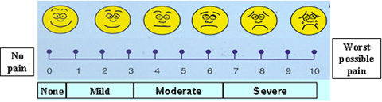
Instructions: Ask your child to score their pain between 0 and 10. 0 is no pain and 10 is the worst pain that they can imagine.
What should I do after I have assessed my child’s pain?

Give your child the pain medications dependent upon their score. Remember to record their score in your child’s Crisis Diary.

Further information

If you have any questions or want any further information please contact your Sickle Cell Team on 0151 252 5079.
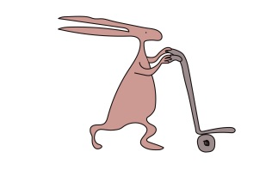
Useful websites
www.alderhey.co.uk
www.sicklecellsociety.co.uk
www.mychildisinpain.org.uk
Alder Hey Children's NHS Foundation Trust is neither liable for the contents of any external internet site listed, nor does it endorse any commercial product or service mentioned or advised on any of the sites

This leaflet only gives general information. You must always discuss the individual treatment of your child with the appropriate member of staff. Do not rely on this leaflet alone for information about your child’s treatment.
This information can be made available in other languages and formats if requested.

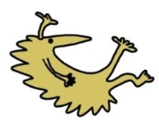
Alder Hey Children’s NHS Foundation Trust
Alder Hey
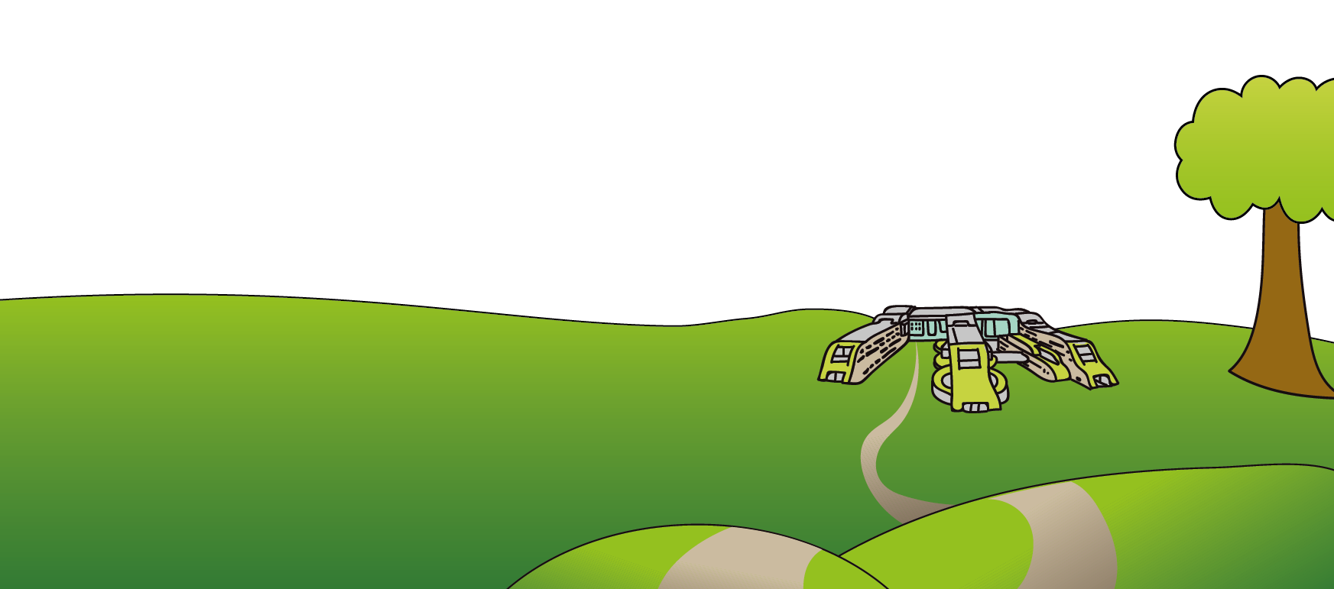
Eaton Road
Liverpool
L12 2AP

Tel: 0151 228 4811
www.alderhey.nhs.uk

© Alder Hey Review Date: April 2024 PIAG: 0066

