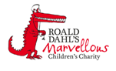

Haematology Department
Sickle Cell Crisis Management – Alternative Pain Therapies
Information for parents and carers

Introduction

This leaflet aims to provide you with general information about the signs and symptoms your child may have when they are having a sickle cell crisis. If you are ever worried about your child please contact your Sickle Cell Team or take your child to the Accident and Emergency Department.

Is there anything I can do for my child to help with the pain?

As well as giving your child medication to help stop their pain there are a number of other things that you can try. These things are known as non-pharmacological techniques.
Comfort A cuddle or hug or anything that gives your child comfort may help to reduce their pain as it can lessen anxiety and offer reassurance.

Rest and When your child is in pain try to make them relax and rest. Relaxation can help to
relaxation calm your child and if your child is in pain encourage them to rest. Being too active can make their pains worse. It is important to ensure your child has some movement as still or bent limbs can reduce blood flow and make the crisis worse.

Massage Massaging the painful area may help to reduce the muscle stiffness and their pain.
Distraction By diverting your child’s attention and getting then to concentrate on something else. It can be used to help your child cope with their pain. Good forms of distractions are:
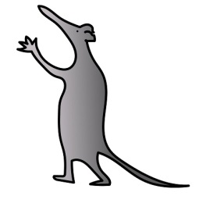
    - Listening to music.
    - Watching television.
    - Playing computer games.
    - Doing puzzles or playing a game.
    - Reading.
    - Listening to a story.
    - Singing.

Heat Applying heat (heat packs or warm towels) to the painful area can help to ease the pain. Do not put anything cold onto the painful areas this can make the crisis worse.
Will non-pharmacological techniques stop my child’s pain?

Non-pharmacological techniques are not meant to replace pain medicines; they are to work alongside them to try to reduce pain. Not every technique works for every child. You will need to try different techniques to see which works for your child.

Further information
If you have any questions or want any further information please contact your Sickle Cell Team on 0151 252 5070.
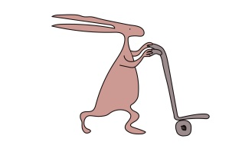
Useful websites
www.alderhey.co.uk
www.sicklecellsociety.co.uk
www.mychildisinpain.org.uk

Alder Hey Children's NHS Foundation Trust is neither liable for the contents of any external internet site listed, nor does it endorse any commercial product or service mentioned or advised on any of the sites.

This leaflet only gives general information. You must always discuss the individual treatment of your child with the appropriate member of staff. Do not rely on this leaflet alone for information about your child’s treatment.
This information can be made available in other languages and formats if requested.

Alder Hey Children’s NHS Foundation Trust
Alder Hey
Eaton Road
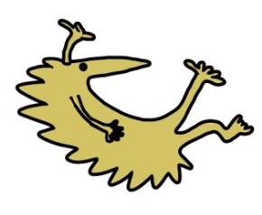
Liverpool
L12 2AP
Tel: 0151 228 4811
www.alderhey.nhs.uk

© Alder Hey Review Date: April 2024 PIAG: 0038

