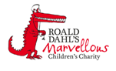

Haematology Department
Sickle Cell Crisis – Dactylitis
Information for parents and carers

Introduction

This leaflet aims to provide you with general information about the signs and symptoms your child may have when they are having a sickle cell crisis. If you are ever worried about your child please contact your Sickle Cell Team/Ward 3B or take your child to the Accident and Emergency Department.

What is dactylitis?

Dactylitis is a painful swelling into the hands and/or feet. It is caused by sickled cells blocking the tiny blood vessels in the hand and feet. It is most common in children aged two years and under. You may also hear it referred to as hand / foot syndrome.
What are the signs and symptoms of dactylitis?

- Swelling to the back of the hand or foot, fingers or toes.
- Painful hand, finger, foot or toe.

What should I do if I think my child has dactylitis?

If your child has any of the above symptoms give your child some paracetamol for the pain. Do not exceed the recommended dose for your child’s age. Ring your Sickle Cell Team (in working hours) or Ward 3B (out of hours) for advice, they will usually suggest that you bring your child to the hospital for review.

What is the treatment for dactylitis?

The main treatment for dactylitis is pain relief. Your child will be given regular pain relief this will usually be Paracetamol and Ibuprofen. If the pain is under control you will be able to do this at home. If the pain is not controlled or the episode of dactylitis is severe your child will be admitted to the hospital. If admitted to the hospital they will also be given intravenous (IV) fluids and stronger pain medicine such as oral morphine. If your child is allowed home it is important to give them more fluids than normal for a few more days.

Where can I get the pain medicines my child needs?

Paracetamol and Ibuprofen are available from your local chemist or supermarket. You can also get a prescription from your GP or the hospital. If your child needs oral morphine the hospital will prescribe it.

How long would my child be in hospital?

Your child may have to stay in hospital for a few days. You will be able to take your child home when their pain has settled down or the swelling has reduced.

Will my child get dactylitis again?

Your child may get dactylitis again. If you do notice your child experiencing the same symptoms again take them to the hospital for review. Recurrent episodes of dactylitis can damage bones in the hands or feet so it is important to seek treatment.

Further information
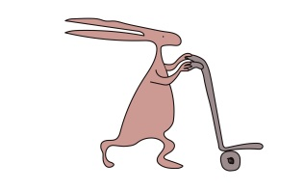
If you have any questions or want any further information please contact your Sickle Cell Team on 0151 252 5070.

Useful websites
www.alderhey.co.uk
www.sicklecellsociety.co.uk

Alder Hey Children's NHS Foundation Trust is neither liable for the contents of any external internet site listed, nor does it endorse any commercial product or service mentioned or advised on any of the sites.

This leaflet only gives general information. You must always discuss the individual treatment of your child with the appropriate member of staff. Do not rely on this leaflet alone for information about your child’s treatment.
This information can be made available in other languages and formats if requested.

Alder Hey Children’s NHS Foundation Trust
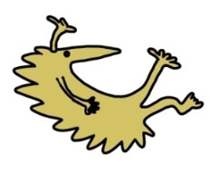
Alder Hey
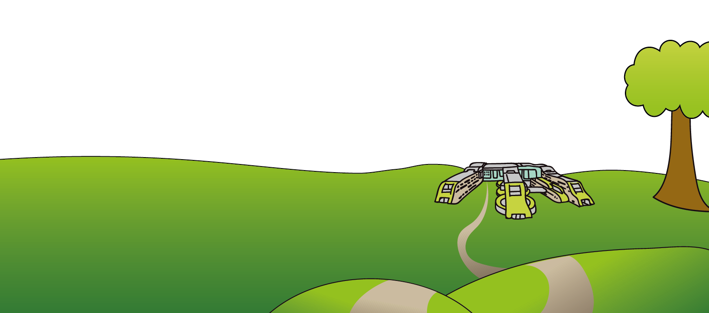
Eaton Road
Liverpool
L12 2AP

Tel: 0151 228 4811
www.alderhey.nhs.uk

© Alder Hey Review Date: April 2024 PIAG: 0056

