Wound reviews should be
completed in 1:2 clinic on
____________ & ____________
by the Neurosurgical Team.
When Hydrotherapy is due to start, the wound MUST be reviewed in clinic BEFORE the session.
Pregablinshould start
reducing 3 weeks post surgery.
Please follow instructions as directed on your medication bottle
______________

Should you have any further questions contact a member of the team:

Miss Pettorini/Mr Vakharia
Consultant Neurosurgeon

Helen Gedrin
Clinical Specialist Physiotherapist
0151 252 5660

Deborah Quirk
Nurse Specialist - Spasticity
deborah.quirk@alderhey.nhs.uk
0151 228 4811 Ext 4349
Ward 4A
0151 282 4489
This leaflet only gives general information. You must always discuss the individual treatment of your child with the appropriate member of staff. Do not rely on this leaflet alone for information about your child’s treatment. This information can be made available in other languages and formats if requested.

Alder Hey Children’s NHS Foundation Trust
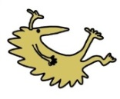
East Precot Rd
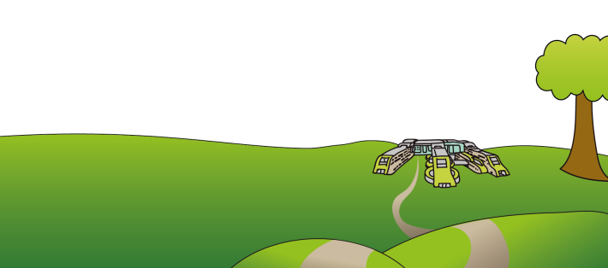
Liverpool
L14 5AB
Tel: 0151 228 4811
www.alderhey.nhs.uk

© Alder Hey
Review Date: June 2025
PIAG: 300



Spasticity Service

Selective Dorsal Rhizotomy
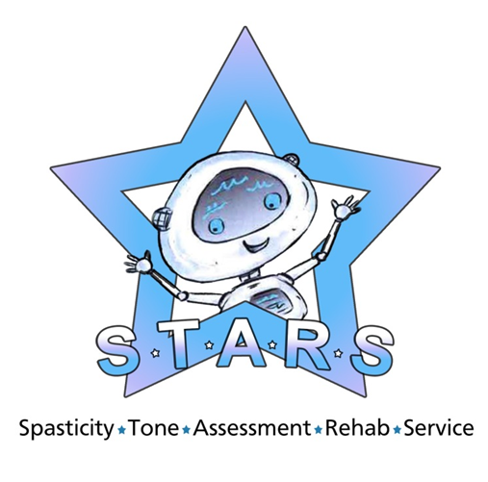

Discharge information for parents and carers

This leaflet aims to provide information for parents and children about the care of their SDR wound.
Your child’s wound will be reviewed by your nurse before discharge to Mac House. If the wound is satisfactory, you will move to Mac House to continue physiotherapy as an outpatient.
A dressing can be left in place for a maximum of 2 day intervals before it should be removed, the wound cleaned and a new dressing applied. Dressings that become contaminated should be removed and replaced immediately.
Daily dressing changes and wound washes should be done following each hydrotherapy session.
Families should attend the 1:2 clinic on the dates and times provided.
If you have any concerns with redness, swelling, leaking, increased pain from the wound or your child has a temperature, you should contact your specialist nurse or Ward 4A.
If this is between 9-5, Monday-Friday, you will likely be asked to attend clinic, however, outside of these hours, you will be asked to present to A&E
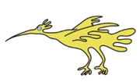
To clean the wound, you should use a mild soap. Using gentle circular motions, clean over and around the wound, before patting dry with a clean towel.

Sutures (Stitches)
We use two different types of sutures; some that are dissolvable, and some that require removal. Dissolvable sutures do not need to be removed, and will dissolve in approximately 2-3 weeks.
Non-dissolvable sutures will need to be removed approximately 1 week after discharge. You will be informed by your nurse when and where suture removal will take place, if required
Dressings are no longer required once hydrotherapy sessions are finished, as long as the wound is satisfactory. Please contact the ward if you have any concerns about it.
Leisure and Schooling
If your child of school age, they may return when they are back to their usual self. This is usually once they have finished their 3 weeks of physiotherapy.
Swimming should be avoided for at least 6 weeks following the operation to allow the wound to fully heal.
Contact sports such as football should be avoided until review by your consultant.


In an emergency do not delay treatment by contacting the ward. Call 999.

You will be discharged from the ward with a supply of Paracetamol, Ibuprofen and Gabapentin. You may find it beneficial to give your child some pain relief before physiotherapy sessions.
Please follow the dose instructions provided on discharge.
Gabapentin should be given 3 times a day whilst completing Physio & Hydrotherapy. It should then be weaned (reduced), using the regime provided overleaf.
If you have issues with your child refusing to take this medication, please contact the ward or your GP.
Do NOT stop giving the medication without seeking further advice.
A follow up appointment will be made for your child, approximately 6 weeks after surgery. You should receive this appointment in the post after discharge. Should you have any issues with this appointment please contact the appointments line on 0151 252 5358.
This leaflet is intended as a guide only. Should you have any concerns regarding your child’s health, please seek medical attention. Do not delay emergency treatment in order to contact the Ward or Spasticity Team.
