Pain and Sedation Service
Sedation for procedures
Information for parents and carers

Introduction
Sedation will make your child feel sleepy and calm. It helps to reduce fear and anxiety, control pain or help the person stay still during a procedure. It is used for a range of painful or unpleasant procedures in children and young people. These procedures could be to help diagnose a condition, or for treatment such as dental work. If the procedure your child is having is painful, sedation can help to reduce the pain. Sedation involves an injection, swallowing a liquid or breathing gas through a mask.

What should happen when we see a healthcare professional?
If your child is having a procedure and their healthcare professional (it could be a doctor or
nurse) thinks that sedation will help, the healthcare professional will first see if sedation is
suitable for your child. They will ask about past medical problems and medicines your child is
taking or has taken in the past (including any allergies). They will also assess:
- current medical condition
- weight
- past experience of sedation or anaesthesia
- their general health, including their breathing, with a physical examination
- their understanding and ability to cope with the procedure.

Different types of sedation
Your healthcare professional will discuss the choice of sedation technique based on:
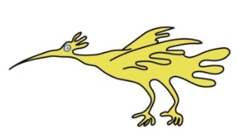
- what the procedure involves, for example if it is painful or painless
- how sleepy and calm your child needs to be
- if the technique is suitable for your child
- what you or your child prefer.
You will be told about, and given written information on, the proposed sedation technique, any
alternatives, and the benefits and side effects associated with each option.
Sedation will go ahead only if you, or your child if they are old enough, consent to it.

The table below shows what usually happens to your child with different levels of sedation.

Level of sedation | How will this affect my child?
Minimal to moderate | They will be relaxed and a little sleepy
Moderate | They will be very sleepy but easily awakened
Deep | They will be in a deep sleep

Some treatments may not be suitable for your child, depending on their exact circumstances. If you have questions about specific treatments and options covered in this information, please talk to a member of your healthcare team.

What does my child need to know?
So that your child is fully prepared for the procedure they are having under sedation, they will
be given advice that is suitable for them about:
- the procedure that they will be having when they are sedated
- what they should do and what the healthcare professional will do
- what they may feel when having the procedure (for example, numbness)
- how to cope with the procedure.
Another leaflet called Children coming into hospital “Hints and tips for parents” contains useful information about how to prepare your child for the procedure. This is available on the Trust Internet page.

Food and fasting
Before sedation, your healthcare professional should check and make a note of the last
time your child ate and drank something.
Your child should not eat for 6 hours before sedation, or drink clear fluids for 1 hour before. If they
are breastfeeding they should not have any breast milk for 3 hours before sedation. This may not
apply in an emergency or for some types of sedation.

Will I be able to stay with my child while they are sedated
You should be offered the opportunity to stay with your child while they are sedated if it is
appropriate. If you decide to be with them while they are sedated you will be given advice
about what to do to help. After your child is sedated you may be asked to wait outside the the
treatment room while a procedure is performed.

Further information
This leaflet only gives general information. You must always discuss the individual treatment of your child with the appropriate member of staff. Do not rely on this leaflet alone for information about your child’s treatment.
This information can be made available in other languages and formats if requested.
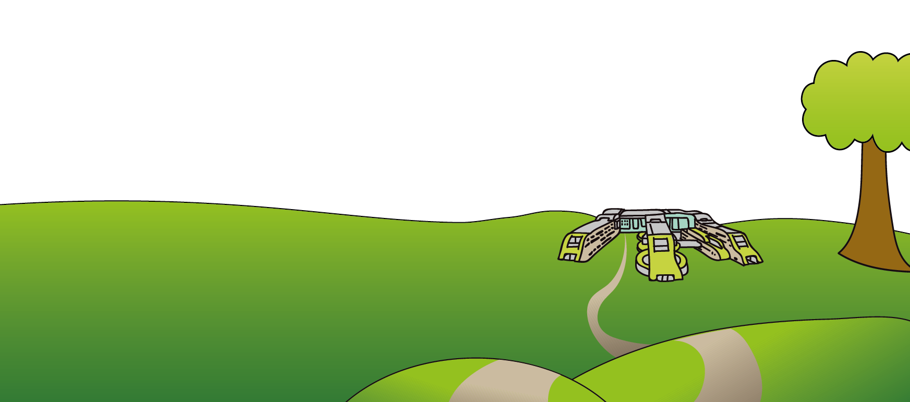
Alder Hey Children’s NHS Foundation Trust
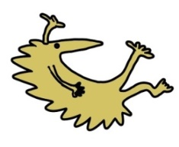
Alder Hey
Eaton Road
Liverpool
L12 2AP

Tel: 0151 228 4811
www.alderhey.nhs.uk

© Alder Hey Review Date: Aug 2025 PIAG: 306

