Surgical Day Care Unit
How to care for your child after Sclerotherapy
under General / Local Anaesthetic
Discharge information for parents and carers

Introduction

There is often most swelling and pain the day after the procedure so it may be wise to take regular paracetamol for the first couple of days until the swelling and pain improves. An ice pack or hot water bottle may help. Keeping the injected area raised can help reduce the swelling and massaging the affected area may also help.

Usually the swelling and pain settle rapidly during the first couple of days following the injection but it can last up to two weeks. After treatment try and lead a normal life.

- If you notice any changes that may be related to the treatment make note of them and inform us on your next visit.

- If the whole limb becomes very swollen, painful or discoloured please contact us immediately for advice.

- If the skin becomes black or very white or an ulcer forms please contact us immediately for further advice.
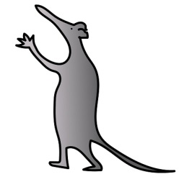
If you have any concerns or worries please do not hesitate to contact us.

Pain relief & medication

Paracetamol is the usually effective pain relief after Sclerotherapy. If there is severe pain then Ibuprofen can also be given regularly.

Getting back to normal

The aim of Sclerotherapy is to get your child to lead as normal a life as possible and after treatment you should try and return to their normal routine as quickly as possible. Most children and young people are able to return to school the next day.

Further treatments

Sclerotherapy is used to get your child’s symptoms under control so there is no limit to the number of treatments we will recommend. If you wait until six weeks after a treatment you can decide if you would like more treatment for your child.

If you would like more treatment

A follow up appointment is easily made by contacting us directly. If a previous treatment has been effective and you feel your child no longer needs Sclerotherapy that is fine you do not need to do anything. If symptoms recur at a later date and you would like more treatment please contact us directly. If this is after a prolonged period we may ask you to get your GP to fax us a letter.
Local anaesthetic

This will give numbness to the affected site for several hours you should keep this in mind when applying anything to skin. Try to avoid and knocks or bumps to the area as they may be felt when the local anaesthetic effects subside.

General Anaesthetic

Most children appear to be alert and active after they are discharged from hospital. However, do not be surprised if your child complains of feeling dizzy, tired, or is a little clumsy. This may last for a couple of days.

For the next 24 hours

- you should encourage your child to rest
- you should make sure your child’s activities are supervised by a responsible adult
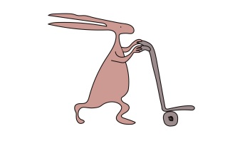
- Do Not let your child ride a bike.
- Do Not let your child take part in any outdoor activities.
- Do Not give your child any fizzy drinks.
- Do Not give your child hard to digest foods such as chips, burgers.

Your child may complain of having a sore throat, hoarseness, muscle aches, or pain following an anaesthetic. You can give your child paracetamol. Do not exceed the recommended dosage for your child’s age.

All advice regarding medicines will be given to you when your child is discharged.

What to do if your child starts to vomit

If your child vomits on the way home or when you get home, do not be alarmed. Do not give your child anything to eat or drink for 1 hour. After that, you can start giving your child a small amount of water or juice. Then gradually start to increase the amount of fluid you give to your child. Once your child can keep fluids down you can begin to give them a light diet.

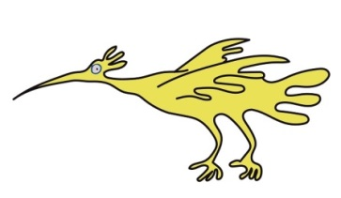
If the vomiting continues, please contact your GP out of hour’s telephone number or your nearest Accident & Emergency Department.

Who to contact if you have any worries

For appointments or advice from one of our doctors 0151 252 5538

For you GP to fax us something 0151 252 5533

Monday to Friday 07.00 - 20.00: Day Care Unit 0151 252 5557 / 0151 282 4509

Weekdays after 7.00pm or Weekends: Ward ___ 0151 252 ____

Medications:

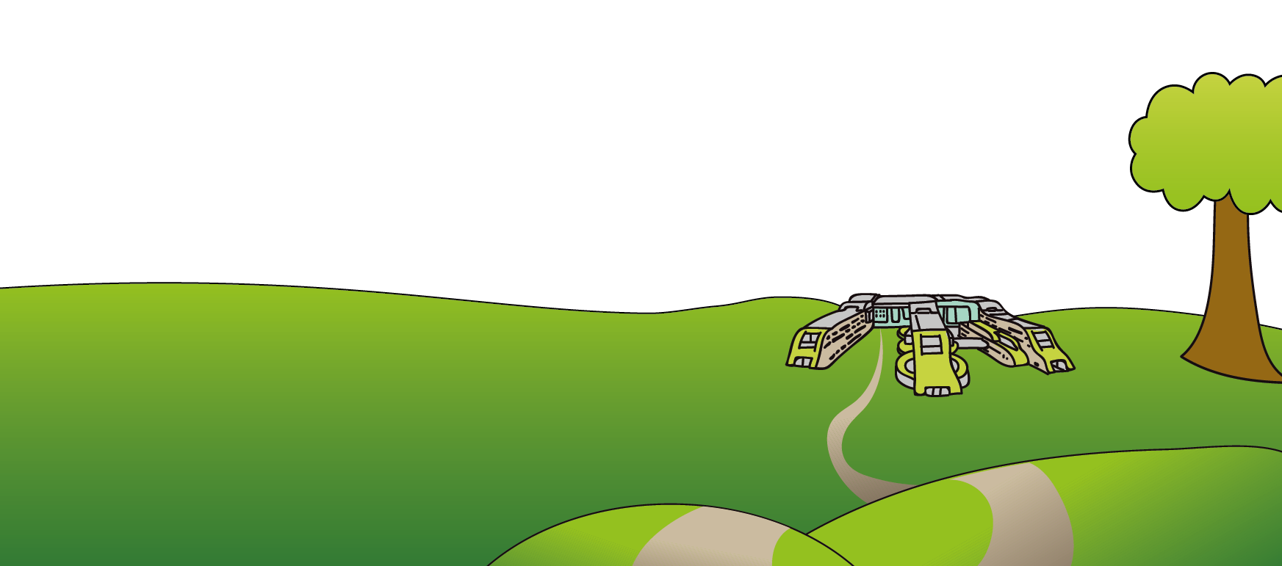
Post operative instruction:

This leaflet only gives general information. You must always discuss the individual treatment of your child with the appropriate member of staff. Do not rely on this leaflet alone for information about your child’s treatment. This information can be made available in other languages and formats if requested.
Alder Hey Children’s NHS Foundation Trust
Eaton Road
Liverpool
L12 2AP
Tel: 0151 228 4811
www.alderhey.nhs.uk
© Alder Hey Review Date: December 2024 PIAG: 61

