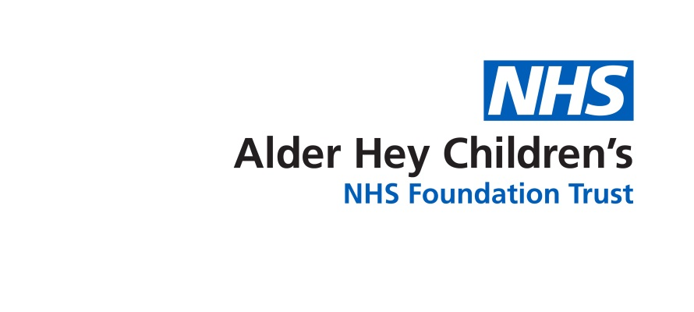

Safeguarding Service

**Safeguarding Procedures**

Information for parents and carers

**Introduction**

This leaflet aims to provide you with an overview of the safeguarding procedures when a health professional is concerned a child is being mistreated. We appreciate this can be a very difficult and stressful time for children and their families and we hope this information will be helpful.

**Responsibilities**

We all have a responsibility to make sure children and young people are safe and well cared for. If anyone has concerns about a child or young person being harmed or being exposed to harm, they have a duty to act on their concerns.

**Harm or Maltreatment**

Children and young people may be harmed or maltreated in a number of ways including: physical, emotional, sexual abuse and neglect.

**Health Professional Responsibilities**

Healthcare professionals have a legal duty to respond to any concerns they have which suggest a child or young person is being harmed or is at risk of harm. If a child or young person is considered to have been maltreated the health professional must follow the hospital safeguarding procedures and inform the specialist Safeguarding Team.

**The Safeguarding Team**

The Safeguarding Team at Alder Hey have expert knowledge in child protection and child abuse issues. The team consist of paediatricians (doctors who are specially trained in medical care for children) and specialist nurses. It may be necessary for the team to work with other professionals such as G.P’s Health Visitors, School Nurses, Children’s Social Care, Police or other professionals within the hospital.

**Medical Examinations**

When a medical examination by a paediatrician from the Safeguarding Team is required, the person with parental responsibility will be asked to give consent. In some cases a young person is able to give their own consent.

The paediatrician will take the lead role in examining the child and recommending if any further medical investigations are needed. This may include: blood tests, examination of the eyes, and a skeletal survey. A skeletal survey is when x-rays are taken of the skull, chest spine, pelvis, arms, legs, hands and feet.

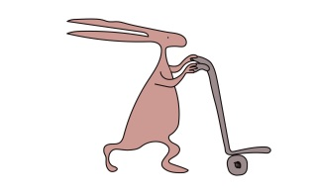In cases of suspected sexual abuse the medical examination will be done jointly with a Police Forensic Medical Examiner.

If it is necessary to have photographs taken, consent will be obtained from the parent /

guardian.

**Refusal of Consent**

If a parent or guardian refuses permission for the medical examination to take place, the Safeguarding Paediatrician must inform Children’s Social Care.

It is likely they will seek legal advice as the child’s welfare must come first. Children’s Social Care and the Police have a duty to think about the immediate safety of the child. They may seek an order from the court giving them permission to interview or examine the child without the parent / guardian consent.

The examination is only one part of the overall enquiry. It may not answer all the concerns, especially if the injuries happened some time ago or if the abuse has been going on for some time.

**Provision of Interpreters**

If English is not the first language of the child / parent / guardian hospital staff or Children’s Social Care will arrange for an interpreter. The interpreter will understand the child protection system and can be present at any meeting.

**Children and Young People’s Rights**

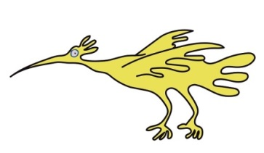All children, regardless of background, cultural and religious beliefs should be entitled to care which protects their welfare and keeps them safe.

**Rights and responsibilities**

Everybody has a right to:

* Be treated with respect
* Be given a clear explanation about what is happening and possible future actions.
* Have all decisions clearly explained.
* Be listed to and have their views taken into consideration.
* Offered appropriate advice and support.

**Contact details and feedback**

We would like to hear from you and would appreciate feedback on your experience of the Safeguarding Service. We may contact you for comments on your experience and suggestions for service improvement.

**Patient Advice and Liaison Service** Tel: 0151 252 5161.

**Social Worker name:** ................................... Contact number: .................................................

****This leaflet only gives general information. You must always discuss the individual treatment of your child with the appropriate member of staff. Do not rely on this leaflet alone for information about your child’s treatment. This information can be made available in other languages and formats if requested.

****Alder Hey Children’s NHS Foundation Trust

Alder Hey

Eaton Road

Liverpool

L12 2AP

Tel: 0151 228 4811

[www.alderhey.nhs.uk](http://www.alderhey.nhs.uk)

**© Alder Hey Review Date: September 2024 PIAG: 042**