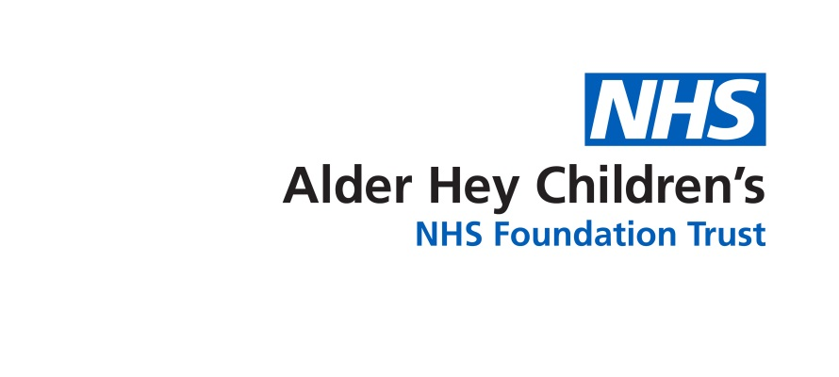

Divisions of Surgery and Medicine

**Risks Associated with Surgery During Pregnancy**

Information for Patients, Parents and Carers

**Risks associated with surgery during pregnancy**

The risk of miscarriage, ectopic pregnancy, stillbirth and birth defects *(see page 2 for what these terms mean)* are all higher in teenage pregnancies than in women in their 20’s. Anaesthesia and surgery in pregnancy may increase the risk of poor outcomes in teenage patients1.

Poor outcome may be due to the operation, the underlying illness, stress, fever, anaesthetic drugs or the body’s response to general anaesthesia (putting you to sleep).

**Risks to the patient**

The body starts to change early in pregnancy. This affects the way the body reacts to drugs and can increase complications with breathing while under anaesthetic. Changes to anaesthetic technique and drugs may be needed during pregnancy to reduce the risk of complications.

**Risks to the pregnancy**

There is an increased risk of miscarriage in patients who have had an anaesthetic and surgery during pregnancy. Reports range from 7.1% to 11.1% miscarriage rate1. Studies looking specifically at patients who have had surgery for appendicitis during early pregnancy have reported miscarriage rates of between 13.3% and 26%1.

**Risks to the baby**

There is an increase in very-low- and low-birth-weight babies born to women having surgery during pregnancy, due both to premature (early) birth and poor growth. Early infant death rate is also increased1.

**Birth defects***(see page 2 for what this means)*

Taking medication during pregnancy, particularly during the first 3 months should be avoided, where possible, as some drugs have been shown to damage unborn babies1.

Large studies of populations of pregnant women have not found an increase in rates of birth defects in babies of those who have had surgery during pregnancy1.

**Type of surgery**

Abdominal (tummy area) surgery does not appear to be more risky than other surgeries, although surgery for appendicitis during pregnancy is associated with a high rate of surgery-induced labour1.

**Our Recommendations**

• Aim to detect early pregnancies prior to exposing a patient to an anaesthetic or surgery.

• Avoid planned surgery during pregnancy and particularly during the first 3 months.

• Proceed with emergency surgery during pregnancy taking account of differences in the body’s reaction to anaesthetic drugs and additional risks of complications.

**Terms used in this leaflet**

**Miscarriage** – losing a baby in the early weeks of pregnancy.

**Ectopic pregnancy** – when a fertilised egg implants itself outside of the womb, usually in one of the fallopian tubes. The fallopian tubes connect the ovaries to the womb. If an egg gets stuck in them, it won’t develop into a baby and the health of the mother may be at risk if the pregnancy continues.

Illustration of female reproductive area

**Stillbirth** – when baby is born dead after 24 completed weeks of pregnancy

**Birth defects** - A problem that happens while a baby is developing in the mother's body. Most birth defects happen during the first 3 months of pregnancy. A birth defect may affect how the body looks, works or both. Some birth defects like cleft lip are easy to see, others like heart defects need special tests to identify what is wrong. Birth defects can vary from mild to severe. Some result from exposures to medicines or chemicals.

**Anaesthetic** – Medicine used during operations to make you unconscious (put you to sleep), and make sure you don’t feel any pain.

**References**

1. Pregnancy Testing Guidance: Risks Associated with Anaesthetic and Surgery in Early Pregnancy. <http://www.rcpch.ac.uk/system/files/protected/page/Pregnancy%20Checking%20supplementary%20paper%20-%20Review%20of%20risk%20of%20anaesthesia.pdf>



This leaflet only gives general information. You must always discuss the individual treatment of your child with the appropriate member of staff. Do not rely on this leaflet alone for information about your child’s treatment. This information can be made available in other languages and formats if requested.

Alder Hey Children’s NHS Foundation Trust

Alder Hey

Eaton Road

Liverpool

L12 2AP

Tel: 0151 228 4811

[www.alderhey.nhs.uk](http://www.alderhey.nhs.uk)

**© Alder Hey Review Date: May 2025 PIAG: 0011**