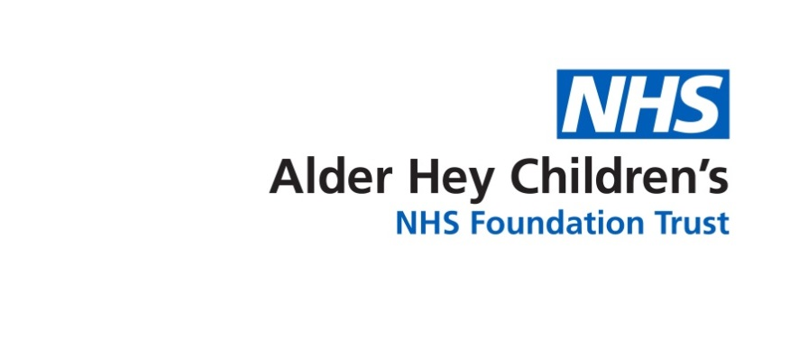

Alder Hey Clinical Academic Department

**Paediatric Rheumatology**

Information about our services for parents and carers



**Overview of the Department**

The Liverpool Clinical Academic Department of Paediatric Rheumatology is based at Alder Hey Children’s NHS Foundation Trust and the University of Liverpool, in the new ‘Alder Hey in the Park’ and ‘Institute in the Park’.

The department is recognised as one of the leading paediatric rheumatology units in the UK, providing the highest level of specialist care to children and young people across the region with an ever growing international profile. It was recently recognised by the European League Against Rheumatism as one of Europe’s outstanding “Centres of Excellence”, in close collaboration with adult rheumatology services here in Liverpool.

We are a major centre for paediatric rheumatology and musculoskeletal research, linking with all major rheumatology centres across the UK and internationally. Our team is trying to improve the care and understanding of rheumatic disorders in children and young people.

**Paediatric Rheumatology Department**

Our department is one of the largest paediatric rheumatology units in the UK. It provides the highest level of tertiary multi-disciplinary rheumatology expertise to children and adolescents in Liverpool, North Wales and the North West**.**

**UK’s First Ever ‘Centre of Excellence for Childhood Lupus’**

Since 2011 we were made the UK’s first ever “Centre of Excellence for Child hood Lupus” by LUPUS UK. LUPUS UK is the major UK charity supporting patients and their families with Lupus. This fantastic status was awarded to us as a result of the excellent clinical care and research we provide to help children with Lupus.

**UK’s First and only “Experimental Arthritis Treatment Centre for Children”**

The EATC4Children was created in 2014 following an award by Arthritis Research UK (now Versus Arthritis), along with the University of Liverpool, Alder Hey Children’s Charity, and Alder Hey Children’s NHS Foundation Trust. This national research centre, the only one of its kind, is tackling childhood arthritis and sight-threatening uveitis, and has dedicated work streams for children with painful metabolic, inflammatory or orthopaedic bone conditions, childhood lupus, childhood scleroderma, juvenile dermatomyositis, and childhood Behcet’s syndrome.

The EATC4Children aims to improve the health and wellbeing of children with these conditions by developing and testing better, safer medicines for children and young people. You can find out more about the EATC4Children by visiting our website [www.EATC4Children.co.uk](http://www.EATC4Children.co.uk) or following us on Twitter @EATC4Children.

**One of three National Centre’s of Excellence for Behcet’s Syndrome**

In 2012, three NHS National Centre’s of Excellence for Behcet’s syndrome were created in Liverpool, Birmingham and London. Alder Hey provides the paediatric arm of the Liverpool Centre linking closely to Aintree. The aims of the centres are to provide holistic and equitable care to children with Behcet’s syndrome, including appropriate, timely access to biologic drugs.

**Training and Education**

* **Departmental Education**

Our team are involved in teaching students. Teaching occurs during ward rounds, clinics and team meetings. Sometimes our patients are invited to assist the team with teaching others.

* **Trainee Rheumatologists**

Alder Hey is a main UK centre for training future paediatric rheumatology doctors and general paediatricians with an interest in rheumatology.

* **Multi-Disciplinary Team**

Our Rheumatology Department is a large team made up of different health professionals. Together, we emphasise the importance of working together to provide the best possible care.

Within the team there are consultants, nurse specialists, research nurses, physiotherapists, occupational therapists, pharmacists, psychologists, junior doctors, play specialists, secretaries, scientists and data managers.

**Clinical Excellence**

**Clinical Care in Paediatric Rheumatology**

We care for patients with severe chronic inflammatory conditions affecting joints, bones, muscles and tissues, as well as other body systems. Some of these conditions are life-long and can have an enormous impact on the child or young person, as well as the wider family. Many conditions can affect different parts of the body, which are rare and difficult to diagnose.

We work closely with other specialists at Alder Hey to provide accurate diagnosis. Treatments include a wide range of drugs and therapies provided by an expert team.

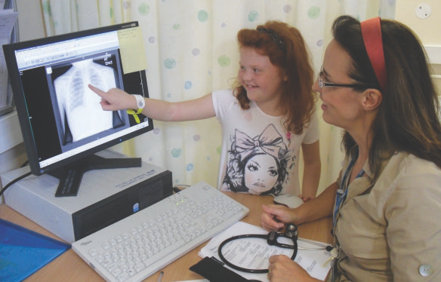

We believe that patients have a right to be involved in research and clinical trials to address gaps in knowledge that exist about their condition.

We are a leading clinical research department and provide all patients with this opportunity.

**Clinical Rheumatic Disorders**

Our department looks after children with conditions including:

* 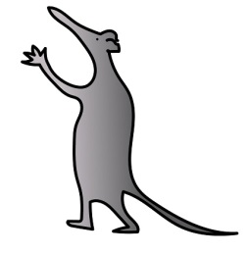Juvenile idiopathic arthritis
* Juvenile-onset systemic lupus erythematosus
* Juvenile dermatomyositis
* Childhood scleroderma
* Systemic vasculitis
* Behcet’s disease
* 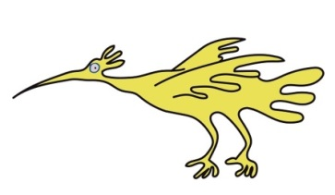Auto inflammatory disorders
* Periodic fevers
* Complex regional pain syndrome
* Chronic musculoskeletal pain syndromes
* Mechanical disorders affecting the musculoskeletal system

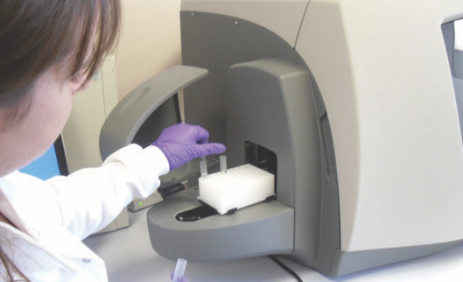**Clinical Research within the Department**

Our department is a world class centre of excellence for research into child and adolescent rheumatic diseases.

Each member of our team helps with research as we believe that it is an important part of our patients’ care.

**UKJSLE Study Group**

Alder Hey is the lead centre of the UK Juvenile-onset Systemic Lupus Erythematosus (JSLE) Study Group.

This group is exploring why Lupus occurs in children by collecting information about children with Lupus across the UK. Laboratory research also takes place in our dedicated laboratories.

**National and International research**

Our department works closely with all major research centres within the UK, along with international colleagues, to support research in paediatric rheumatology nationally and around the world.

**Overview of Current Research Activity**

The following information summarises just some of the current research taking place in our department.

**Research Portfolio**

Our department is active in a wide range of local and multi-centre collaborative research involving all members of the multi-disciplinary team.

**NIHR CRN: Children / Arthritis Research UK Paediatric Rheumatology Clinical Studies Group**

The Institute in the Park hosts the National Institute of Health Research (NIHR) Clinical Research Network (CRN) National Co-ordinating Centre for Children and supports the co-ordination of the UK’s Paediatric Rheumatology Clinical Studies Group. The group co-ordinates a UK wide programme of clinical trials and clinical studies across the entire spectrum of paediatric rheumatology.

Professor Beresford is the Brough Chair and Professor of Child Health at the University of Liverpool Honorary Consultant Paediatric Rheumatologist, Programme Director for Liverpool Health Partners ‘Starting Well’, Director of the UK’s ‘Experimental Arthritis Treatment Centre for Children,’ Chair of the  EULAR Paediatric Rheumatology Committee, and Executive member of the Paediatric Rheumatology European Society (PReS).

Professor Hedrich is Head of Department, Women’s and Children’s Health, ILCAMS, University of Liverpool, Associate Director of the UK Experimental Arthritis Treatment Centre for Children, Member of CARRA CRMO international work group and one of international leads, OMERACT CRMO interest group, Co-Chair for Europe

Dr Pain is the Co-Chair of NIHR CRN: Children / Arthritis Research UK Paediatric Rheumatology Clinical Studies Group, Associate Director of the UK Experimental Arthritis Treatment Centre for Children (Behcet’s and scleroderma workstreams) and UK PRINTO representative.

Dr Mahmood is a member of CARRA CRMO international work group and one of the international leads, and member of BSPAR Clinical affairs group.

Dr McCann is the Chair of the PReS JDM working party, member of Euromyositis Steering Committee (paediatric representative) and co-lead of British **Society of Rheumatology (BSR) myositis guideline group, developing NICE accredited UK guidelines.**

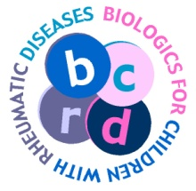**Biologics and New Drugs Registry**

Our department is one of the main contributors to the national registries, looking at the long term safety and effectiveness of new medication.

**Childhood Arthritis Prospective Study (CAPS)**

We are a major centre providing data to the Childhood Arthritis Prospective Study (CAPS) which looks at children who present with new onset of inflammatory arthritis.

**Juvenile Dermatomyositis Registry and Repository**

The work for this study includes collecting detailed clinical data and samples to help research. Our department has been involved with this study since it began. In addition, Dr McCann has led an international study developing a core set of data for children with JDM.

**British Paediatric Surveillance Unit national study of Behçet’s syndrome in children.**

This national study aims to understand how many children in the UK are affected with Behçet’s syndrome and how they are treated. It is led by Dr Pain.

**Clinical Trials in Paediatric Rheumatology**

Alder Hey is a major centre for clinical trials in children and young people with rheumatic disorders. The Department works closely with the NIHR Alder Hey Clinical Research Facility in providing excellent care for children participating in this research.

**Vision for the Future**

Our aims for the next five years include:

* Clinical excellence

To continue to work as a team to deliver world-class care to children, young people and their families within Alder Hey.

* Clinical and Basic Science Research

To continue to combine medical treatment with research to improve the care of children in the future.

* Expansion of services

To expand our team and allow others to learn from our excellent work.

* National and international collaboration

To continue to work closely with others across the UK, Europe and beyond to help all children with rheumatological conditions.

**The Clinical Academic Team**



**Consultants**

Dr Gavin Cleary

Dr Liza McCann

Dr Clare Pain

Dr Kamran Mahmood

Dr Beverley Almeida

Professor Michael Beresford

Professor Christian Hedrich

**Rheumatology Pathway Co-ordinator** 0151 282 4521

**Database Manager** 0151 282 4521

**Blood Clerk** 0151 282 4521

**Rheumatology Nurses**  0151 293 3556

**Chronic Fatigue/Pain Nurse Specialist** 0151 293 3544

**Lead Rheumatology Pharmacist** 0151 282 4811

(Mondays and Tuesdays via Pathway Co-ordinators)

**Occupational Therapists** 0151 252 5236

**Physiotherapists** 0151 252 5236

**Play Specialist** 0151 252 2027/2744

**Clinical Psychologists** 0151 252 5586/5879

**Extended Scope Practitioner** 0151 282 4811

(Via Pathway Co-ordinators)

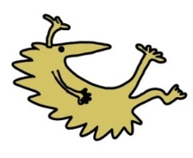If you would like further information about rheumatic disorders please visit our website at [www.alderhey.nhs.uk](http://www.alderhey.nhs.uk)

**Other useful contact details**

UK JSLE Cohort Study and Repository 0151 293 3566

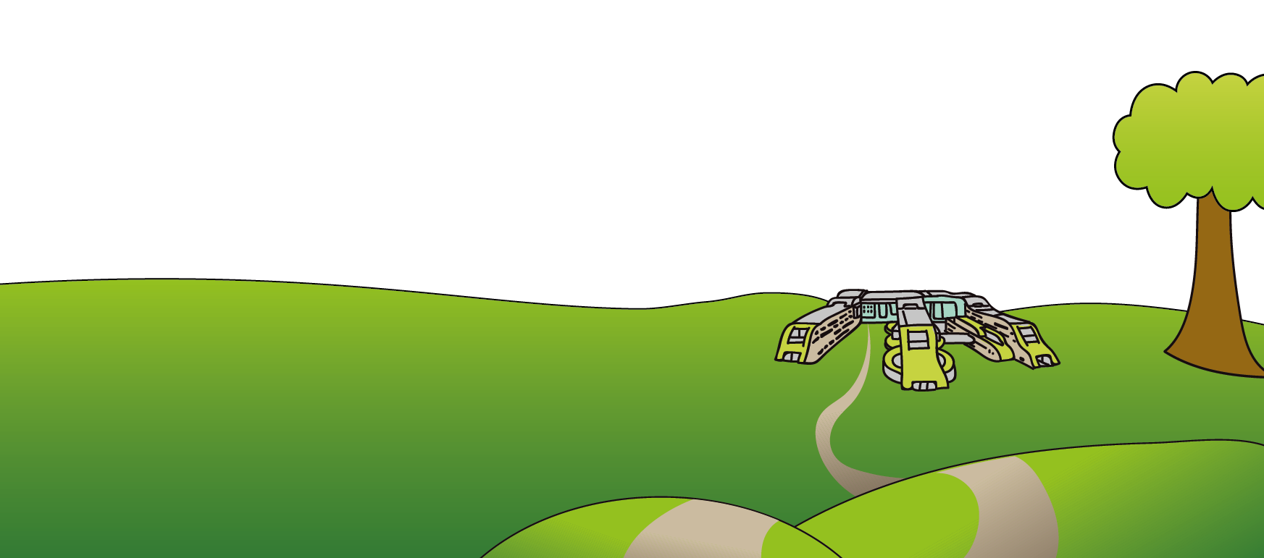This leaflet only gives general information. You must always discuss the individual treatment of your child with the appropriate member of staff. Do not rely on this leaflet alone for information about your child’s treatment. This information can be made available in other languages and formats if requested.

Alder Hey Children’s NHS Foundation Trust

Eaton Road

Liverpool

L12 2AP

Tel: 0151 228 4811

[www.alderhey.nhs.uk](http://www.alderhey.nhs.uk)

**© Alder Hey Review Date: April 2025 PIAG: 50**