This leaflet only gives general information. You must always discuss the individual treatment of your child with the appropriate member of staff. Do not rely on this leaflet alone for information about your child’s treatment.
This information can be made available in other languages and formats if requested.

Alder Hey Children’s NHS Foundation Trust
Eaton Road
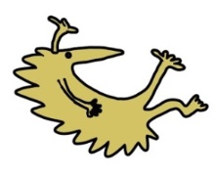
Liverpool
L12 2AP

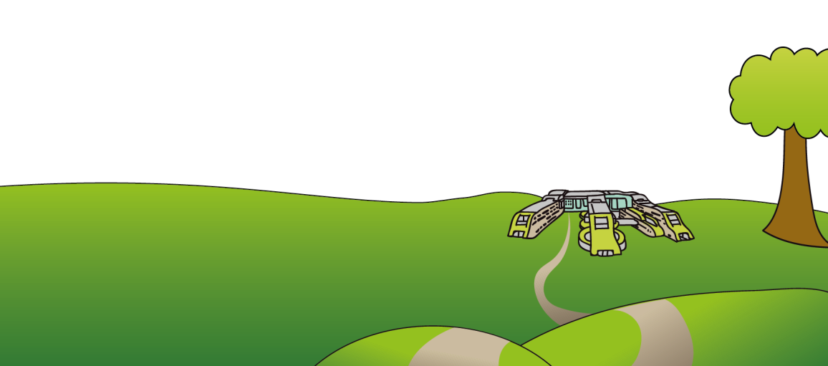
Tel: 0151 228 4811
www.alderhey.nhs.uk

© Alder Hey Review Date: July 2024 PIAG: 349

Returning to the Craniofacial Service

Information for patients

When can I see the Craniofacial Team?

You can re-access our service for craniofacial related care no matter how old you are.
How do you contact us once you have been discharged?
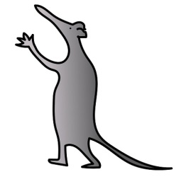
Ring the craniofacial team and explain that you are a returning adult that would like to be seen by the craniofacial team again.
In order to locate you on our system and access your records, the team member will ask you a few questions including what your name and date of birth is.
Then they may ask you why you would like to be seen by the craniofacial team. This helps us to decide if we are the best placed service to help your needs and that we book you into the most relevant clinic for your concerns.
If appropriate, you will be invited to attend an appointment with the team or a team member.
This is so we can discuss your current concerns in more detail and speak about how we might be able to help.

Why might I want to see the Craniofacial Team?
As an adult, you may want to access the craniofacial team due to:

- Concerns relating to your appearance
- Experiencing difficulties (e.g. speech, drinking, eating)
- Requesting a referral to the genetics team
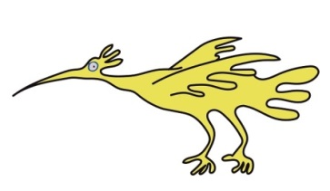

What if I move out of an area?
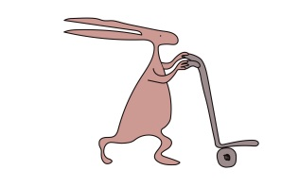
Please let us know if you move out of an area so we can refer you to a new craniofacial team.
Contact Numbers:
Alder Hey: 0151 252 5209
http://craniofacialuk.com/alderhey/

