Clinical Psychology for the Rhematology Team

Resources you might find useful

Information for children and young people

Living with a health condition can cause lots of different feelings, such as feeling sad, angry or worried.

We hear from young people that coming to hospital appointments, managing symptoms, needing to take medication and perhaps being admitted to hospital, are all tricky things to manage. We want you to know that you’re not on your own in feeling this way.

We’ve put together some downloads and links that children, young people and their families sometimes find helpful. Perhaps a member of the team has offered you this leaflet because they thought it might help. What do you think?

Sometimes, children and young people tell us that they would like to meet us in person to have a space away from the team, maybe even away from family, to talk about what it is like to have a health condition. The Rheumatology team would be happy to chat with you about this if you would like.

On this leaflet, there are links to lots of different topics. You might feel that some of them are not going to be useful to you, this is OK, maybe scroll through until you find something which might be.

If you feel that it would be helpful to discuss any of your needs (and/or any parental concerns) further, please contact the Rheumatology team in the first instance, who can discuss this with us should you agree to this.
Children and young people can struggle with different things, at different times. These web-sites have advice and techniques about lots of things, including managing feelings of low mood, anger, anxiety, and self-esteem for example.
http://www.getselfhelp.co.uk/
https://www.camhs-resources.co.uk/
http://www.moodjuice.scot.nhs.uk/

http://www.mymind.org.uk/thebox/

We hope you find this helpful,

Sally Bell & Marilena Hadjittofi
Clinical Psychologists

Clinical Health Psychology
Linked to the Rheumatology
Service
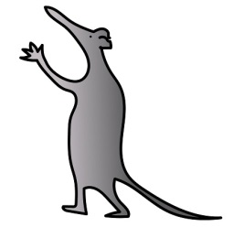
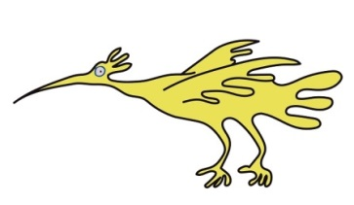
It can be difficult to know how to manage tricky thoughts and feelings if they show up for you.

Breathing and relaxation exercises
can help to reset what might be going on inside our bodies, which can help to bring about a sense of calmness. The internet has lots of audio and video clips….maybe try out the ones ones below…
Bubble Breathing https://www.youtube.com/watch?v=5DqTuWve9t8
Mini-meditation
https://www.youtube.com/watch?v=cEqZthCaMpo
Belly Breathing
https://www.youtube.com/watch?v=sn_2GY1gTyo
Muscle Relaxation
https://www.youtube.com/watch?v=JPrKsWgI66g

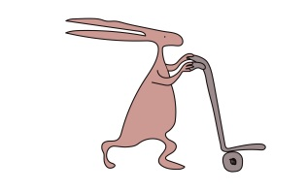
Feeling worried or anxious?
It is not uncommon to experience feelings of worry or anxiety. This could be linked to how you feel about your health condition, or might be caused by a number of other things…maybe school, your friends, or home life.
To understand more on axiety, and other tricky feelings, try this link;
https://youngminds.org.uk/find-help/conditions/anxiety/
Don’t forget the ‘get self-help’ website for advice around a range of difficulties as well

Sleep and feeling tired
For advice on chronic pain and
fatigue, try reading this online leaflet;
http://www.getselfhelp.co.uk/chronicfp.htm

This includes advice on pacing, goal setting and also talks about the role of our thoughts and feelings.

https://www.headspace.com/ Here
you can download an app to try some mindfulness exercises which might
also help with sleeping and feeling
calm. For more sleep tips, try https://www.mymind.org.uk/media/1488/mmb006_chillax.pdf or https://youngminds.org.uk/find-help/feelings-and-symptoms/sleep-problems/

Appearance

Does your health condition affect your appearance? If this is something which you would like support with, the changing faces website has some downloads you might find helpful. There are some around building confidence and feeling different you might like to look at.

https://www.changingfaces.org.uk/get-support/self-help-guides/children-young-people

Pain
When you have a health condition, it is not uncommon to experience pain. We have found a you tube video explaining about pain with ideas for ways to manage this;
https://www.youtube.com/watch?v=C_3phB93rvI

https://www.parksmed.co.uk/wp-content/uploads/2013/09/Pain-Toolkit-for-teenagers.pdf

This resource above has information, tips and skills, to help you understand and manage chronic pain.

The ‘Unwelcome Party Guest’
Sometimes, young people tell us, that no matter what they might be struggling with, they wish that it would just ‘go away’. Below, is a video clip all about an unwelcome guest at a party. Maybe play this clip, and imagine that ‘Brian’ is playing the part of something you struggle with; pain, fatigue or anxiety for example.
https://www.youtube.com/watch?v=VYht-guymF4

This leaflet only gives general information.
You must always discuss the individual treatment of your child with the appropriate member of staff.

Do not rely on this leaflet alone for information about your child’s treatment.
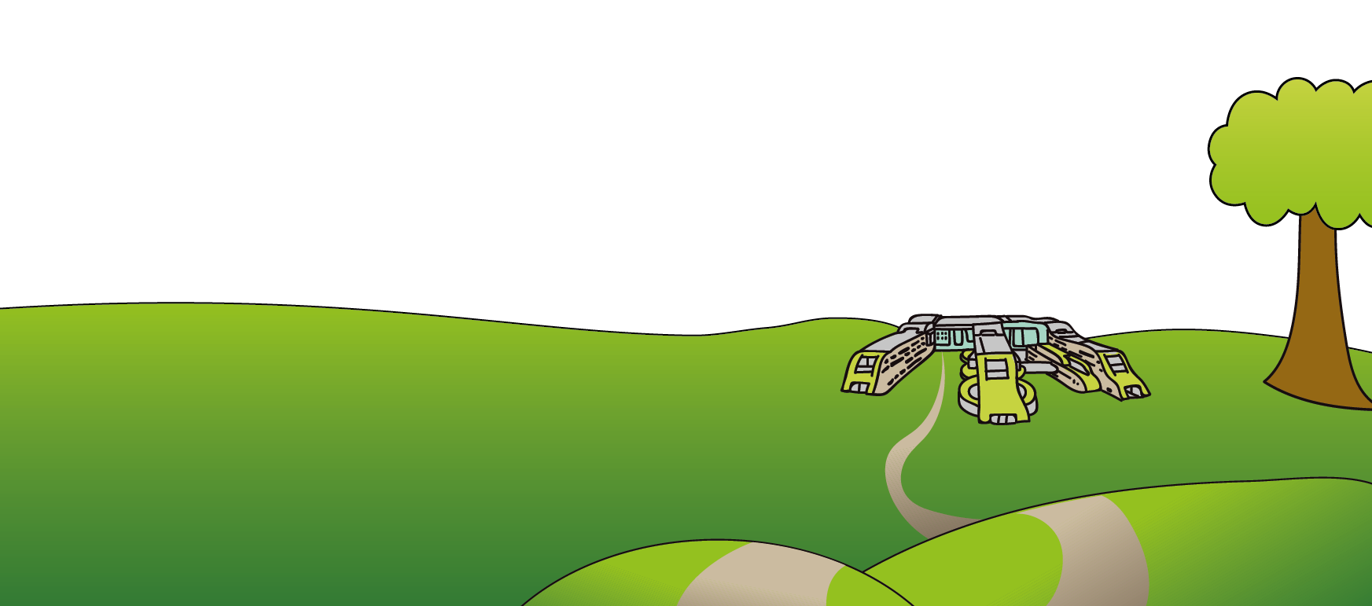
This information can be made available in other languages and formats if requested.

Alder Hey Children’s NHS Foundation Trust
Eaton Road
Liverpool
L12 2AP

Tel: 0151 228 4811
www.alderhey.nhs.uk
© Alder Hey
Review Date: May 2024
PIAG: 55

