Day Care Unit

Removal of metal work

Information for parents and carers

Introduction

This leaflet aims to provide you with information about how to care for your child once you are at home.

Most children appear to be alert and active after they are discharged from hospital. However do not be surprised if your child complains of feeling dizzy or being tired. Your child may feel dizzy and unco-ordinated for the next couple of days.

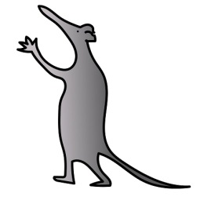
For the next 24 hours
- You should encourage your child to rest.
- You should make sure your child’s activities are supervised by a responsible adult.
- Do not let your child ride a bike.
- Do not let your child take part in outdoor activities.
- Do not give your child fizzy drinks.
- Do not give your child hard food to digest foods such as chips, burgers.

Your child may experience a sore throat, hoarseness, muscle ache or pain following an anaesthetic.
You can give your child Paracetamol, unless you are told otherwise by a doctor or discharging nurse.
Do not exceed the recommend dosage for your child’s age.
All advice regarding medicines will be given to you when your child is discharged

What to do if your child starts to vomit

If your child vomits on the way home or when you get home, do not be alarmed. Do not give your child anything to eat or drink for one hour. After that you can start giving your child a small amount of water or juice. Then gradually start to increase the amount of fluid you give to your child. Once your child can keep fluids down you can begin to give them a light diet.

If the vomiting continues please contact your GP out of hour’s telephone number or your nearest Accident & Emergency Department.

Caring for your child at home
You will be given further post-operative information to help you care for your child when they discharged.
Please remember to keep the wound clean and dry as advised by staff.

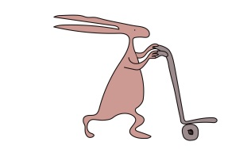
Bring your child to the Accident and Emergency Department if:
- Your child feels a burning sensation
- Your child’s nail or skin changes to blue/purple
- Your child feels persistent pain even after they have been given pain killers.
Do not exceed the recommend dosage for your child’s age.
- Your child’s fingers/toes become swollen. If this happens, raise the area operated on.
- There is an unusual coldness of your child’s fingers/toes.
Who to contact if you have any worries

Please contact the Day Care Unit for advice by telephoning:
0151 252 5480 Monday to Friday 7.00am – 7.00pm

If you have any problems at any other time please contact
Ward 4A - 0151 252 5578

This leaflet only gives general information. You must always discuss the individual treatment of your child with the appropriate member of staff. Do not rely on this leaflet alone for information about your child’s treatment.
This information can be made available in other languages and formats if requested.

Alder Hey Children’s NHS Foundation Trust
Alder Hey
Eaton Road
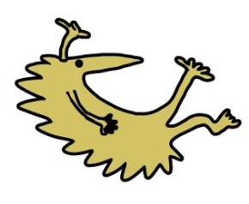
Liverpool
L12 2AP

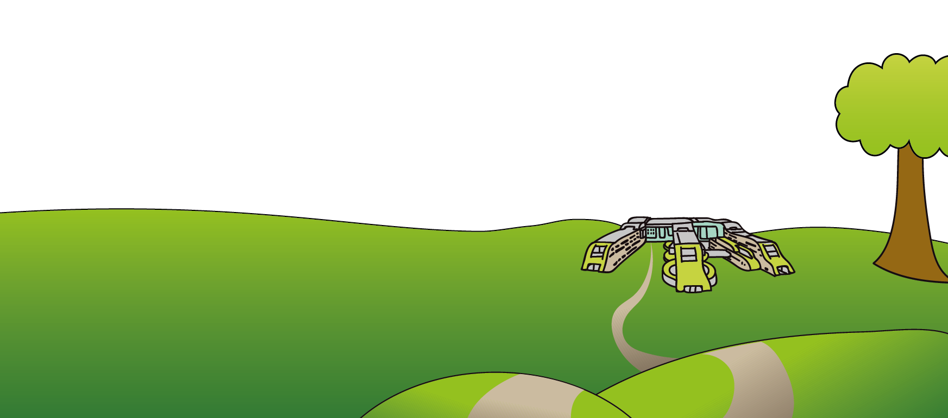
Tel: 0151 228 4811
www.alderhey.nhs.uk

© Alder Hey Review Date: March 2025 PIAG: 001

