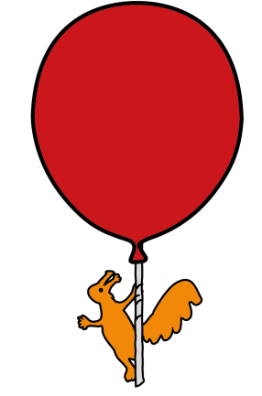


Department of General Surgery

Rectal Washouts

Information for Parents & Guardians

Introduction
This leaflet aims to teach parents how to perform rectal washouts safely on their child. It explains the reasons for the treatment, the equipment involved, how to do the procedure, and how to deal with any problems, including who to contact. If you have any further questions, please speak to a doctor or nurse caring for your baby.
What is a rectal washout?
A rectal washout involves passing a flexible tube (NG tube) into your baby’s bottom and up into their bowel. The bowel is then flushed with a warm saline to clear out any faeces (poo).
Why is it necessary?
Your baby’s surgeon has decided that your baby requires rectal washouts to help your them empty their bowels of poo. This is to make sure your baby does not become sick if they can not empty their bowels completely by themselves.
If successful, regular rectal washouts can keep the bowel empty so that the next stage of treatment can take place several weeks later. Your baby’s surgeon will discuss this with you.
Before going home, the nurses will teach you how to perform the rectal washout on your baby and you will be given time to practice.
Where should I carry out the rectal washout?
You can carry out the procedure wherever suits you, for example on a changing table, or in the cot. The environment must be warm as your baby will be undressed.
What equipment do I need?
- changing mat, incontinent sheets or towel.
- warm saline
- two bowls

- syringe
- NG tube (rectal tube)
- lubricating gel
- disposable bag
- clean nappy and baby wipes.
How and when do I do the rectal washout?
The timing of the washout is up to you. It should not be painful but your baby may become upset, so having a comforter may help to settle them. Stop the procedure and seek medical advice if your baby becomes very distressed and appears to be in pain.
- Warm the saline by placing the bag / bottle unopened in a jug of hot water. The temperature of the saline should be body temperature (37ºC).

- Gather everything you need. (see above)

- Carefully open the saline and pour it into a bowl. Test the temperature of the saline as if you were testing the temperature of bath water.

- When ready to begin, undress your baby leaving a vest on. Remove your baby’s nappy.

- Look at and gently feel your baby’s tummy. Any swelling should go down during the procedure with the release of air and bowel contents.

- Wrap your baby in a towel leaving their bottom exposed and lay them on the surface you have chosen, for example a changing table.

- Draw up the saline in a syringe. Syringe the saline into the tube until the tube is full of saline. This will prevent air going into the bowel when you start the washout.

- Add lubricating gel to the tip and first couple of centimeters of the tube to aid insertion.

- Lay your baby on their back with their legs raised, or lay your baby on their left side.

- Gently insert the tube as far as instructed (see table below).

- Holding the tube in place with one hand, gradually push in the saline with the syringe, over one to two minutes.

- Leave the tube in place, remove the syringe and let fluid run out of the tube into the bowl or nappy. The bowl ideally should be lower than the baby’s bottom to aid drainage.

- Gently massage your baby’s tummy. This helps the fluid and any wind to be removed.

- If the tube has come out, reapply some gel and reinsert. Refill the syringe and repeat the procedure using the correct amount of saline.

- Gently withdraw the tube while massaging your baby’s tummy.

- Look at and gently feel your baby’s tummy, which should now look flatter and feel soft.

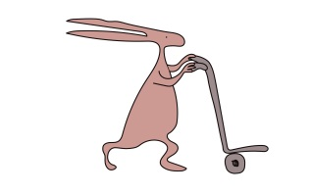
- Also look at the colour, consistency and smell of the poo.

- Signs of infection can include:

  - offensive smell
  - unusual colour
  - Watery consistency or blood in the stool.

- If there are any of these signs, or your baby’s tummy remains swollen and tense, or your baby appears unwell, please ring for advice (contact details at the end of this leaflet).

- Wash and re-dress your baby, making sure they are warm.

- Wash all of the equipment in hot soapy water, preferably in the bathroom. Allow to dry and store ready for the next use. A new NG tube and a new bag of saline should be used daily.
Are there any specific instructions or equipment?
Frequency of washout
Size of tube
Approximate length to be inserted
Total amount of saline to be inserted (mls)

What should I do if I have a problem?
Problem | Action | Contact
Difficulty passing tube to suggested length. | - Don’t try to force the NG tube in.  - Change baby’s position on to their side.  - Try again in 30 minutes.  - Use smaller amounts of fluid to release wind. | If you are still unable to insert the tube after trying these actions, seek medical advice (contact details at the end of this leaflet).
Saline does not drain out after washout. | - Check to see if the tube is blocked  - Gently turn the tube when removing it.  - Rinse the tube.  - Change baby’s position.  - Check nappy after to see if saline has passed. | 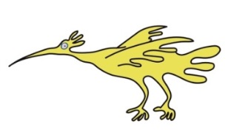  If problem persists, seek medical advice.
Washout produces no poo. | - Repeat washout in a few hours.  - Baby may pass poo unaided. | If the tummy remains swollen, or your baby is vomiting (being sick), seek medical advice immediately.
Bleeding from the bottom. | - Tube may have caused irritation to bottom when being inserted. | If it is only a small amount of blood, you do not need to do anything. However, if bleeding continues seek medical advice.
Baby passes poo unaided. | - It is difficult to know if baby has passed enough poo. | Do not miss washouts without guidance from medical staff.

Going home
Before going home, you should have had the rectal washout demonstrated to you, and had the chance to practice the procedure on your baby. How the procedure may affect your baby, the potential problems which may happen and how to deal with any problems, should all have been discussed with you.
Please sign below to confirm that you have had the procedure demonstrated to you, that you have had the opportunity to practice, and that you now feel confident and competent to carry out rectal washouts on your baby at home. Please make sure that any questions you have, have been fully answered.
Parent / carer’s signature ....................................................... Date ………….................................
Print Name ......................................................................................................................................
Practitioner
Please sign to indicate that the parent / carer has been taught how to perform the rectal washout, and demonstrates competency and safety.
Practitioner signature ............................................................ Date ................................................
Print name .......................................................................................................................................
You will need to have registered your baby with a GP so that an order can be placed for the equipment required at home. This will be provided by a supply company who will liaise with the baby’s GP, and deliver to your home.
Discharge Checklist
 | Date | Signature
7 x NG Tube
7 x 50ml syringes
Lubricating jelly
0.9% Sodium chloride 25ml bags 1 box

Will my baby have a follow-up appointment?
An appointment will be sent to you to come back to see the surgeon in the outpatient department. We may also arrange for you to come back to the ANP led clinic to be seen.
The GP, health visitor and paediatric community team will be informed of your baby’s discharge home.
Further sources of information
Hirschsprungs and Motility Disorders Support Network (HMDSN), www.hirhirschsprungs.info
info@hirschsprungs.info
Contact us
If you have any questions or concerns, please contact the Surgical secretaries via switch board Tel: 0151 228 4811.

Alternatively, Ward 3A General Surgery 0151 252 5416.

This information has been adapted from patient information produced by Evelina London
This leaflet only gives general information. You must always discuss the individual treatment of your child with the appropriate member of staff. Do not rely on this leaflet alone for information about your child’s treatment. This information can be made available in other languages and formats if requested.
Alder Hey Children’s NHS Foundation Trust
Eaton Road
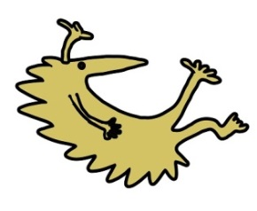
Liverpool
L12 2AP

Tel: 0151 228 4811
www.alderhey.nhs.uk

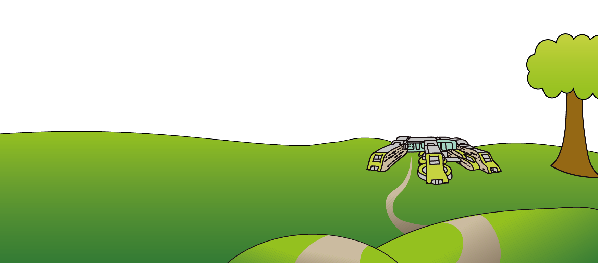

© Alder Hey Review Date: October 2028 PIAG: 315

