Infection Prevention and Control Department

Respiratory Syncytial Virus – RSV

Information for parents and carers

Introduction

This leaflet is aimed at providing parents and carers with information about RSV (respiratory syncytial virus)

What is RSV?

RSV is a common respiratory virus which causes cold-like symptoms in most children before they are two years old.

It affects up to one in three babies between the months of November and March. The virus exists all year round.

What causes this condition?

RSV causes the tiniest air passages in children’s lungs to become swollen and full of mucus. This can make breathing and feeding more difficult for some children.

What are the signs and symptoms of RSV?
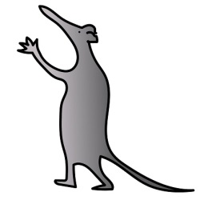
Minor symptoms include:

- runny nose,
- cough
- Mild fever.

Serious symptoms include:

- difficulty in breathing,
- wheezing,
- irritability
- Restlessness.

Sometimes RSV may cause very small children to have brief pauses in their breathing.

The period of breathlessness and poor feeding may last for several days but the cough can last for several weeks.

Can I prevent my child from getting RSV?

RSV is very difficult to prevent in small children and it also causes coughs and colds in older children and adults. It is infectious and can be picked up through close contact or from touching their surroundings

What steps can I take to reduce the chance of my child getting RSV?

One of the most important things that you can do to prevent the spread of RSV is to wash your hands before and after touching your child.

Your child’s close surroundings and toys should be kept clean.

Member of the family or friends must not visit your child in hospital if they have any cold-like symptoms as they may infect other children.

What treatments are available?

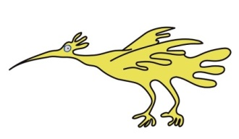
Minor cases of RSV usually resolve within seven to ten days. If your child’s symptoms are more severe then treatment such as an oxygen mask/nose tube to help your child’s breathing, medication for fever and fluid therapy may be given. A nasal gastric tube may be passed through the nose and into their stomach to help with feeding.

RSV is caused by a virus so antibiotics won’t help. Antibiotics may be given
if your child develops a secondary bacterial infection.

What are the next steps?

A single swab to the back of the nose will be taken if RSV is suspected. This will not hurt your child and confirmation of the infection will usually take only a few hours after the swab has been taken. To prevent the virus spreading your child will be nursed in a separate room or bay with our children with the same infection .Staff treating your child will wear apron and gloves.

Will RSV have any long term effects on my child?

Most children recover well from RSV and do not have long term breathing problems. Some children who have had RSV can remain mildly wheezy at times for several months after the illness.

Where can I get further information or support?

Please contact the Infection Prevention and Control Team on: 0151 255 5485

This leaflet only gives general information. You must always discuss the individual treatment of your child with the appropriate member of staff. Do not rely on this leaflet alone for information about your child’s treatment.
This information can be made available in other languages and formats if requested.

Alder Hey Children’s NHS Foundation Trust
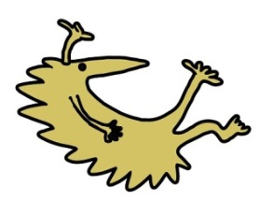
Alder Hey
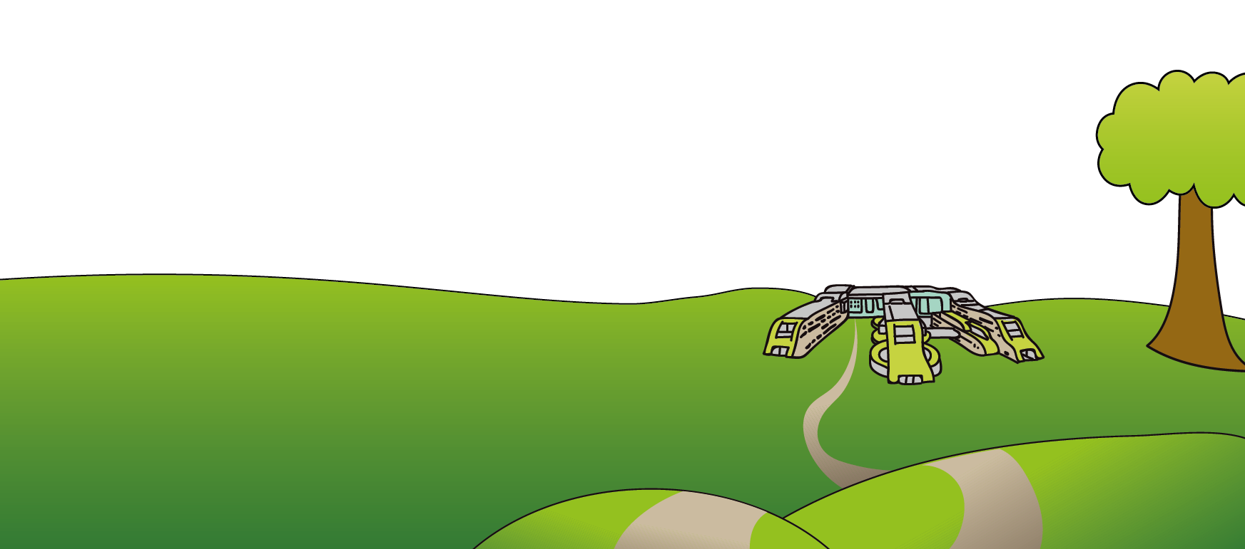
Eaton Road
Liverpool
L12 2AP

Tel: 0151 228 4811
www.alderhey.nhs.uk

© Alder Hey Review Date: May 2024 PIAG 44

