
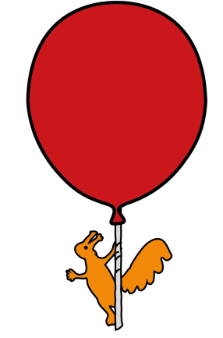

What is a pulled elbow?
Emergency Department

Pulled Elbow

Information for parents and carers

A pulled elbow is a fairly common minor injury generally affecting children under the age of 5 years.

At the elbow three bones join to form a hinge. There is a loop of ligament around the narrow ‘neck’ of one of these bones. In adults the head of this bone is shaped like a mushroom, so the ligament cannot be pulled over the head. Young children also have the loop of ligament, but the head of the bone will not have developed fully into its mushroom shape yet. This means that sometimes, when a child’s elbow is stretched the bone gets stuck in the loop of ligament.
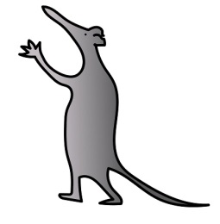
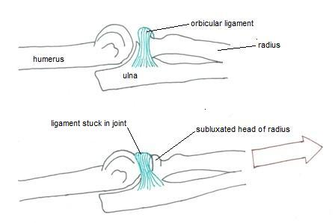
What causes a pulled elbow?

Pulled elbows happen because young children’s joints are not completely developed and the ring shaped ligament is looser at this age. Any sudden pulling, lifting, jerking or swinging of the child’s hand or forearm may cause it to slip.

What are the symptoms?

If your child has had a sudden pull or jerk to its arm, your child may be in sudden pain, may cry and appear anxious and be unable to fully bend their elbow. Your child will be reluctant to use its arm, which may hang loosely at their side or across their tummy.

How is it diagnosed?

The healthcare professional will diagnose a pulled elbow from hearing how it occurred and by examining your child’s arm. An x-ray is not normally necessary because there is no break and no dislocation with a pulled elbow injury. Young bone is not yet completely developed and so we are unable to see it or the ligament on an x-ray.
How is it treated?

Initially your child may be given simple pain killers such as paracetamol or ibuprofen. Your child’s forearm will then need to be moved in a particular way to manipulate the head of the radius bone back into the ligament. This is a quick and simple manoeuvre, but may cause a brief moment of discomfort. Often a click is felt as the bone slips back into position. Shortly after this your child should start to use their arm normally, especially if distracted by playing with a toy.

Occasionally this manipulation is not successful. If this is the case it is possible that an x-ray will be performed to rule out any other possible diagnoses, before repeating the manoeuvre.

Are there any alternative treatments?

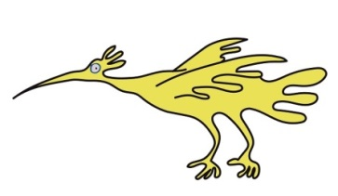
Your child does not have to have their arm manipulated. However, if your child’s arm is not treated there will be a longer recovery period.

Are there any possible complications?

There are no risks involved in the treatment.

If you have any concerns that your child’s arm has not recovered within 2-3 days you should either return to the Emergency Department for a further examination, or make an appointment to see your GP.

How to prevent this from happening again.

- Avoid lifting or pulling your child by the hands, wrists or forearms.
- Avoid swinging your child around by the wrists or forearms.
- Use upper arms or arm-pits to lift or swing your child.

This leaflet only gives general information. You must always discuss the individual treatment of your child with the appropriate member of staff. Do not rely on this leaflet alone for information about your child’s treatment.

This information can be made available in other languages and formats if requested.

Alder Hey Children’s NHS Foundation Trust
Alder Hey
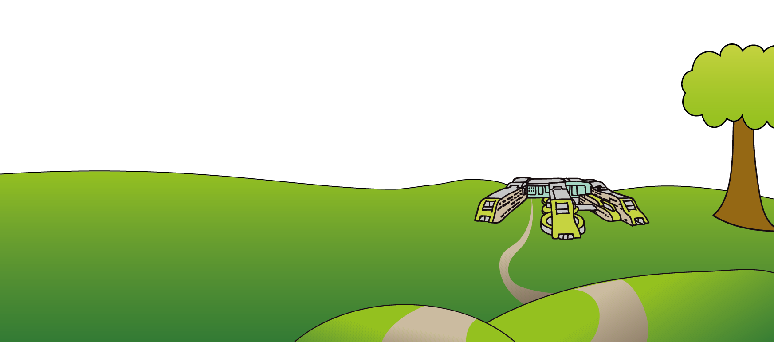
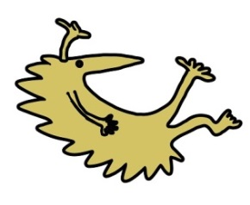
Eaton Road
Liverpool
L12 2AP

Tel: 0151 228 4811
www.alderhey.nhs.uk

© Alder Hey Review Date: September 2027 PIAG: 74

