This leaflet only gives general information. You must always discuss the individual treatment of your child with the appropriate member of staff. Do not rely on this leaflet alone for information about your child’s treatment.

This information can be made available in other languages and formats if requested

Alder Hey Children’s NHS Foundation Trust

Eaton Road

****Liverpool

L12 2AP

****Tel: 0151 228 4811

[www.alderhey.nhs.uk](http://www.alderhey.nhs.uk)

**© Alder Hey Review Date: March 2028 PIAG: 388**



**Department for Clinical Health Psychology**

**Feeling Nervous About Hospital Procedures**



**Information for patients, parents and carers**



**Introduction**

Lots of people can feel a bit nervous if they have to have a hospital procedure. For you, this might be a blood test, an x-ray, surgery or something else.

Some people may have had a difficult experience in the past. For example, where a procedure might have hurt, or they cried and now they feel nervous about having more procedures in the future.

If they feel nervous all the time it may become a bit of a problem for them. Some people feel scared, even just being reminded of the procedure, or thinking or reading about it. They might worry about what will happen or feel anxious that the procedure might be uncomfortable or hurt.

**What does it feel like?**

When we are worried about something like a hospital procedure we might notice…



· Our heart beating fast

· Finding it difficult to breathe

· A tummy ache

· Feeling hot and sweaty

· Feeling faint and dizzy

· Having scary thoughts

· Crying

· Needing the toilet

· Wanting to run away

These feeling come from our brain and body and are normal. It’s our body’s way of telling us we’re feeling scared or worried about something—even if we don’t need to be!



They are automatic feelings. This means, while they can feel tricky and uncomfortable, they are normal responses. They can feel uncomfortable, but they are not dangerous, and they will go away eventually.

**What might people do when they are nervous?**

These feelings might make you want to avoid the hospital procedure that you need to have done.

The problem is that not having the procedure could prevent you from getting better or could even make your illness worse. That’s why it’s important to know what can help you feel better when you feel nervous. And it’s important to tell other people (like our mums, dads, siblings, doctors, nurses and teachers) if you are feeling nervous.

**Coping with worry**

There are lots of things we can do to help us feel less worried. We can teach our brain and bodies to understand that these procedures are not so bad after all.

Here are some things that you could try:

**1) Time**

Give yourself plenty of time when going to the appointment for your procedure. If you, the nurse or the doctor is rushing, it will make everyone feel more stressed and nervous. You can also tell whoever is doing the procedure that you are nervous so that they know that they need to put more time aside for you.

**2) Understanding**

If you have any questions about your procedure, like what it will involve or why it will be done, it can be helpful to ask your medical team. Having a better understanding of what is going to happen will help you feel less worried.

**3)The past**

If you have had procedures in the past that went well, you could think about what you used to help you cope with it. Could you use something like that again?

**4) Playing**

The hospital has play specialists who can meet you before your procedure. the procedure. They can help you understand the procedure in a fun way. For example, you could practice the procedure together on a toy. You could look at needles and syringes to see what they look like and get used to them.

**5) Distraction**

Thinking about and doing other things can help to take your mind off of your procedure. Some things you try are:

· Colouring or playing with Play-Doh

· Reading or having someone read to you

· Playing with your toys

· Blowing bubbles

· Watching videos

· Talking to people around you

**6) Relaxing**

One of the ways we can help ourselves relax is by using breathing techniques. When we feel worried, we tend to breathe very fast which can make us feel dizzy.

One way to stop us doing this is to breathe deep breaths from our tummy instead of our chest.

We can imagine a balloon in our tummy that we are blowing up and deflating every time we breathe in and out. It’s helpful to practice this before your procedure so that it’s easier to use when you need it.

You could also try box breathing! (See below)

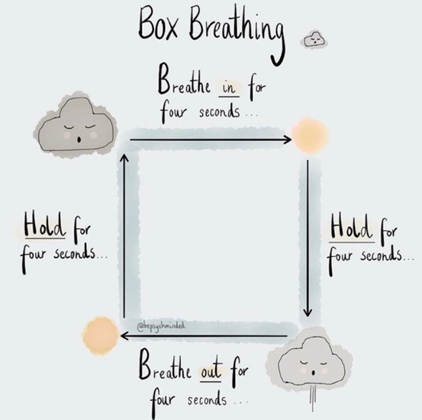

**7) Talking to others**

Sometimes when we feel anxious it can be helpful to meet with a person who works as a play specialist or clinical psychologist. These are adults who can talk to you about how to beat your anxiety and will answer questions you have.

Remember-there is nothing to feel embarrassed about if you are worried about a procedure. It is a very common fear (even in adults) and you are not alone.

Leaflet produced by the Clinical Health Psychology team at Alder Hey Children’s Hospital.

Email: ClinicalHealthPsychology@alderhey.nhs.uk

Telephone: 0151 252 5586