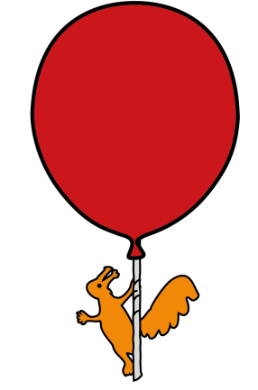
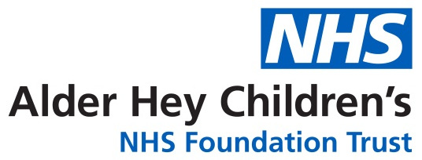
Urology Department
Preputioplasty for Balanitis Xerotica Obliterans
(BXO) in Children
Information for boys, parents and carers

What is this leaflet about?
BXO is a scarring condition of the foreskin that affects less than 1 in 100 boys. We do not know why it occurs, but a similar condition can also affect the genitalia of girls.
What does BXO do?
BXO usually causes the foreskin to become thickened and it’s opening to be narrowed. As a result of this, the foreskin cannot be pulled back (retracted). BXO can also affect the ‘head’ of the penis (the glans) and this can cause the opening that urine passes through (urethral meatus) to become narrowed, so called meatal stenosis. Narrowing of both the foreskin opening and the urethral meatus can cause difficulty in passing urine.
How is it treated?
Mild forms of BXO can be treated by cream or ointment that contain steroids. Your son may have already been treated by this method. When BXO is more severe, it needs an operation to treat it.
Traditionally a circumcision was used in all boys who required surgery for BXO. In a circumcision, the foreskin is permanently removed. More recently, a technique called ‘preputioplasty and injection of steroids’ has been offered as an option that keeps the foreskin.
During a preputioplasty, the foreskin is preserved and the opening is made wider so it can be pulled back over the glans. At the same time, an injection of strong steroid medicine is given into the skin to treat the BXO itself.

Which operation is best for my son?
Currently we do not know the answer to this question.
Recent studies found that most boys (about 8 out of 10) treated with preputioplasty and injection of steroids have a good result and avoided circumcision.
However, about 2 out of 10 boys treated with preputioplasty and injection of steroids required a repeat procedure or a circumcision within 1-2 years.
One study showed that boys who underwent preputioplasty appeared to have a lower likelihood of needing surgery for meatal stenosis (6%) compared to those who had been circumcised (19%).
What does the operation involve?
The operation of preputioplasty and injection of steroids involves widening the opening of the foreskin by putting 2-3 cuts in the edge and then injecting some strong steroid medicine directly into the skin.
The operation is usually performed when your son has had a general anaesthetic, as it would be too uncomfortable to perform with your son awake.
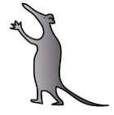
After the surgery the foreskin always looks very swollen but the opening is wider and your son should be able to pass urine easily despite the swelling. The swelling goes down after a week or so.

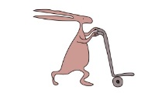
Some boys are found to have meatal stenosis at the time of the operation. Your doctor may advise a further operation to widen the meatus at the same time. The doctor will tell you about this if they think that your son may need it.
Are there any ‘down-sides’?
There are some risks of the surgery itself that you should consider.
1. There is a small risk of bleeding or infection, this occurs in less than 1 in 50 cases. The risk is lower than for circumcision.
2. After the swelling from the surgery has settled, it is very important that the foreskin is pulled back over the glans regularly, we advise boys to do this at least 3 times per week, but ideally every day.
If this is not done, there is a higher risk that the foreskin opening will become tight again and your son may need more surgery. This surgery may be a repeat preputioplasty or a circumcision.
3. There is a chance of your son developing metal stenosis after the surgery. This risk seems to be higher after a circumcision than after preputioplasty and injection of steroids. About 1 in 10 boys may need surgery to widen the urethral meatus after a preputioplasty.
4. The opening of the foreskin will be uneven after the surgery, For most boys this is only seen during foreskin retraction and does not cause any concern.
However, some boys find the cosmetic appearance of the foreskin to be unsatisfactory and sometimes they will chose to have the foreskin removed (circumcision) as a result. This would mean they need a further operation.

This leaflet only gives general information. You must always discuss the individual treatment of your child with the appropriate member of staff. Do not rely on this leaflet alone for information about your child’s treatment.
This information can be made available in other languages and formats if requested.

Alder Hey Children’s NHS Foundation Trust
Alder Hey
Eaton Road
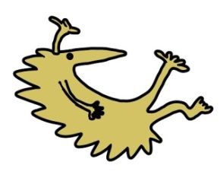
Liverpool
L12 2AP
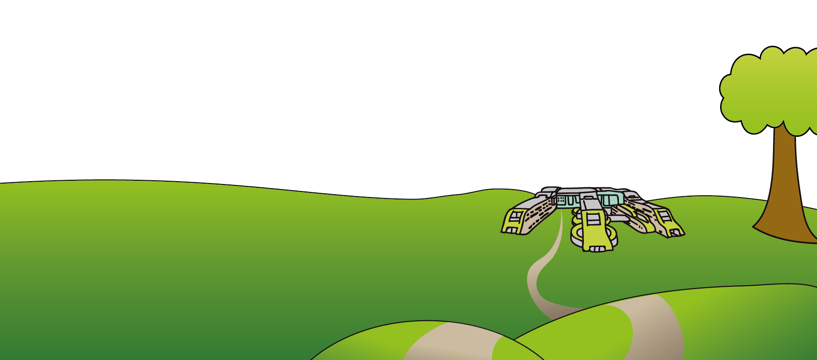
Tel: 0151 228 4811
www.alderhey.nhs.uk

© Alder Hey Review Date: August 2029 PIAG: 101

