
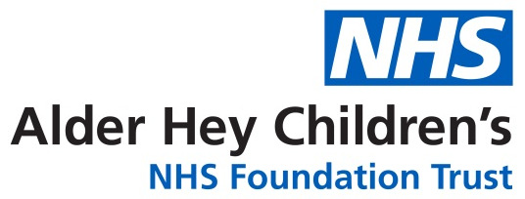

Oncology/ Haematology Unit

Pregnancy testing before cancer treatment

Information for girls and young women

Introduction

This leaflet aims to provide information about the reasons why pregnancy testing is important for girls and young women who are about to receive chemotherapy treatment.
Why it is important you tell us you might be pregnant?

If you are pregnant when you have treatments for cancer (which may include chemotherapy, radiotherapy, surgery, scans/x-rays), it may harm your unborn baby. This is especially true at the beginning of a pregnancy, when you might not realise you are pregnant. There is also a chance of you having a miscarriage (losing the baby).
The treatment you have been prescribed is very important for the management of your cancer. If you are pregnant, we need to know before any further treatment can be given. Difficult decisions may need to be made about how your cancer and pregnancy are managed. We will offer support to help you make the decision that is right for you.
Why we are asking girls and young women if they might be pregnant
We understand that many girls / young women are not having sex, so it is not possible for them to be pregnant. We do not know who is and who isn’t sexually active and many girls may not want to tell us if they are.
By doing a pregnancy test, we hope to prevent harm to any unborn baby.
Pregnancy testing at Alder Hey
Women and girls considered to be of a “child bearing age” is generally agreed to be between 12-55 years. National guidance recommends that pregnancy is excluded. This means we have to know whether a female patient aged 12 years or older undergoing treatment for cancer is pregnant.
Some drug manufacturers now state that a pregnancy test must be performed before giving treatment to any female patient of childbearing age.
All female patients aged 12 years or older attending Alder Hey for chemotherapy will be asked to have a pregnancy test before starting their treatment. Each month they will be asked to have a pregnancy test again until chemotherapy has been completed.

Pre-procedure pregnancy checking for under-16s: guidance for clinicians | RCPCH

This leaflet only gives general information. You must always discuss the individual treatment of your child with the appropriate member of staff. Do not rely on this leaflet alone for information about your child’s treatment.
This information can be made available in other languages and formats if requested.

Alder Hey Children’s NHS Foundation Trust
Alder Hey
Eaton Road
Liverpool
L12 2AP

Tel: 0151 228 4811
www.alderhey.nhs.uk


© Alder Hey Review Date: August 2027 PIAG: 090

