

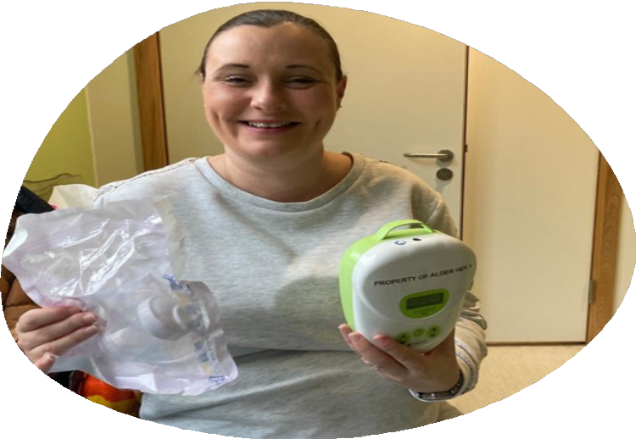Power pumping

This leaflet only gives general information. You must always discuss your individual treatment with the appropriate member of staff. Do not rely on this leaflet alone for information about your treatment.

This information can be made available in other languages and formats if requested

Alder Hey Children’s NHS Foundation Trust

Eaton Road

Liverpool

L12 2AP

Tel: 0151 228 4811

[www.alderhey.nhs.uk](http://www.alderhey.nhs.uk)

**© Alder Hey Review Date: November 2027 PIAG: 341**

**Information for parents**

Here at Alder hey we recognise that your

breast milk is the optimal source of nutrition for your baby and provides protection that will last way beyond the neonatal period.

There is no hard or fast rule

Aim to power pump for one hour per day.

You can use different timing patterns, here is one idea...

**20**m, **10**m, **10**m, **10**m, **10**m

Some mothers experience a drop in milk supply due to various reasons. Here at Alder Hey we support our mothers to increase their milk production by using a technique called Power Pumping!!

Another option could be listening to your favorite songs, pump for one song and have a break for another, or as you are watching TV, you could pump during the adverts.

Power pumping mimics ‘cluster feeding’ which is when a baby has shorter feeds more frequently, this in turn stimulates the breast more frequently, causing Mum to naturally increase her milk supply.

Some mothers experience a drop in

milk supply due to various different reasons, here at Alder Hey we support our mothers to increase their milk production by using a technique called power pumping!!

Some mothers experience a drop in

milk supply due to various different reasons, here at Alder Hey we support our mothers to increase their milk production by using a technique called power pumping!!

Some mothers experience a drop in

milk supply due to various different reasons, here at Alder Hey we support our mothers to increase their milk production by using a technique called power pumping!!

It may be 2-3 days before you see results and your milk supply increases.

Aim to continue power pumping for at least a week.