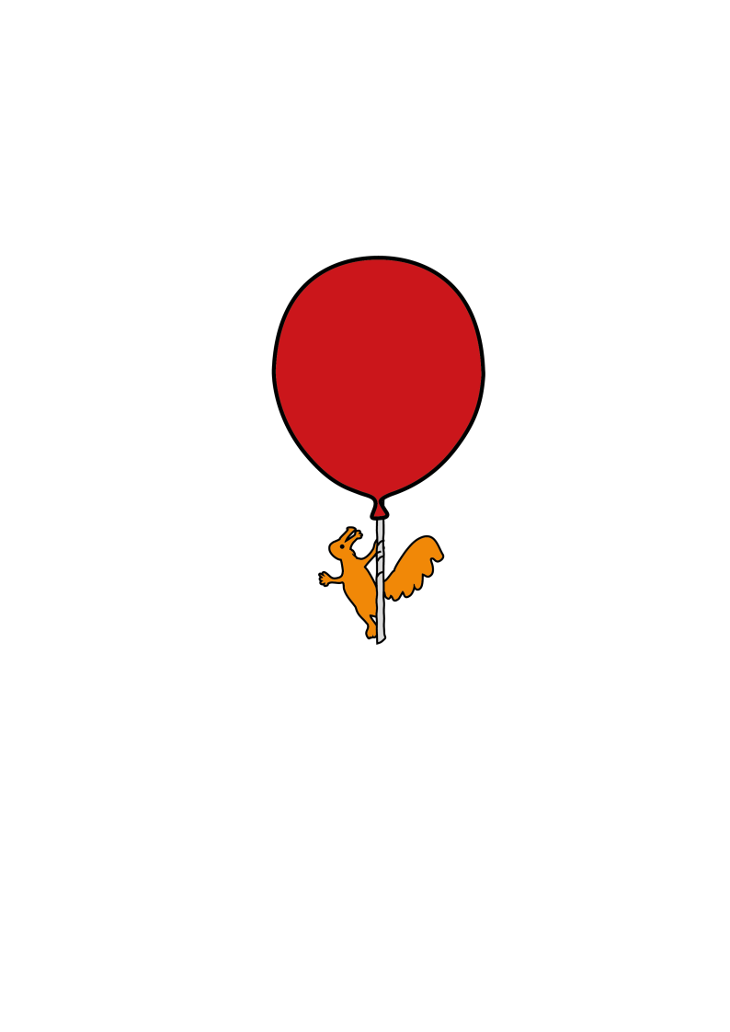[](https://en.wikipedia.org/wiki/ROYGBIV)****

Children’s

OT

Occupational Therapy Department

**Post Traumatic Amnesia**

Information for parents and carers

**What is Post Traumatic Amnesia?**

Post Traumatic Amnesia (PTA) is one of the stages of recovery after having a traumatic brain injury. During this stage the child may seem confused, disorientated and have memory loss. PTA can last for hours, days, weeks or months depending on the severity of the injury. When a child is in PTA they can usually remember up to the time of injury but have difficulty remembering what happened afterwards. They will have difficulty remembering day to day events such as who has visited them and will sometimes not remember who people are. This can be distressing for both the child and their family. They may not know where they are or what time of day it is. Most children will come out of PTA, even in the most severe cases.

Although they can recall past events, the child may have difficulty retaining new information. You can tell them something and they may forget within minutes. The child may become fixated on certain ideas or memories that may seem strange. This can be very confusing for the child. Confusion may appear worse at night when they are tired and there are fewer cues to help orientate them to their environment. Due to their high levels of confusion, they may put them selves at risk by trying to climb out of bed or wander.

The child may have difficulty paying attention and may take information in at a slower rate. Exposing them to a task that requires high levels of attention may be distressing and confusing. The child may feel tearful, anxious and frustrated. The child may display behaviours that are not usual for them, including physical aggression, disinhibition or impulsivity. This can be distressing to observe, but will often stop when PTA resolves.

PTA does not have any long term adverse effects on the child. PTA may last for a few minutes, hours, days, weeks or even, in rare cases, months. The length of time the child is in PTA is often a good indicator of the severity of the brain injury and the long-term effects.

**Helping your Child**

* It is important not to correct memory mistakes whilst the child is in PTA as this is likely to be distressing. Instead provide gentle prompts and cues, distraction and reassurance. You could try playing a game or taking them off the ward for a change of scenery.

* It is important to remain calm and avoid confrontation as this may lead to anxiety, agitation and distress.
* A child in PTA may not be able to cope with too much noise or activity and will need an environment that is not over-stimulating.

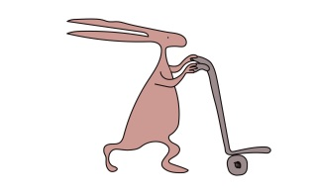

* + Reduce noise in the room by switching off the TV.
  + It may be beneficial to limit visitors to two people at a time.
  + Limit conversations to only one person talking at a time.
  + Avoid giving too much information, keep sentences short.
* It may be beneficial to draw up a rota for visitors to ensure everyone gets to see the child, without overwhelming them. This also allows the family time to rest as it is a distressing time for them and they may need a break.
* If they are agitated, restless or at risk of climbing out of bed, they may need a mattress on the floor initially.
* To ensure the child’s safety whilst they are agitated, increased supervision is required, they may need someone sat with them at all times. This could be a family member or 1:1 supervision from staff can be arranged if required.
* Stay calm. Seeing you distressed will add to their confusion and will be distressing for the child.
* Ensure the child is encouraged to rest, as PTA can cause increased fatigue, and rest will help the brain recover.
* Discuss any concerns you may have with staff members.

It may be comforting to know the child will usually not remember much of this time. They may get pockets of memory of this time, but most of it will not stay with them.

Be sure to take time out for yourselves and to share visiting amongst family members, if possible. You can also access clinical psychology to help support you through this. Please let a member of staff know if you feel this will be beneficial and they will complete a referral to this service.

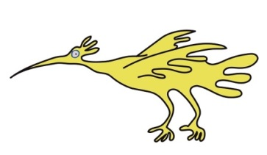**Useful Links**

[Post-traumatic amnesia | Headway](https://www.headway.org.uk/about-brain-injury/individuals/effects-of-brain-injury/post-traumatic-amnesia/)

**Contact us**

Therapy Department

Lower Ground Floor

Alder Hey Children’s Hospital

0151 252 5102

This leaflet only gives general information. You must always discuss the individual treatment of your child with the appropriate member of staff. Do not rely on this leaflet alone for information about your child’s treatment. This information can be made available in other languages and formats if requested.

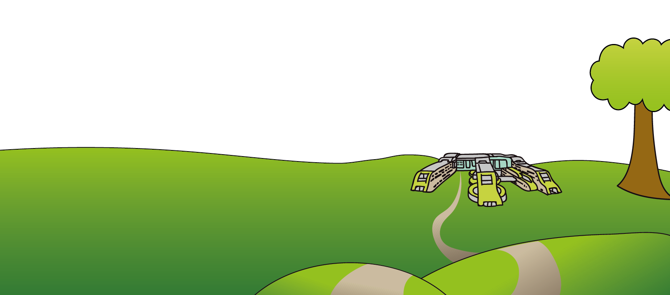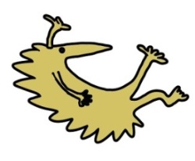Alder Hey Children’s NHS Foundation Trust

Alder Hey

Eaton Road

Liverpool

L12 2AP

Tel: 0151 228 4811

[www.alderhey.nhs.uk](http://www.alderhey.nhs.uk)

**© Alder Hey Review Date: April 2028 PIAG: 268**